SECTION 1
Introduction

1.0 INTRODUCTION

Background
bpTT LLC is a significant member of the BP group of companies, one of the world's largest petroleum and petrochemicals organizations. bpTT has been operating in Trinidad and Tobago for over 40-years and is one of the major companies in the Trinidad and Tobago’s energy sector. bpTT explores for and produces oil and gas, but are also involved in other areas of the energy sector.
bpTT is the country's largest producer of oil and natural gas, accounting for 45 per cent of the country's total production, it also sells in excess of one billion standard cubic feet of gas daily for use as fuel or feedstock for various industries in Trinidad and Tobago. Much of the Company’s operations are located offshore the East coast of Trinidad and onshore on Trinidad’s South-Eastern peninsula.
The island of Trinidad & Tobago sits on the South American Continent at the north-eastern boundary of Venezuela and separated only by a body of water known as the Gulf of Paria to the west and the Columbus Channel to the south. Guayaguayare Bay is located on the south-eastern coast of Trinidad (Figure 1-1). Guayaguayare Bay is a major hub of activity for oil and natural gas companies operating in Trinidad.
bpTT is seeking to replace its existing Oil Export Pipeline System which comprises a 42” crude oil loading pipeline and 16”deballast pipeline. This has become necessary as the existing pipeline system has reached the end of its design life of 30 years. The New Oil Export Line (NOEL) Project is therefore a replacement of the existing Oil Export Pipeline System and will maintain the current loading capacity.

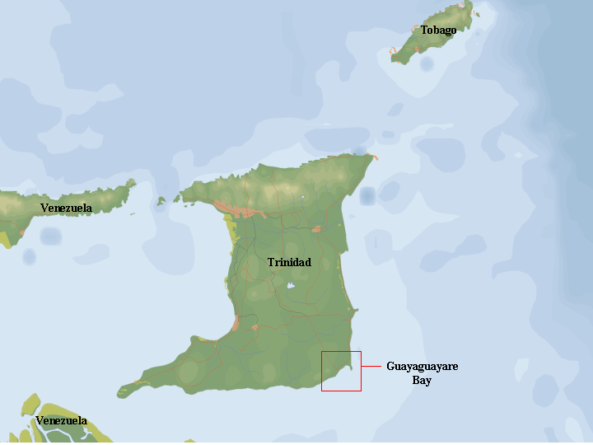
Figure 1.1 Location of Guayaguayare Bay
The New Oil Export Line (NOEL) will originate within the bpTT Galeota Point Facility (Facility) and extend approximately 5 km terminating at the existing single point mooring buoy location (Figure 1.2). The new pipeline will be in close proximity to the existing line (maximum distance from existing pipeline 500 meters).
The specifications regarding the new system are as follows:
- The new system will reduce the diameter of the loading line to 30”
- The new system will maintain the same loading capacity of 700 Mbbl tankers in 36 hours every 7 to 10 days.
- The pipeline will be designed to enable intelligent pigging options for future technical integrity testing (a future piggable system).

Proposed Route

Figure 1. 2 Proposed New Oil Export Pipeline

As part of the new regulatory requirements for the establishment of infrastructure for pipeline systems, bpTT submitted an application for a Certificate of Environmental Clearance (CEC) {CEC #0618/2003} to the Environmental Management Authority (EMA) for the proposed pipeline replacement activities. The application was reviewed by the EMA and an EIA(EIA) requested as a precursor to further evaluation of the application and award of approval. This EIA was requested in accordance with the CEC rules, 2001 and Activity 27 of the CEC (Designated Activities) Order, 2001. epas Consultants Ltd. (epas) were commissioned by bpTT to prepare the EIA, following the TOR (TOR), which the EMA provided as a guide.

This document, which is the EIA study report, provides a detailed description of the proposed activities relating to the replacement of the 42” pipeline and the 16” deballast line with a 30” pipeline as well as a description of the biophysical and human environments of the study area in which the activities will occur. Guayaguayare Bay area has in the past been subject to extensive development and the EIA report also looks at the cumulative impacts of the past and on-going operations in this area in relation to the proposed pipeline replacement activities. The document also includes the results of public consultations conducted, and a ranking of all potential impacts (positive and negative), which may arise during all phases of the project. Finally, the document presents the commitments to be made by bpTT in the implementation of impact mitigation measures before the development takes place as well as for the implementation of monitoring requirements for the Operational Phase of the project.

TOR And Scope Of EIA

The TOR for the conduct of this EIA study and the preparation of the Environmental Impact Statement were provided to bpTT by the EMA. A copy of these TORs are provided in Appendix I.
Based on the TORs, the scope of works for the project were divided into the following areas:
- Conduct of a literature review (including legislative requirements) of existing information related to the Guayaguayare Bay and of the study area in which these operation take place
- Field work collection of social and environmental data (as outlined in the TORs) to establish baseline conditions
- Determination of the potential impacts of the proposed activity
- Analysis of alternatives for the project
- Conduct of consultations with all relevant stakeholders and members of the general public
- Development of a management plan for all phases of the project life
- Development a monitoring plan for on-going operations of the Oil Field

Objectives

The main objective of this study was to conduct an EIA in conformity with the EMA’s TOR in order to obtain a CEC for the replacement of bpTT’s 42” and 16” Oil Export Pipeline with a new 30” Pipeline.
The sub-objectives were as follows:
- Conduct an environmental and hazard/risk assessment of the proposed activities on the site
- Prepare a management plan to mitigate the negative impacts and enhance the positive impacts of the project
- Determine the extent of environmental and social impacts arising from the proposed activities
- Examine the cumulative impacts from ongoing and other proposed exploration and production programs

Project Summary

The NOEL will originate within the Facility and extend approximately 5 km terminating at the existing single point mooring (SPM) buoy location (Figure 1.2). This project will consist of essentially two components, an onshore component and an offshore component. The key aspects of each phase component are as follows:

Onshore Component:
All of the proposed activities will be located within bpTT's Galeota Point Terminal where the development area is within land leased from the Government of Trinidad and Tobago. The development area will be located within 1 km inland from the Guayaguayare Bay. The main activities associated with this phase are:
Replace and re-route onshore piping from the pump house to the tie in point for the offshore line.
- The conduct of civil works, which would include the construction piping supports for the above ground piping with underground piping at road crossings. The above ground piping would be designed to meet the API/TTBS pipe colour coding standards.
- Onshore Pipe lay
- Decommissioning of existing onshore pipeline which connects to the existing offshore 42” and 16” pipelines

Offshore Component:
The proposed activity offshore entails replacement of the existing offshore 42” pipeline, Pipe Line End Manifold (PLEM) and 16” ballast pipeline with new 30” pipeline and PLEM. This activity will extend for a distance, which ends approximately 3 miles (5 km) offshore from the Guayaguayare Bay, off the South Eastern Coast of Trinidad. The main activities associated with this phase component are:
- Replacement of the existing 42” and 16” pipeline and PLEM with the installation of new 30” pipeline and PLEM
- Horizontal Directional Drill (HDD) Shore Approach (The HDD drill-site will be located onshore)
- Offshore pipelay and pipeline end manifold (PLEM) installation
- Hydrostatic testing of the pipeline
- Commissioning of 30” pipeline
- Decommissioning of the existing 42” and 16” pipelines and PLEM.
- Flushing pipelines to remove entrained oil
- Flooding pipelines with seawater

Approach And Methodology

The specific activities of the EIAwere as follows:

Activity 1 – Literature Review

Task 1: Review of all available information for the study area
Task 2: Review of detailed project development plan
Task 3: Identification of data gaps

Activity 2 – Filling of Data Gaps

Task 1: Review of existing operation
Task 2: Collection of additional baseline data (air, noise, water, groundwater, soil, flora, fauna, socio-economic)

Activity 3 – Risk and Hazard Assessment

Task 1: Identification of impacts – pre and post-operational, production phase
Task 2: Assessment of potential impacts
Task 3: Development of mitigatory measures

Activity 4 – Identification and Analysis of Alternatives

Task 1: Review and assessment of operations and procedures
Task 2: Determination of possible alternatives

Activity 5 – Stakeholder participation

Task 1: Identification of all relevant stakeholders
Task 2: Preparation of stakeholder questionnaire
Task 3: Stakeholder consultation

Activity 6 – Development of Management Plan and Monitoring Programme

Task 1: Identification of aspects of operations requiring management and
Monitoring via risk and hazard analysis, stakeholder interviews, and a consideration of the entire project description
Task 2: Preparation of appropriate monitoring programme along specific timescales for each activity.

The methodologies used in the collection, analyses and interpretation of data and information are included in Appendix II. Local (EMA) and international (USEPA, NIOSH) sampling and testing protocols were employed in the sampling and analyses of all physiochemical variables.

EIA Project Team

epas was required to conduct an EIA for the replacement of bpTT’s 42” and 16” Oil Export Pipeline with a new 30” Pipeline.

The study was conducted by in-house staff of the firm and associate consultants of the firm, with assistance provided to the study team by staff of bpTT. The study team included:

Ahmad A Khan; Ph.D. | Technical Director/Project Manager
Kirkland Braithwaite, MSc. | Team Leader/Project Coordinator
Erin Mangal, MSc. | Ecologist
Floyd Lucas | Consultant Ecologist
Carol Ramjohn | Consultant Ecologist
Fazal Hosein, MSc. | Consultant Geologist
Lisa James, MSc. | Consultant Social Scientist
Frank Teelucksingh | Consultant Dispersion Modeller
Roderick Toussaint | Field Technician
Nathaniel Phillip | Field Technician

Data and reports were commissioned on various aspects of the marine work, including sea grass ecology, reef ecology, benthic macro and micro flora, mangrove ecology and coastal zonation. These were compiled by the Institute of Marine Affairs.

