SECTION 3

project discription

3.0 PROJECT DESCRIPTION
  - Project Overview

bpTT operates out of the Facility which is located on the extreme south east corner of Trinidad on a peninsula which bounds the Guayaguayare Bay. This Facility is sited on approximately one hundred and four (104) acres land leased from the state. The initial deed of lease was for a period of thirty (30) years from May 1971 and as such the current lease has expired. An application for an extension/ renewal of the lease has been lodged with the Director of Surveys for an additional period of thirty years.

The existing pipeline operates under a pipeline license issued by the MEEI issued in March of 1972. The existing pipelines, a forty- two (42”) inch oil transmission pipeline and a sixteen (16”) inch deballast pipeline have reached the end of their design life and as such need to be replaced. The New Oil Export Pipeline will originate within the bpTT Facility and extend approximately 5 km terminating at the existing single point mooring (SPM) buoy location (Figure 3.1). This project will consist of essentially two components, an onshore phase component and an offshore component.

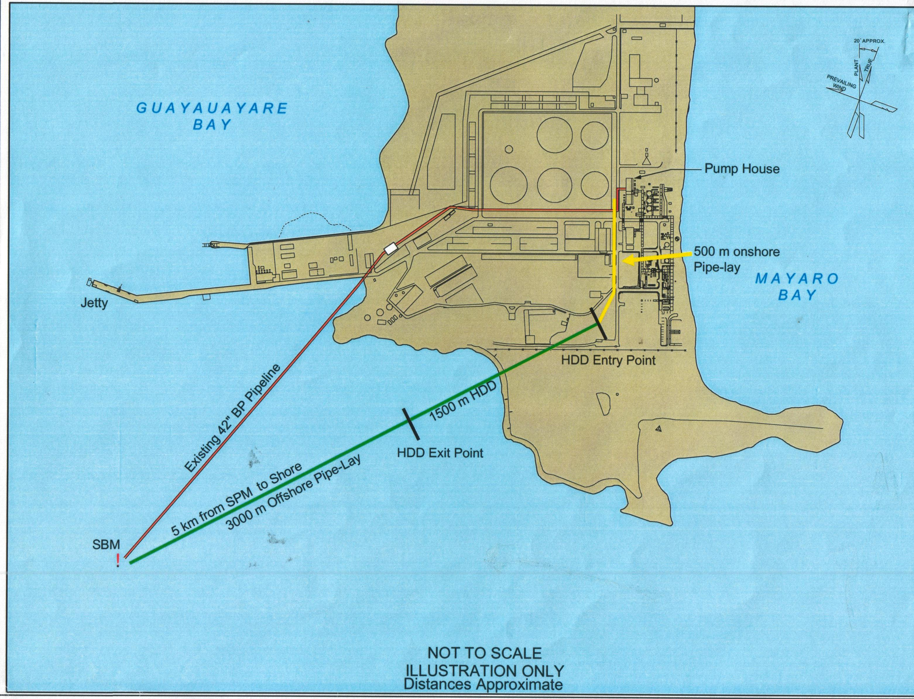

Figure 3.1: Existing Facilities and General Layout

The existing crude oil transmission-loading (42”) pipeline begins at the pump house and runs in a general westward direction along the southern boundary of the tank area. Upon reaching the south end of the wastewater area the pipeline veers in a south westerly direction and continues so until it exits the facility into the Guayaguayare Bay to the south of the Jetty. The pipeline continues in this general direction until it terminates at the SPM buoy location. This current pipeline route is shown in both Figure 3.1 and Figure 3.3.
  - Current Operations
bpTT operations are centred around the Facility. The major operations occurring at the bpTT Facility are the collection, primary processing, storage, and loading of crude oil onto tankers. The crude oil is sourced from bpTT’s five offshore fields on the east coast of Trinidad. Figure 3.2 shows a general overview of the processes at the Facility.
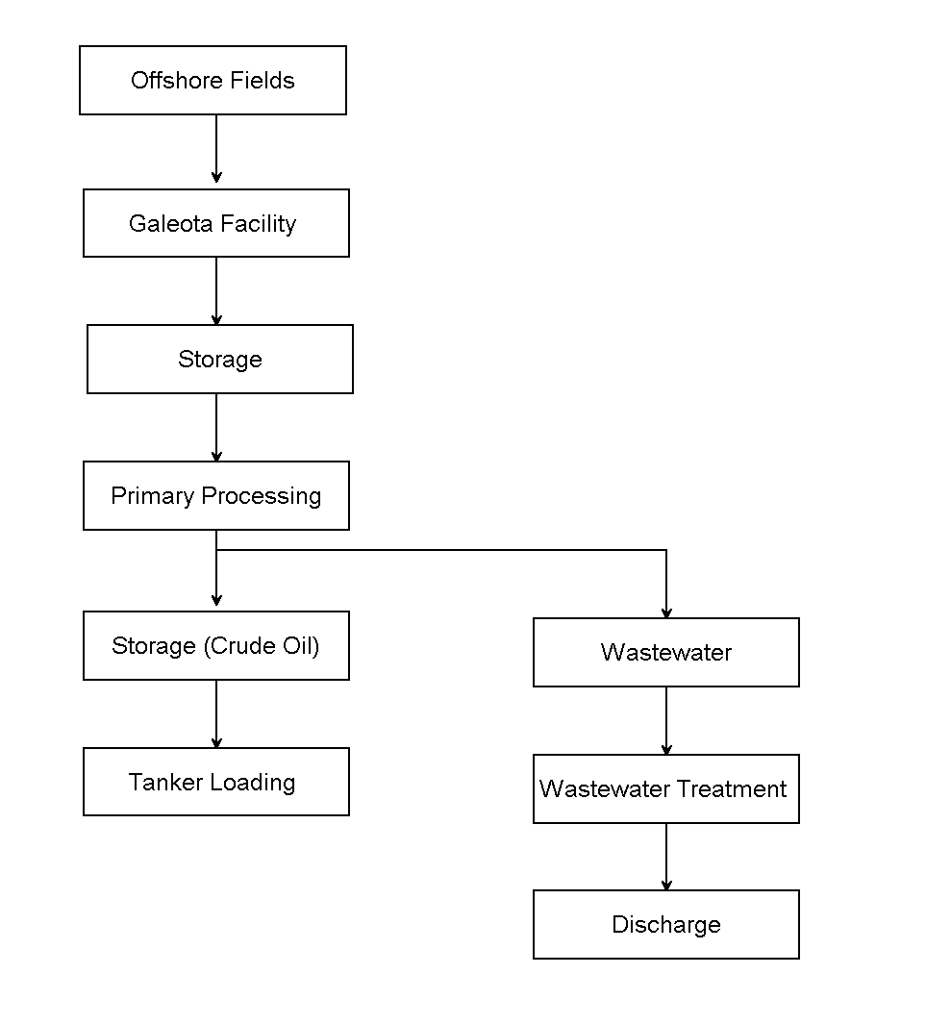
Figure 3.2: Overview of the Processes at the Facility

  - Proposed Changes to the Layout
The changes in the pipeline route are illustrated in Figure 3.1 and Figure 3.3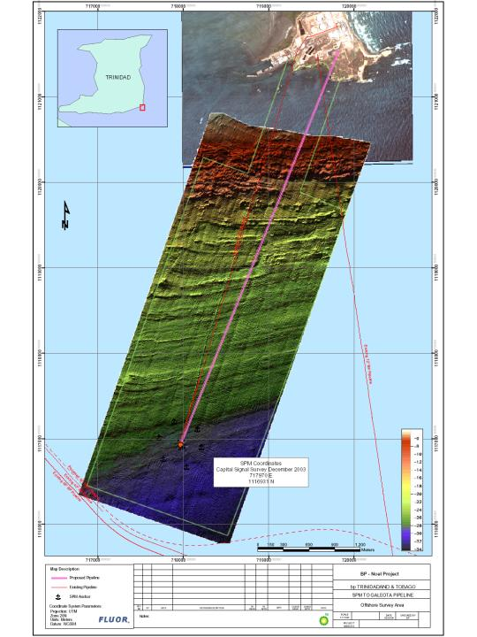
Figure 3.3: Proposed Changes in the Pipeline Route

The proposed route for the new pipeline will originate at the existing pump house and follow an existing road to the south for approximately 500 meters where it will be horizontally directionally drilled for a distance of approximately 1200-1700 meters to the southwest and then extend along the seabed floor to the existing SPM buoy location.

The changes in the pipeline route will not result in a change in the process flow of the general operations as shown in Figure 3.2 above. Changes in the technology of modern oil tankers has eliminated the need for deballast lines, and as a result a single loading line is sufficient. The existing 42” oil transmission pipeline and 16” deballast pipelines will now simply be replaced with a single 30” pipeline.

  - Pipeline Design
The new pipeline will be made of steel and have a diameter of 30” (762mm) and a wall thickness of 0.625” (15.88mm). It will be designed to the ASME B31.4; 150# Class standard for liquid hydrocarbon pipelines and will be colour coded to the API/TTBS standard. The maximum operating temperature will be 38ºC and the minimum will be 21ºC. The new pipeline will be valved on both ends such that tie-ins can be made to existing onshore pumping system and offshore Pipeline End Manifold (PLEM), as well as new future replacement systems on both ends. The pipeline, subject to detailed engineering study, will have one (1) chemical injection point, one (1) corrosion coupon point, one (1) sample point and one (1) spare access fitting onshore all of which will be double-block & bleed. The double block and bleed requirements for all valves will be determined by bpTT in accordance with all relevant standards. Additionally, all subsea valves at SPM and PLEM will be Remote Operated Vehicle (ROV) operable.

The near shore section of the pipeline will be installed by the Horizontal Directional Drill (HDD) method and is therefore sheltered from wave and current action. The remainder of the pipeline will be installed by the conventional S-lay method from a pipe lay-barge and is designed to be laid on the seabed without burial. Hydrodynamic stability analysis was carried out for the exposed portion of the pipeline using AGA Level 2 (PRCI/AGA Submarine Pipeline Stability Program) to assess the feasibility of using concrete coating for the section of the line from 50 ft (15 m) depth contour to the end of the line in 97 ft (30 m) water depth. The analysis was based on a 30" pipeline using existing Metocean and soils data. From the analyses, the 30" pipeline can be stabilized with a concrete weight coating of 4.25" for the 2,752 ft (839 m) segment near shore and 2.5" for the remaining 8,712 ft (2,360 m) portion of the pipeline. Additional stability analysis will be performed once final pipeline installation design is completed and appropriate stabilization techniques will be employed based on the results.

The new design will allow for the existing line loading capacity to be maintained. It therefore means that the line will maintain the current maximum flow rate of 35,000 bbls/hour with the ability to load 700Mbbl tankers in 36 hours. The pressure limitations of the line were determined based on flow rates required and the maximum pressure the tankers can tolerate. The new line was designed to operate at a maximum of 285psi. The pipeline is inherently safe as the maximum pressure cannot be exceeded by existing pumping capability. The maximum pressure that the existing pumps can supply is 268 psig (this pressure assumes the tanks are completely full).

Sacrificial anodes will be utilized for offshore cathodic protection. Onshore cathodic protection will be provided from impressed current sourced from onshore.

  - Project Activities
The project activities will consist of a pre-installation, installation, and decommissioning and operational phases. The equipment and machinery to be involved in the execution of this project are:

1. During the pre-installation phase
- Survey vessels
- Survey equipment

2. During the installation phase
- Pipelay vessel and supporting marine spread
- Horizontal directional drilling rig and associated support equipment
- Earthmoving equipment
- Lifting equipment
- Welding machinery

3. Operational phase
  - Four (4) pumps used intermittently (existing)
  - Chemical Injection skid and metering station (replacement in kind)
  - Single Point Mooring buoy (SPM)

The project activities have been divided into the onshore and offshore components.

3.5.1 Onshore

3.5.1.1 Pipe storage & Assembly
Pipes for the onshore portion of the pipeline will be stored in the existing pipe yard which is located on the Facility. No additional land area or land clearance activities will be necessary in support of this portion of the project. Similarly, pipe assembly will occur in the pipe yard area.

3.5.1.2 Site Preparation & Replacement
Most of the piping for the onshore segment will be above ground and as such the site preparation for this activity will be limited to the construction of pipe racks. A minimal amount of underground piping will be installed and these will be limited to areas such as road crossings. The activities involved in the execution of this phase of the project will therefore include fabrication, mechanical/ piping, welding, civil earthwork, civil concrete, lifting/rigging and painting. The impacts of these activities will be limited to the Facility, temporary in duration and will be have a minimal impact.

3.5.1.3 Horizontal Directional Drill Spread
The HDD Spread will be located onshore within the Facility near the compost area east of the fire water training site. This location was deemed to be the most suitable as it does not have any significant environmental impacts and it provides the least interference between HDD process and day to day plant activity. The proposed HDD Spread is depicted in Figure 3.4:
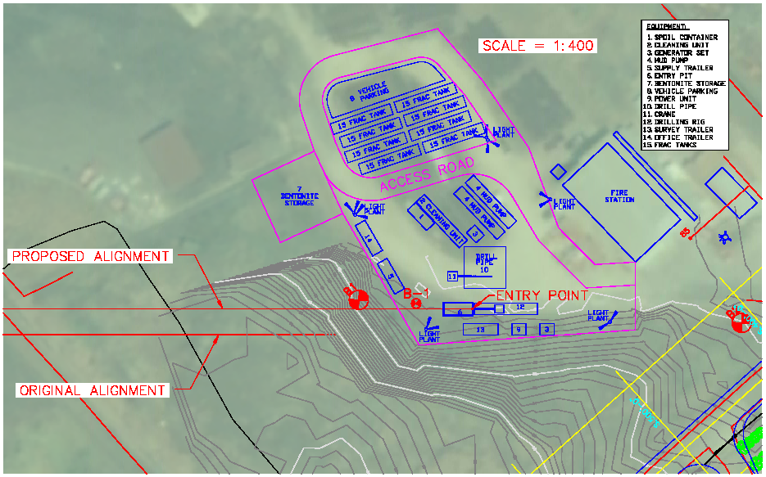
Figure 3.4: The Proposed HDD Spread

      - Decommissioning of Existing Onshore Pipelines
The decommissioning of existing onshore pipeline which connects to 42” and 16” offshore pipelines will be achieved through pushing oil back to storage tanks by seawater from pumps on an offshore tanker at the PLEM and then flushing the pipelines with additional seawater using the fire water system as described in the overall system decommissioning process described below. Some above ground piping will be removed, but underground piping will not be removed.

The decommissioned lines will be monitored as part of routine Terminal maintenance procedures on a quarterly basis for signs of deterioration such, as corrosion, and the necessary corrective actions, if required, will be taken.

    - Offshore

      - Horizontal Directional Drilling
The HDD approach was selected over open trenching in order to minimize environmental impacts caused from the shore crossing. The HDD process begins with mobilization of drilling equipment to the onshore location. The HDD rig drills a guided pilot hole through the subsurface to the exit point offshore. For the NOEL Project, the pilot hole will be approximately 10” in diameter. The pilot hole is drilled beginning at a prescribed angle from horizontal and continues under the shoreline and near-shore areas along a design profile made up of straight tangents and long radius arcs. The directional control of the bore is brought about by a small bend in the drill string just behind the cutting head. The pilot drill string is not rotated except to orient the bend. The drill path is monitored by an electronics package housed in the pilot drill string near the cutting head. The electronics package detects the relation of the drill string to the earth’s magnetic field and its inclination. This data is transmitted back to the surface where calculations are made as to the location of the cutting head.

Once the pilot hole is complete, it must be enlarged or reamed to accommodate the product pipeline. Generally the pilot drill bit is replaced by a reamer attached to the drill string on an offshore barge near the exit location. Joints of drill pipe are added as the reamer makes its way back through the pilot hole to the drilling rig. The reaming process is repeated with stepped-up diameters until the required hole diameter is reached. It is expected that the NOEL Project will take 4 reams to reach a final bore hole diameter of 42”. Large quantities of slurry are circulated in the hole to maintain the integrity of the hole and to flush out soil borings.

Concurrent to drilling operations, the pipeline string is laid offshore, and hydrostatically tested. Upon completion of the HDD reaming operations, the pipeline string is dewatered and attached to the HDD drilling string. The pipeline string is pulled into and through the drilled hole to the entry point onshore.

Following a post-pullback hydrotest, a flanged subsea tie-in of the pipe string to the offshore section of the pipe will be made. The HDD shore approach will span approximately 1200-1700 meters and include the subsurface crossing of the existing 12” pipeline. The exact distance of the HDD shore approach will be determined after the selection of the HDD contractor.
      - Dredging
The creation of transition zone/ fluid collection pit through minor offshore dredging will be necessary for the dual purpose of creating a drilling fluid collection pit and a transition area to provide a suitable radius of curvature between the drill exit point and the position of the pipeline on the seabed. This impact will be mitigated through process design to minimize surface area impacted. The dredge area will be backfilled to pre-construction conditions using pre-fabricated concrete mats and natural sedimentation. The dimensions of the dredge area will be determined after detailed design engineering is complete and a HDD contractor is selected, but a conservative estimate of the pit dimensions will create a conical shaped excavation of approximately 53 meters long, 6 meters wide and 5 meters deep.

      - Drilling Fluids
The drilling fluid is usually a mixture of fresh water, bentonite (sodium montmorillonite) and benign polymers. Bentonite is natural clay that is very hydrophilic causing the clay particles to swell when mixed with water. This swelling increases the fluid viscosity and helps create an impervious coating on the wall of the drilled hole. Bentonite and several of its additives are non-hazardous as defined by the U.S. Environmental Protection Agency. Material Safety Data Sheets (MSDS) are readily available and examples are included in the Appendices. The actual mud mixture and additives will not be determined until a HDD contractor has been selected.

A waste management plan will be developed to ensure proper disposal of used drilling fluids and soil boring material generated during the HDD. As part of this, a model will be developed to assess the probable distribution patterns and impacts of used drilling fluids on the marine environment. Additionally a contingency plan will be developed to minimize the impact of inadvertent return of drilling fluid events. Part of this process involves the development of a drilling fluid model which will assist in determining the fate of drilling fluids. This model will be submitted to the EMA prior to the start of operations.

      - Water for Drill Operations
The HDD operation requires fresh water for the make-up of the bentonite-based drill slurry. Depending on drilling methodology, it is estimated that total water consumption may range from 4 to 5 million gallons. During peak consumption, water needs to be delivered at rates up to 18,000 gallons per hour (71 m³ per hour). The NOEL project recognizes that these quantities of fresh water may be difficult to source near the location and are actively working to ensure that sufficient fresh water is available for the drilling activities. As part of the HDD contract, the HDD contractor is required to prepare a Fresh Water Plan that considers options for sources of fresh water, associated risks of transport to the site, any required on-site storage, and impacts to the source. This plan will be approved by bpTT prior to the start of the HDD and will ensure that potential impacts have been addressed. bpTT will stockpile 2 million gallons of freshwater during the rainy season in existing Facility deballast pond 5 for use in the HDD.

      - Inadvertent Returns
Proper contingency planning is critical for an effective response to inadvertent returns. It is important not to delay or impact the HDD operations, particularly during reaming or pullback. The NOEL project will develop an Inadvertent Return Contingency Plan than includes:
- Methods of rapid detection (access to the drill alignment and associated areas)
- Have suitable containment materials at the HDD site (silt curtain, hay bales, sand bags, excavation tools, plywood sheeting etc.)
- Identify the length of time before clean-up begins (if in a traveled street then it is most likely immediate; however, it may be more suitable in other areas to allow the bentonite gel to set and dry)
- List regulatory agencies which should be notified in the case of an inadvertent return event
- Establish ingress/egress routes and methods into environmentally sensitive areas to minimize disturbance from equipment and personnel

      - Offshore Pipe Lay
Given the relatively shallow depths along the pipeline route and the seafloor conditions it is expected that approximately 3300 meters (see Figure 3.3) of 30” pipeline will be laid directly onto the seafloor using the S-Lay Method. The S-Lay is the traditional method for installing offshore pipelines in relatively shallow water. It is so called because it forms an elongated “S” as it moves in a horizontal plane from the welding and inspection stations onto the lay barge and on to the ocean floor. As the pipeline moves across the stern of the lay barge and before it reaches the ocean floor, the pipe is supported by a truss-like structure, which is equipped with rollers and is known as a stinger. The purpose of a stinger is to minimize curvature, and therefore the bending stress, of the pipe as it leaves the vessel (Cranswick, 2001). The lay barge will have an 8-point anchor mooring system, which is maneuvered to pull the barge forward as the pipeline is laid. In addition to the pipeline, the lay vessel will also install the PLEM on the seabed floor. Once on the sea floor the 30” pipeline will be stabilized by its wall thickness and the presence of a concrete coating which will be placed around it.

  - Pipeline Integrity Testing

WELDS
The welds represent the potential weak points in the overall structural integrity of the pipeline. Welds are also the area where corrosion is most likely to start from. As such the quality of the welds is of paramount importance. Welding will occur onboard the pipe-lay vessel. Upon completion of a weld, the quality will be subjected to a non-destructive test method to confirm the structural integrity of the weld before the pipeline is laid. Failure of this test would require the weld to be redone and retested before the pipe can be used. Once the entire pipeline length is constructed it will be hydro-tested according to the MEEI’s “Guidelines for Pipeline Hydrotest Permits” and in accordance with the NOEL Project requirements described in this report. Any pipe leaks or failures found will be repaired and the segment will be retested to ensure the pipeline’s integrity.

    - HYDROSTATIC TESTING
Hydrostatic pressure testing of the pipeline is a procedure where the pipeline is pressure filled with water for a period of time to ensure there are no leaks. The NOEL pipeline will actually include 4 separate hydrostatic tests:

1. The 1200-1700 meters of pipe for the HDD will be welded offshore, flooded with approximately 180,000 gallons of sea water and pressure tested. This water will remain in the pipeline to keep the pipeline near the bottom of the seabed until the pipeline is ready to be pulled through the HDD hole (approximately 3 months).

2. Next the section of pipe will be pulled through the HDD hole during which time the flooding of seawater will be controlled to maintain buoyancy during the pull back. Once the pull back is complete, additional seawater will be added to 1200-1700 meter section and the pipeline will be pressure tested again. To make this hydrotest, approximately 6,600 gallons of seawater will be released subsea at the tie-in point to accommodate the changing of the equipment for the pressure test (the volume of water is based on the equalization of the water level from the proposed entry point down to the sea water surfaced elevation and the release of this volume is for the safety of the diver as he makes the connections).

3. Once the offshore pipeline is connected to HDD tie in point then the final pressure test will occur. An additional 6,600 gallons of seawater will be released for this pressure test as well. Finally, once the hydrotests are completed, then the pipeline will be connected to the PLEM and a leak test of the entire system will be performed.

4. A separate pressure test for the onshore portion of the pipeline will be performed by the onshore pipe-lay contractor prior to the final “golden” weld connecting the offshore section to the onshore section.

To eliminate bacterial growth and potential corrosion, it is standard industry practice to add treatment chemicals when seawater is introduced into the pipeline. The addition of treatment chemicals is not about corrosion during installation, but rather the introduction of contamination. If the bacteria find the conditions to form colonies in the pipeline during hydro-testing, they will also be active under normal service and continue to damage the pipeline. Once these colonies have settled on the steel service is very difficult to get rid of them.

The highest risk from the corrosion point of view is Microbially Induced Corrosion (MIC):
- Aerobic microbes thrive in presence of oxygen
- Anaerobic microbes thrive in the absence of oxygen

Oxygen scavenger will prevent growth of aerobic colonies and oxygen induced corrosion. The biocide will prevent growth of anaerobic colonies.

The hydrostatic test water treatment chemicals expected to be used for the NOEL pipeline are on the approved list from the MEEI and will be obtained from the manufacturer, Baker Petrolite, and are as follows:

- Biocide: X-cide(r) 102. The expected dosage rate is 300 ppm, which contains 75 ppm (i.e., 25%) of the active ingredient – glutaraldehyde.
- Oxygen Scavenger: OSW5200. The expected dosage rate is 100 ppm, which contains 60 ppm (i.e., 60%) of the active ingredient – ammonium bisulfite.

The oxygen scavenger has a detoxifying effect on the biocide. Therefore, the hydrostatic test water must be treated with the oxygen scavenger at a point located sufficiently upstream of the injection point for the biocide to allow the oxygen scavenger adequate time to react with oxygen in the seawater. If this “slip streaming” of the two chemicals at their respective target concentrations is not properly performed, the two products will effectively neutralize each other and be wasted prior to their intended use.

After following proper chemical injection procedures, it is expected that virtually all of the oxygen scavenger will have reacted with the available oxygen in the seawater and have been consumed prior to the injection of the biocide. Due to its lengthy half-life, there will be a residual amount of biocide present when hydrostatic testing is completed. Glutaraldehyde in concentrations above the range of 10 to 15 ppm is potentially hazardous to organic life including marine organisms. Therefore, bpTT plans to neutralize (i.e., detoxify) the biocide prior to discharge of the hydrostatic test water.

For all occurrences where the duration of seawater in the pipe segments will be longer than 30 days, treatment chemicals will be added. Provisions will be made to neutralize these treatment chemicals prior to the discharge back to the sea. Detailed modeling plans for hydrostatic discharges is submitted within Volume 2, Appenidx IV. The final treated hydrotest water will stay in the system until the commissioning of the system is started (approximately six weeks). Commissioning activities have been designed to utilize the existing 16” line to transport the treated hydrostatic test water from the new 30” line to the Galeota Terminal deballast ponds 4 and 5 for neutralization, aeration, monitoring and discharge to sea through existing outfall. Deballast ponds 4 and 5 have a capacity of 3.5 million gallons. It is estimated that the volume of treated hydrotest water will be less than 700,000 gallons.

  - Commissioning of New 30” Loading Line and Decommissioning of 42” and 16” Pipelines
The commissioning and decommissioning operations will be conducted in tandem to ensure smooth transition from old system to new and minimal disruption to loading operations.
Overview of process:
- 30” line will be pressure tested and left filled with treated hydrotest water.
- 42” line will be backfilled from SPM buoy to shore with seawater to displace oil utilizing pumps on a tanker and obtaining seawater from the SPM buoy location. Once complete tanker can be released.
- Pump discharge spools that are connected to the 42” line will be removed and new spools connected to the 30” line will be installed.
- 30” line will be connected to 16” line utilizing a “subsea jumper” and hydrotest water will be displaced with oil. This will allow for the transfer of hydrotest water to shore for treatment prior to discharge. The hydrotest water will be displaced into deballast ponds four and five.
- 42” line will be connected to the 16” line through the existing PLEM and will continue to be flushed with seawater from fire water system and using deballast ponds to treat water prior to discharge. The fire water pumps will circulate the sea water. The intake for the seawater will be the fire water system intake. Sea water will continue to be flushed through the 42” line to the 16” line and then to ponds 4 and 5 for treatment until flush water considered clean (water is within parameters of TTS547).
- 30” line will be connected to SPM buoy using new hoses and will continue tanker load out upon arrival of tanker.
- Once deemed clean and full of saltwater, the 42” and the 16” lines will be blind flanged, valves locked and pipelines and existing PLEM mothballed.

During the initial two weeks after decommissioning, the pipeline route will be monitored for oil sheens. If any sheens are noted, a response plan will be activated. The incident commander will be notified, upon his evaluation of the spill he will then mobilize the Incident Mangament Team (IMT). This response team is cross functional and multidisciplinary. It possesses both relevant human resources and access to pertinent oil spill equipment required to manage spills of varying sizes. Thereafter, the status of the decommissioned pipelines will be reflected in the bpTT Pipeline Integrity Plan, but the pipelines will not be removed from this program.

  - Disposal of Waste Material

ONSHORE
The Galeota Terminal is ISO 14001 certified and maintains a comprehensive waste management program. Onshore waste generated during the construction process will be managed in accordance with this plan.

OFFSHORE
Waste will be contained and sent to shore for appropriate disposal.

Anticipated waste streams
- Used / removed piping/ scrap metal (approximately 38,800 pounds to be disposed of offsite at non-hazardous waste facility)
- Consumable welding waste
- Paint waste and used solvents
- Recovered drilling fluids (disposed of utilizing the existing bioremediation pads at the Facility)
- Hydrostatic Test water- collected, aerated and tested prior to discharge as described in the Hydrostatic Pressure Testing of the Pipeline (approximately 180,000 gallons each for the HDD and 700,000 gallons for the final test)

  - Replacement of Single Point Mooring Buoy

Based on the design life of the buoy, the current SPM buoy and sub-sea hoses are scheduled for replacement in 2005 - 2006. The replacement SPM will be utilized to lift and load crude oil onto tankers through the BP Galeota Terminal at a rate of 28,000 to 35,000 bbl/hr and shall be sized and outfitted to accommodate any crude tanker size from 50,000 DWT to 250,000 DWT The SPM shall be provided with a PLEM to transition from the submarine pipeline to the underbuoy hoses. During installation of the SPM, the underbuoy hoses will be installed to approved configuration as defined by the SPM manufacturer. The floating loading hoses are part of routine maintenance and replacement schedule and will be washed, flushed and shifted from the existing SPM to the new SPM as appropriate. The SPM shall be permanently moored by the existing drag-type anchors and chains which shall be inspected prior to installation. . The anchor chains will be tested for integrity and repaired/ replaced as warranted by the evaluation. This is a replacement in kind of the existing system, anchors and the location of the SPM buoy will not change.

  - HSSE During Construction

The NOEL Project Team has developed a comprehensive HSSE strategy for the selection and management of contractors during construction. An HSSE questionnaire accompanies all requests for proposal packages and the evaluation of the responses is incorporated into the selection of the contractor. Detailed HSSE minimum requirements and expectations are incorporated into contracts. Once a contract is signed, then the contractor and bpTT jointly develop a bridging document that shows the alignment between contractor and bpTT expectations. During the actual execution of the work, contractors are required to have an HSSE professional monitoring the work. As an additional assurance measure, the NOEL Project will have a HSSE advisor monitoring contractor work. Finally, all onshore work involved in the execution of the project will occur within the bpTT Facility. This provides for an additional measure of control and oversight of contractor work.

The onshore scope of work will be executed under the existing Terminal Emergency Response Plan. An addendum to the plan will be developed to ensure adequate emergency response capabilities for the offshore portion.

  - Operation of 30” Pipeline

    - Pipeline Pigging – frequency, duration & disposal of materials arising

The NOEL pipeline will load out BS&W 0.5% market quality crude oil and therefore it is not anticipated that this line will require regular pigging from either a build up of sand and sludge or from wax. At the conclusion of the pipelay, the lay vessel will perform a testing and gauging pig run to determine a baseline for any future pigging should it be necessary. The pipeline has been designed with pre-investment of a valve to be installed at the pump header and a guidance frame to be placed on the PLEM to allow for future pigging capability. The actual design of pig launcher and receiver has been removed from the project scope. It is not anticipated that the pipeline will be pigged for 5 to 7 years.

3.11.2 Corrosion Control
3.11.2.1 Coatings
The pipeline will have an external coating of fusion-bonded epoxy (FBE), with a rough coat finish to ensure concrete coating adhesion and 3” to 4.5” of concrete coating for protection and stability.

      - Cathodic Protection
Sacrificial anodes will be utilized for offshore cathodic protection. Cathodic protection calculations will be performed in Mathcad and in compliance with DNV RP401, 1993 to determine the anode design and spacing. The anodes will be composed of aluminum in a half-shell bracelet shape. Onshore cathodic protection will be provided from impressed current.

    - Monitoring of Decommissioned Pipelines
During the initial two weeks after decommissioning, the pipeline route will be monitored for oil sheens. If any sheens are noted, a response plan will be activated. The incident commander will be notified, upon his evaluation of the spill he will then mobilize the Incident Mangament Team (IMT). This response team is cross functional and multidisciplinary. It possesses both relevant human resources and access to pertinent oil spill equipment required to manage spills of varying sizes. Thereafter, the status of the decommissioned pipelines will be reflected in the existing bpTT Pipeline Integrity Plan, but the pipelines will not be removed from this program.
    - Maintenance & Repair
The maintenance and repair schedule for the pipeline will be influenced by the condition of the pipeline and the necessity for corrective action. The pipeline will be evaluated as described in the existing Facility Pipeline Integrity Plan.
  - Decommissioning of 30” line

At the end of the design life for the 30” pipeline, decommissioning activities will occur. At a minimum, a risk assessment will be conducted and any impacts will be modelled and mitigated. The pipeline will be flushed clean of hydrocarbon, capped and decommissioned utilizing the best available technology at the time. This will be done in accordance with any legislation that is applicable at the time.

  - Project Schedule

The project schedule for the execution of this project is indicated below. The dates indicated here are all tentative.
Engineering
- Design (January 2004 to December 2004)
- Sanction by BPTT (January 2005)
Construction
- Onshore Civil Work and Piping (February 2005 to May 2005)
- Offshore Pipe Lay and HDD (March 2005 to September 2005)
- Commissioning of new system (September 2005 to October 2005)
- Decommissioning of existing system (October 2005 to November 2005)

  - Employment & Other Community Benefits

Due to the nature of the operation, that is a replacement of an existing pipeline, there will be no anticipated creation of new jobs for the operation of the new system.

As detailed below, there will be temporary jobs created during the construction phase, but both the HDD and Offshore pipelay are highly skilled activities and it is anticipated that skilled workers will be required for these activities.

Onshore Construction Approximately: 37,500 work hours
  - Scope includes:
    - Civil Earthwork
    - Civil Concrete
    - Mechanical / Piping
      - Welding
      - Painting
      - Fabrication
      - Lifting / Rigging
    - Electrical & Instrumentation

Offshore pipeline Construction: 56,700 hours on the barge
  - Up to 25% available to locals – 14,175 hours

The Construction Contractors will be advised that they need to liaise with local employment groups such as the MGUOCC (Mayaro Guayaguayare Unemployment Council) to ensure that residents of the Mayaro/Guayaguayare area are adequately represented in the project workforce.

