
3 Second Avenue
Cascade, Port of Spain
Republic of Trinidad And Tobago

Phone (868) 627 4336 Fax (868) 627 1183
email coastaldynamics@coastaldynamics.com

August 20, 2004

MODELLING REPORT FOR THE BPTT NOEL HYDROTEST WATER DISCHARGE

INTRODUCTION
bpTT plans to install a 30” pipeline from their Point Galeota operations to their Single Point Mooring (SPM) located southwest of Point Galeota. The project is entitled the New Oil Export Line Project (NOEL). EPAS Consultants Limited is conducting an Environmental Impact Assessment (EIA) of the construction activities associated with the laying of this 30” pipeline. Figure 1 below shows the general study area with the SPM location identified off the southeast coast of Trinidad.

On completion of the pipeline laying operations, tests will be performed on the pipeline designed to determine its integrity. One of these tests involves filling the pipeline with seawater under pressure and then monitoring the pressure within the pipeline. This is called hydrotesting the pipeline. After the conclusion of the test this “hydrotest” seawater within the pipeline will be discharged into the marine environment. Since the hydrotest water can be left in the pipeline for up to several weeks it is important that chemicals be introduced into this water to reduce bacterial growth that can erode the inner lining of the pipeline. The chemicals used are usually a combination of biocide (to kill the bacteria) and an oxygen scavenger (to remove the oxygen in the water that can promote bacteria growth).

It is the potential release of these chemicals into the sea that can have an impact on the surrounding marine environment. As part of the EIA being conducted for the NOEL project, EPAS has asked Coastal Dynamics to conduct modeling to determine the fate and trajectory of the discharged hydrotest water to assist in determining the potential impacts.

This report presents the results of this oceanographic modeling exercise.

Background
The NOEL project involves the installation of a 30” pipeline from the Port Galeota operations to the SPM located approximately 5km southwest of the port. Figure 2 below shows the location of the SPM and the Port Galeota as well as the general layout of the proposed pipeline. The pipeline will be laid on the seabed before being installed down the drill hole. The hydrotesting of this pipeline is to begin as part of the commissioning process for the pipeline and will occur as the pipeline lies on the seabed. There are several hydrotesting scenarios contemplated by bpTT and each one will be modeled to help determine the potential impacts of the discharge of the hydrotest water. Several discharge scenarios have been contemplated. These scenarios include the variation in flow rates and locations and the neutralization/non-neutralization of the effluent before discharge.

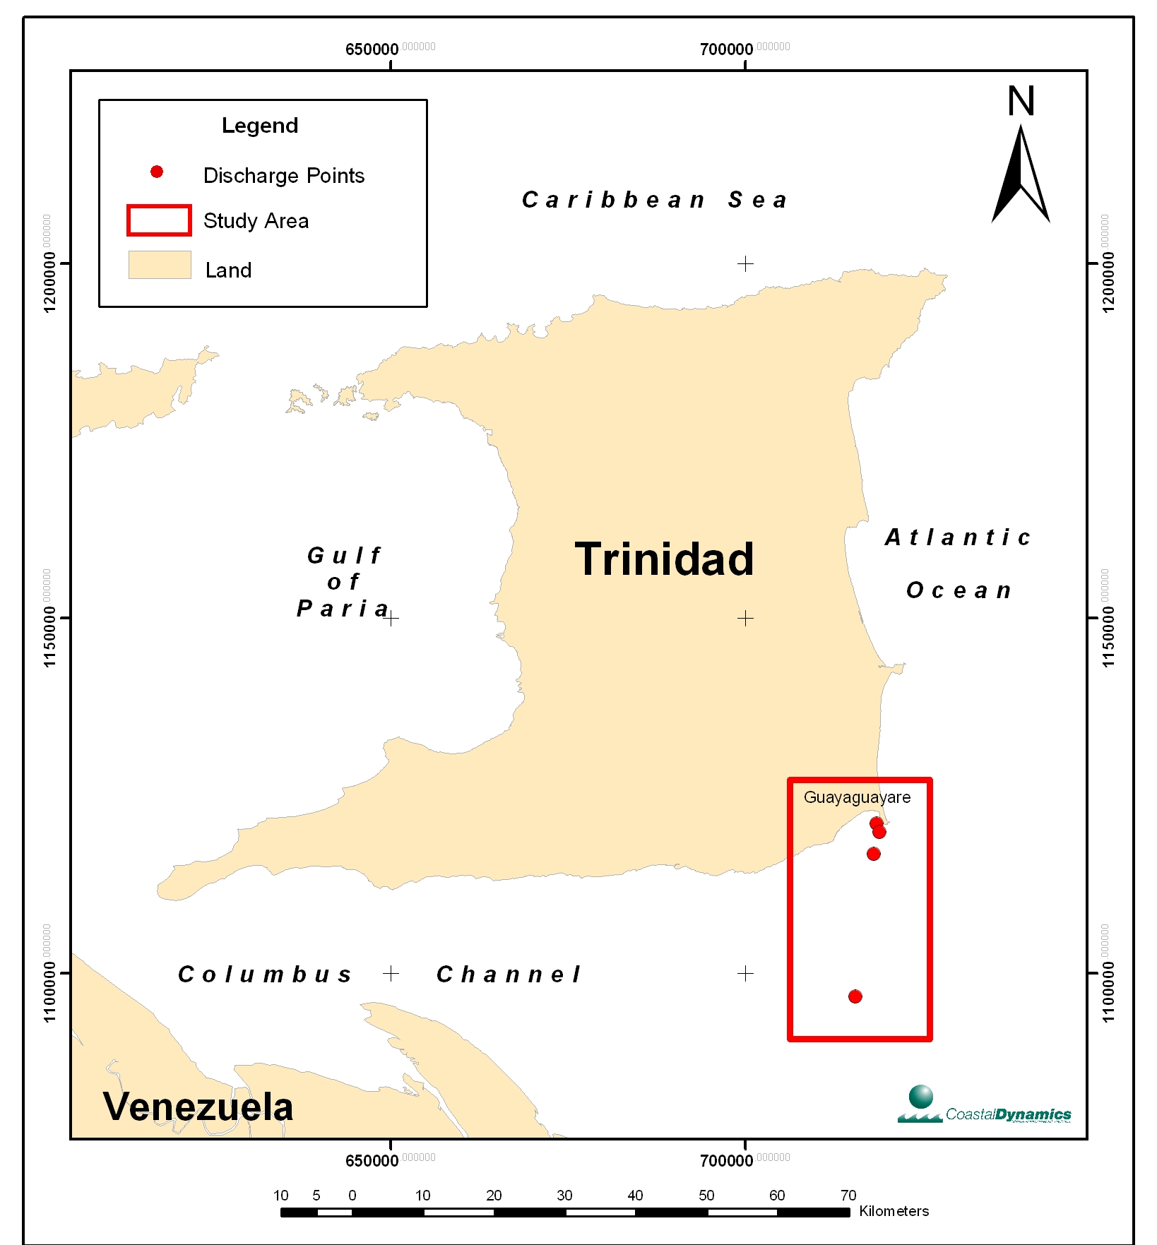
Figure 1: General Location of the Study Area

The scenarios modelled were identified by the use of the location identifier (A to D) and a number (1-5) representing preset concentrations of biocide. The variable parameters inputted into the model were as shown below.

- Location A: Seabed Disposal at surface near navigational channel from land pits
- Location B: Seabed and Surface Disposal at 1700m from the shoreline
- Location C: Seabed Disposal at SPM, approximately 5km from the shoreline
- Location D: Surface Disposal in the Columbus Channel
- Concentration of biocide in 4 predefined steps – 100%, 50%, 20% and 5%
- Flow rate of discharge - 0.3m³/s
- Ambient current speed – 0.46m/s

Items (f) and (g) were varied by use of a feature of the CORMIX model referred to as CORSENS which conducts sensitivity tests to vary the flow rates about the expected average of 0.3m³/s. This was also conducted for the ambient flow.

Scenario A: The hydrotest of the pipeline will occur while the pipeline lies on the seabed for a few weeks. The hydrotest water will contain a biocide, XC-102 a glutaraldehyde based biocide, at a concentration of 300ppm (100%) in 5 steps down to 3ppm (1%). This scenario considers the effect of disposal of the hydrotest water at the seabed for varying concentrations from the non-neutralized (100%) biocide to the neutralized form (1%). The discharge point for this scenario is located at point Approximately, 500m from the shoreline as shown in Figure 2 below, at this distance the flow is relatively stronger than the nearshore and contains sufficient water to allow dispersion of the effluent. The hydrotest water will be discharged through a 30” pipeline in the water column at a rate of 0.3m³/s. Sensitivity testing of the variation in flow rate and ambient current speed on the Toxic Dilution Zone (LC₅₀) was conducted.

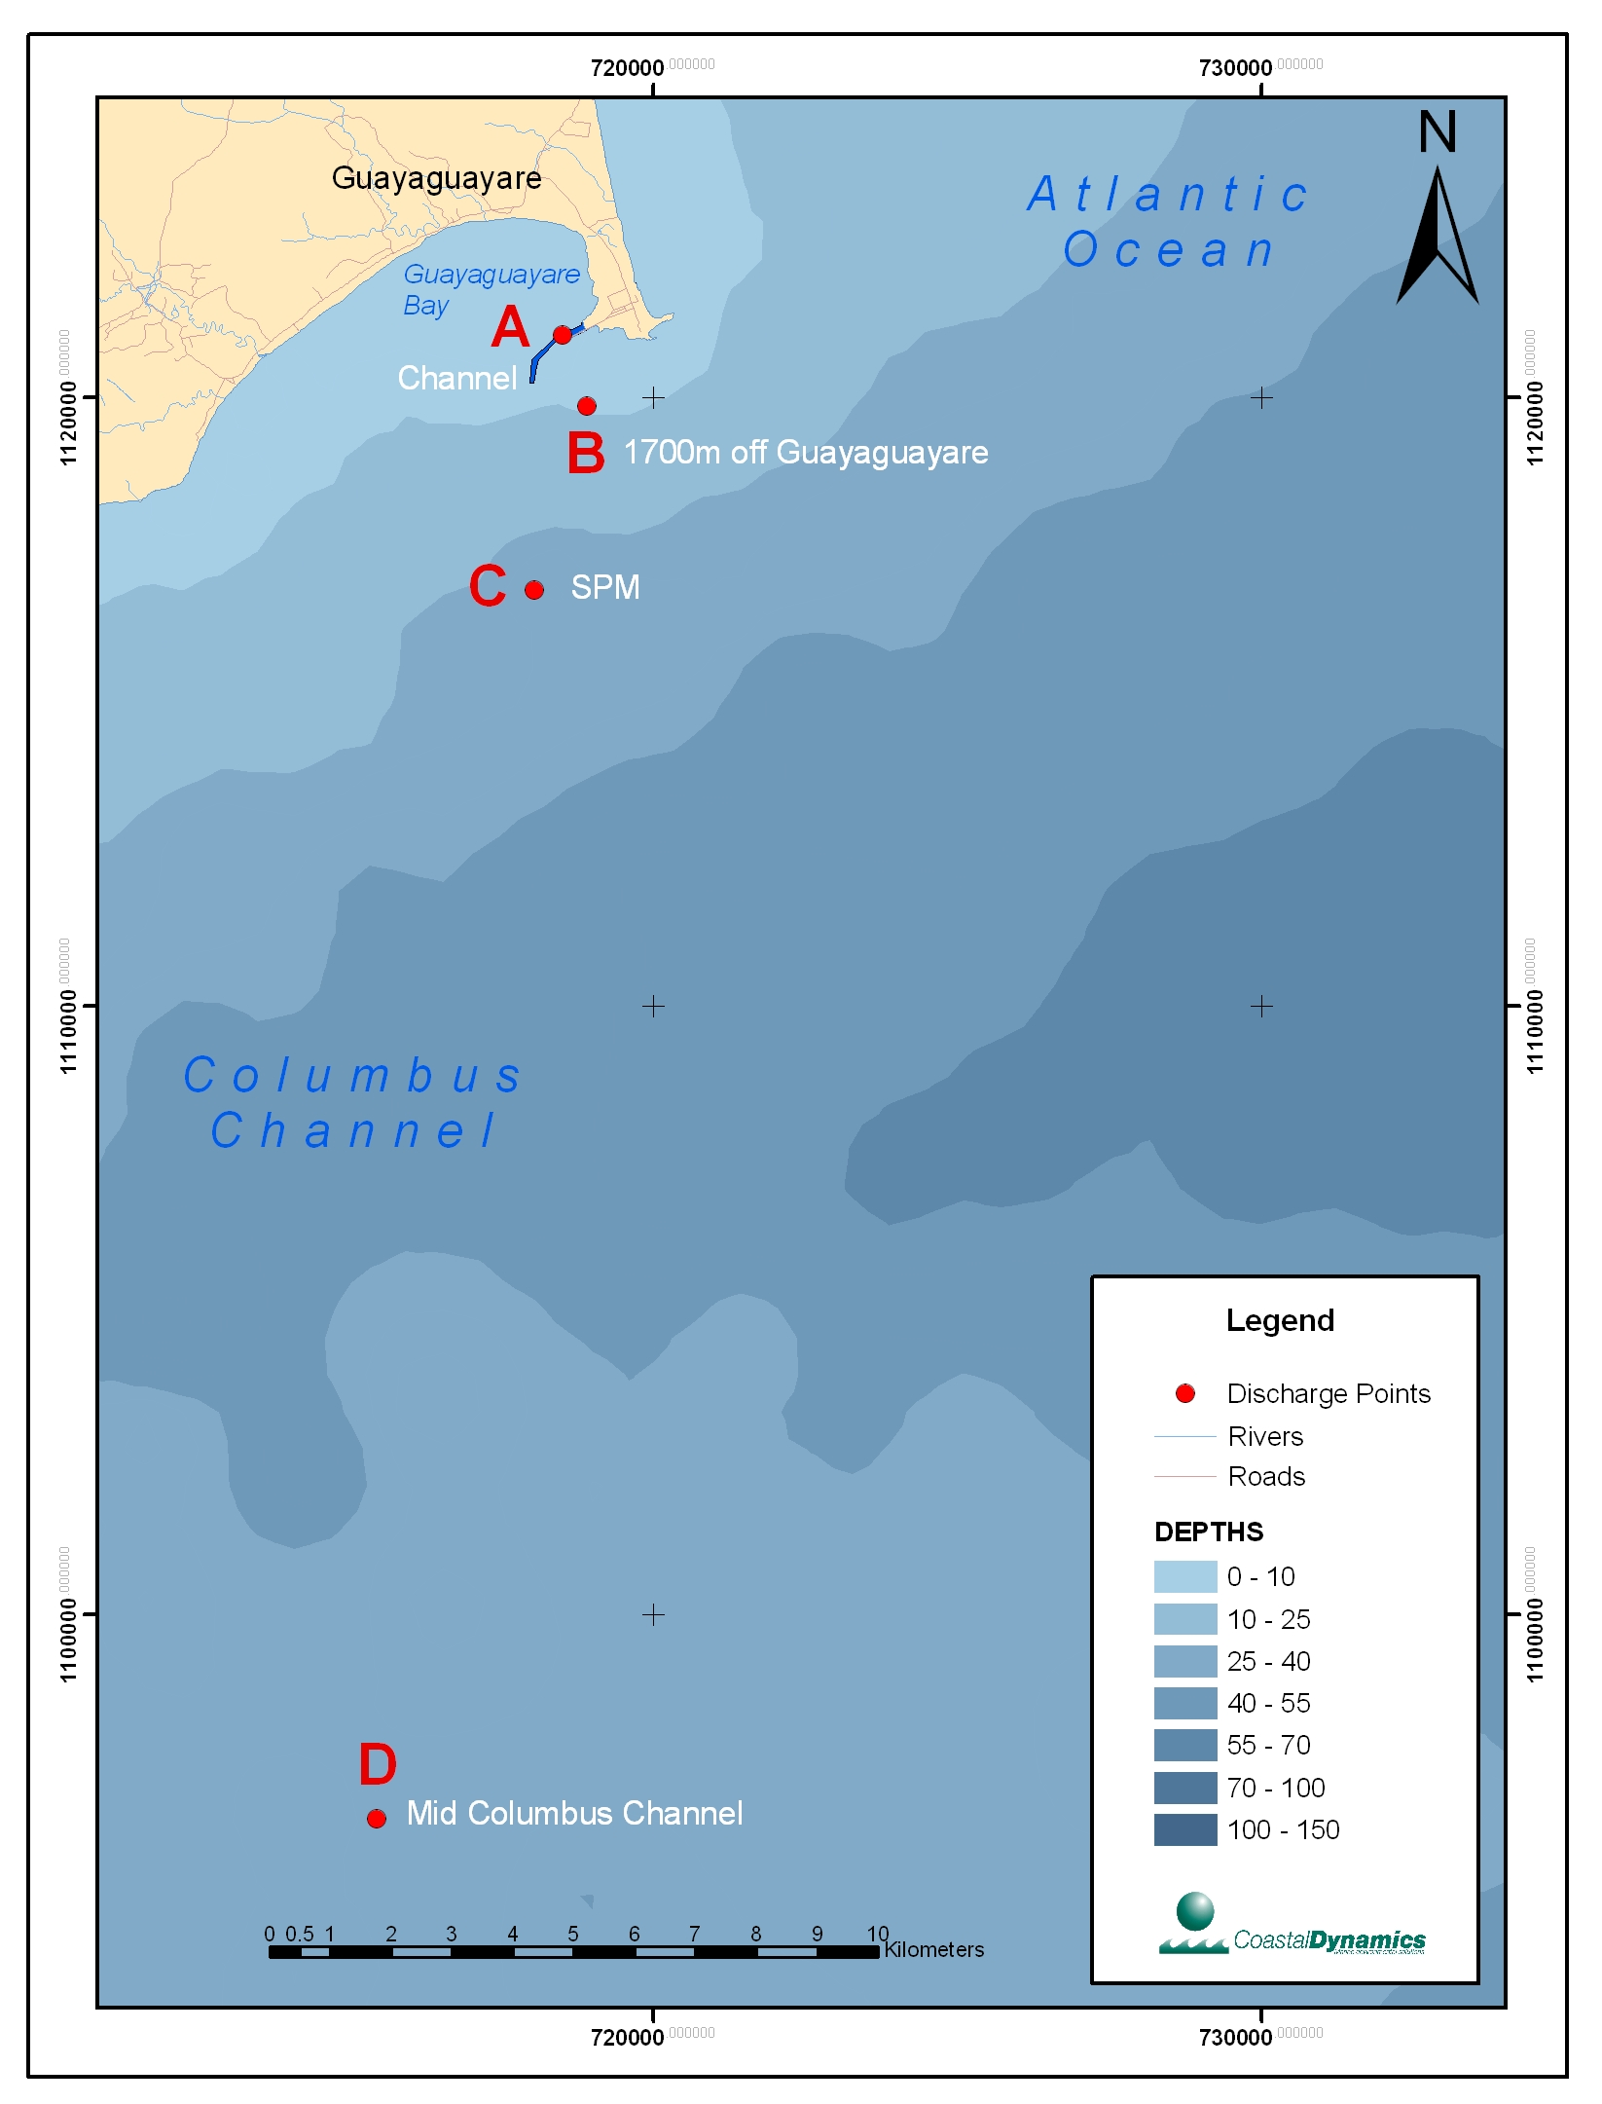
Figure 2: Location of the modelled discharge points for the NOEL Hydrotest Water. Scenario locations (A-D) are shown as red dots.

Scenario B: In this scenario, the hydrotest water will either be pumped at the seabed or off a barge and discharged into the surface waters at the 1,700m discharge point shown in Figure 2. The modelled runs examine the variation of the concentration over the 4 steps previously defined. The hydrotest water will be discharged through a 30” opening near the seabed at a rate of 0.3m³/s. Sensitivity testing of the variation in flow rate and ambient current speed was conducted. The surface discharge could not be modeled using CORMIX since it involves the surface discharge of a negatively buoyant effluent.

Scenario C: This scenario describes the disposal of the hydrotest water at a distance of approximately 5km from the shoreline at the Single Point Marker (SPM). The concentration of the biocide is varied over the 4 steps as previously defined. The hydrotest water will be discharged at the seabed via a 30” pipeline as in the other cases. The flow rate is set at 0.3m³/s. Sensitivity testing of the variation in flow rate and ambient current speed was conducted.

Scenario D: This scenario required modelling the discharge of hydrotest water from the barge used to transport it into an area in the middle of the Columbus Channel (Figure 2). The hydrotest water will be discharged at the sea surface from the barge through a 30” diameter pipe at a rate of 0.3m³/s. The concentration of the biocide is varied over the 4 steps as previously defined. This scenario could not be modeled using CORMIX since it involves the surface discharge of a negatively buoyant effluent.

The scenarios are described in more detail in Section 2.

Approach
In order to determine the fate and transport of the discharge of this type of hydrotest water within the Guayaguayare Bay area, it would be necessary to implement a hydrodynamic numerical model with an advection/dispersion model to predict the dilution and fate of any discharges within the area. Proper implementation of such a model requires long term oceanographic data such as tidal information and current speed and direction information. These data will form the basis for the setup of the model and its validation and calibration.

However, there is little or no long term oceanographic data for the Guayaguayare Bay area. There is some discrete data from various environmental projects that have been collected over the years in the form of spot measurements of current vectors and Conductivity, Temperature, Density (CTD) data but no long term data. Given this lack of data and the time frame in which to conduct this modeling, Coastal Dynamics will utilise the Cornell Mixing Zone Expert System (CORMIX) models. CORMIX is a water quality modeling and decision support system designed for environmental impact assessment of mixing zones resulting from wastewater discharge from point sources. It is used extensively at the US Environmental Protection Agency (USEPA) as a decision tool for water quality regulations. The system emphasizes the role of boundary interaction to predict plume geometry and dilution in relation to regulatory mixing zone requirements. As an expert system, CORMIX is an application, which guides the water quality analyst in simulating a site-specific discharge configuration. To facilitate its use, instructions are provided, which include suggestions for improving dilution characteristics, and warning messages are displayed when undesirable or uncommon flow conditions occur (USEPA, 2004).

The CORMIX model was used since a full hydrodynamic model could not be setup due to the lack of long term oceanographic data from the east coast of Trinidad. CORMIX has been tested for a variety of discharge conditions and therefore is a useful model to examine possible effects of discharges when extensive modelling is not possible. The model results must be interpreted with caution because of approximations made in the flow field and the outfall pipeline configuration. The CORMIX model only allows surface discharges near the shoreline. Since some of the NOEL hydrotest discharge scenarios are further offshore no shoreline interaction of the discharge plume is expected. In order to model the plume satisfactorily with this configuration a half-line concentration distribution is assumed with the CORMIX run representing the half of the plume distribution. The other half of the plume distribution is the mirror image of the modeled one. The model runs are for the steady state conditions and therefore do not represent the dispersion of the plume under all oceanographic conditions experienced within Guayaguayare Bay. The runs however, provide a worse-case assessment of the scenario and are therefore suitable for the general examination of the impacts of the hydrotest water discharge.

Other models were considered such as VISUAL PLUMES 3, a Windows-based software application for simulating surface water jets and plumes. However, our discussions with the Ministry of Energy and Energy Industries (MEEI) indicate that they recommend usage of CORMIX rather than VISUAL PLUMES 3.

Potential Impacts of the Hydrotest Water Discharge
The hydrotest water discharge will have an impact on the surrounding marine environment through the presence of the added biocide which is used to stop the bacterial corrosion that may occur when the hydrotest water is in the NOEL 30” Pipeline. This biocide is toxic to the flora and fauna within the influence of the hydrotest water as it is being discharged. The impact on the flora and fauna of the hydrotest water will depend on the level of toxicity that the hydrotest water has due to the biocide. The level of toxicity (and the extent of the impact) depends on the following:

- The dilution of the hydrotest water. On discharging the hydrotest water into the marine environment, the toxicity of the biocide will be reduced by dilution of the hydrotest water as it mixes with the surrounding water masses. This dilution depends on the current speed of the surrounding water, the difference in density of the hydrotest water and the receiving water, the depth of the discharge, the rate of discharge and the size of the pipeline discharging the hydrotest water. Whether or not the discharge is at the surface will also determine the amount of dilution of the discharge water. If the discharge is at the seabed and the discharged water is positively buoyant then the rise of the discharged water will increase the dilution factor due to the increased mixing that occurs as the discharge plume rises.

- The biocide used in the NOEL project is Biocide XC-102 (a glutaraldehyde based biocide) at a concentration of 300ppm. The toxicity of this biocide will decrease the longer the hydrotest water stays within the pipeline due to its natural half life stability. From previous studies examined by Coastal Dynamics (bpTT’s Cannonball Field Development EIA, 2004), the XC-102 biocide will reduce in toxicity by 50% for a 30 day stay within the pipeline.

The toxicity of the hydrotest effluent is best expressed as a percentage that can result in a mortality rate determined by testing in a laboratory using standard methods. This type of analysis, referred to as Acute Toxicity Testing, is conducted using the estuarine mysid shrimp, Metamysidopsis insularis. The toxicity is expressed as a LC₅₀ number which is the Lethal Concentration of the biocide that will kill 50% of the Metamysidopsis insularis. It is difficult and beyond the scope of this study to relate the toxicity of the discharged hydrotest water to the actual impact on the flora and fauna of the receiving water. This would require extensive tests relating the concentrations of the biocide with mortality rates of local species of flora and fauna under in-situ conditions. From previous studies examined by Coastal Dynamics (bpTT’s Cannonball Field Development EIA, 2004), the XC-102 biocide has a LC₅₀ (96 hour) toxicity of 8.47 mg/l. This concentration is therefore used to establish a Toxic Dilution Zone in the CORMIX modelling.

At present there is no Trinidad and Tobago standard for toxicity of discharged effluent. Coastal Dynamics’ approach to determining the impact of the discharged hydrotest water is to determine the distance from the discharge point at which the LC₅₀ of the biocide (8.47 mg/l) is obtained through dilution. The CORMIX model will determine the dilution factor of the discharged hydrotest water as it enters the receiving water.

The potential impact of the biocide in the seawater is reduced by neutralization of the glutaraldehyde based biocide followed by aeration of the de-oxygenated water. This procedure will serve to mitigate further the impact of the combination of biocide and oxygen scavenger (bisulphite). The biocide is readily converted to its neutralized form by the use of bisulphite (oxygen scavenger) and converted to a glutaraldehyde-bisulphite complex under aerated conditions. The glutaraldehyde complex is less toxic to the environment than glutaraldehyde (Jordan et al., 1996).

Data requirements of CORMIX
For CORMIX to work the following data is needed for each discharge point and scenario:

- Discharge rate of the hydrotest water
- Diameter of the discharge pipe
- Position of the discharge pipe in the water column and its configuration
- Concentration of discharge chemical (in this case the XC-102 Biocide)
- Density of the discharge water
- Temperature of the discharge water
- Depth of water at discharge point
- Current speed and direction of the water flow at the discharge point
- The density of the receiving waters

Items 1 – 6 above depend on the configuration of the discharge scenario and this data is provided by bpTT for each scenario.

Items 7 – 9 have to be determined from baseline oceanographic data collected previous for each of the four (4) potential discharge points shown in Figure 2. For this modelling effort, Coastal Dynamics has assessed the following datasets:

Locations A and B: Discharges at the bpTT Approach Channel (500m from shoreline) and 1,700m from shore (See Figure 2 above).
The location of these discharge points are shown in Figure 3. The only available dataset for these areas are from an October 2002 spatial survey conducted by Cane and Associates for bpTT for a port expansion project. The survey consisted of sampling currents and hydrographic data at the surface (1m below surface), mid-depth and bottom (1m above seabed) at 9 stations for a 24 hour period. The data was collected using a current meter lowered over the side of a boat, which was moving back and forth between stations throughout the 24 hour time period. The data gap at each station is, therefore, the time it takes for the boat to return to the station after sampling the other stations. Conductivity, Temperature and Density (CTD) were also measured at each sampling station to record salinity and temperature and therefore vertical profiles of density. The survey was conducted during the spring tide of the week of October 6th 2002. Figure 3 shows the location of Spatial Station 6 for this survey. The current speed and direction data as well as the salinity and temperature data for this station was used for the application of the CORMIX modelling for Scenarios at locations A and B. At location A the current speed was further reduced to approximately half this value as the water depth decreases to less than 10m. An estimated nearshore current speed of 20 cm/s was used. Since this is an estimated value sensitivity testing was conducted using the ambient current speed.

The oceanographic data for this Spatial Station 6 shows the current speeds and direction data are similar throughout the water column. The currents flow generally constantly to the southeast (65°) except for 2 hours during the rising tide when they flowed to the northwest (275°). The salinity and temperature data shows a homogeneous water column with the temperatures ranging from 28.1°C to 29°C and the salinity ranging from 27.8 psu to 30.7 psu. Table 1 summarises the data for the station. This is representative of wet season conditions during the dry season the salinity and temperature variations are less distinct from the surface to the seabed. No data are available for these conditions but the variations are not expected to produce significantly different results for the dispersion of the plumes under the examined scenarios.

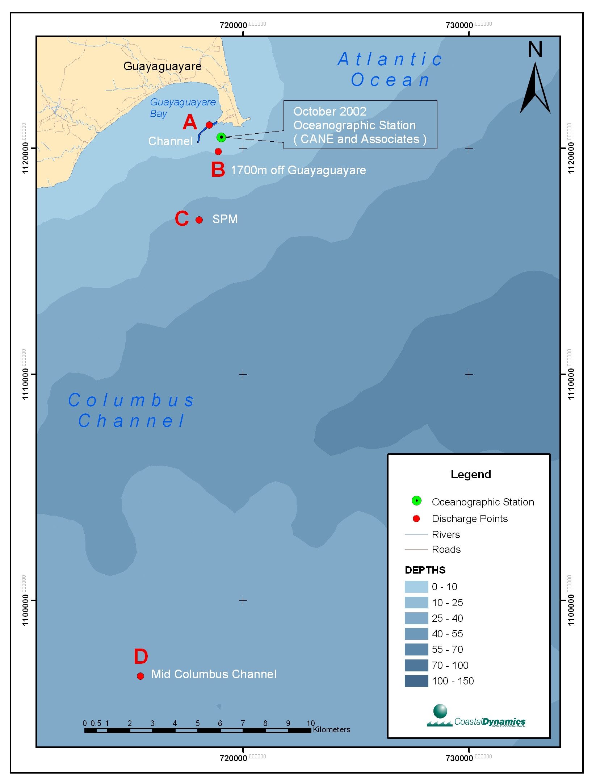
Figure 3: Location of Data Point from October 2002

Table 1: Oceanographic Data for Spatial Station 6 (October 2002)
Depth | Speed (Max) cm/s | Direction (°) | Salinity (psu) | Temperature (°C) | Density (mg/l)
Surface | 71.7 | 70 | 27.8 | 28.4 | 1016.9
Mid-Depth | 54 | 60 | 30.5 | 28.6 | 1019.9
Bottom | 46 | 60 | 30.7 | 28.7 | 1019.9

Locations C and D: Discharges at the Single Point Mooring (SPM) and Mid Columbus Channel (See Figure 3 above).
Figure 3 above shows the location of the discharge points used in Scenarios C and D. These discharge points are located within the Columbus Channel. Unfortunately, there are no historical data for this area. We cannot use the data from the October 2002 Spatial Survey by Cane and Associates since the oceanographic regime within the Guayaguayare Bay is different from the Columbus Channel conditions.

The currents within the Columbus Channel are generally unidirectional to the west since it is dominated by a branch of the Guiana Current which flows north west along the South American coastline. This current bifurcates off the southeast coast of Trinidad. One branch of the current flows northwards along the East Coast of Trinidad while the other branch flows to the west through the Columbus Channel.

In the absence of any oceanographic data, we have to assume oceanographic conditions based on data from another part of the Columbus Channel. The data of interest is the current speed and direction in the upper water column as well as the salinity and temperature. In 1995, a 1 month current meter deployment was conducted off the Erin Bay coastline as part of a research project conducted by Gopaul and Wolf (1996). Figure 4 below shows the location of the current meter mooring. The deployment was conducted during the dry season. Figure 5 shows a current rose for dry season currents collected for this 1 month deployment. The instrument was deployed in approximately 13m water depth at 4.5m from the sea surface. Even at this depth the currents are very strong and persistently to the west. The direction may reverse for very short periods during peak falling tide. The currents are very low during these periods. The current rose shown in Figure 5 shows that the currents are in excess of 40cm/s for most of the survey period. The currents are to the west for greater than 90% of the time. The mean current speed over the month long sample period was 28cm/s to the west. It is expected that currents within most of the study area are of similar strength.

Coastal Dynamics will use the above datasets to model the discharge of the hydrotest water for Scenarios A – D.
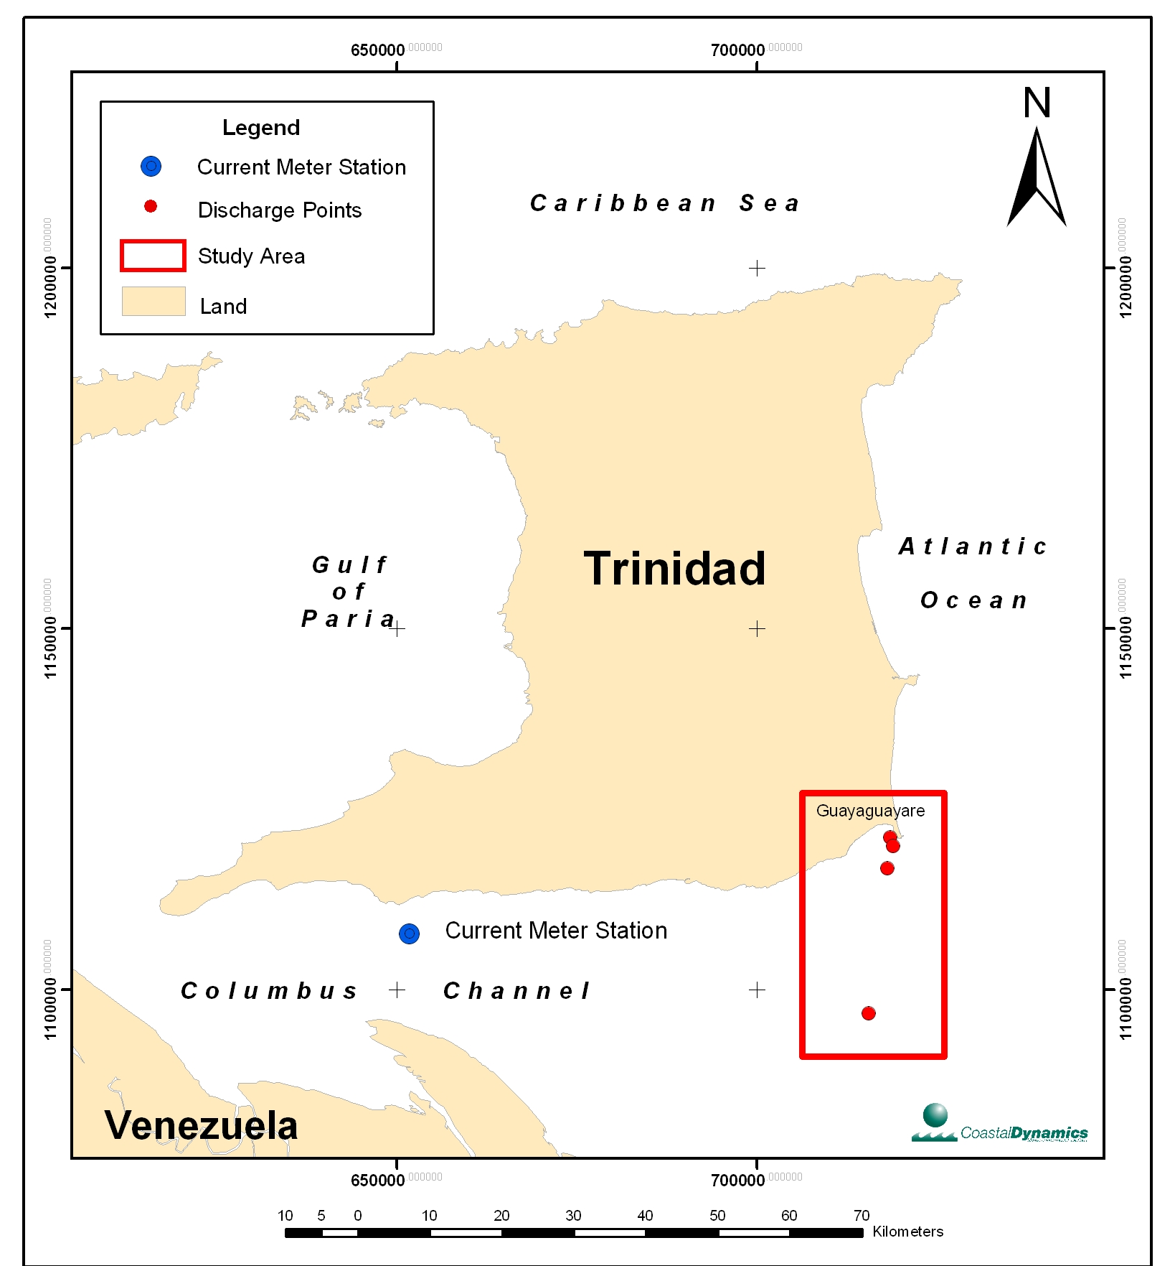
Figure 4: Location of the Erin Bay Current Meter mooring from 1995.

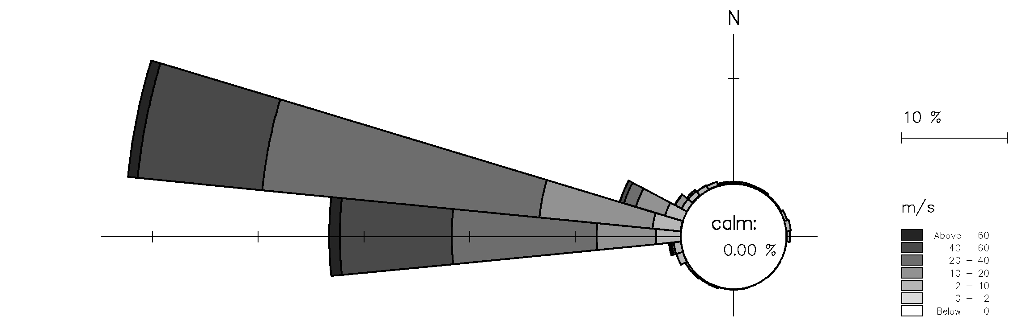
Figure 5: Current Rose for the 1 month current meter deployment at Erin Bay 1995

RESULTS OF THE CORMIX MODELLING

Scenario A – Nearshore discharge

Scenarios A1 – A4
A1 to A4 differ only in the concentration of glutaraldehyde based biocide in the test water. Table 2 shows the parameters tested.

Table 2: Parameters used in Scenarios A1 – A4.
Scenario | Location | Concentration of biocide  % (mg/l) | Ambient Current Speed | Ambient Current Direction (°) | Water Depth  m | Ambient seawater density  (kg/m³) | Density (kg/m³)
A1 | 500m from shoreline at seabed | 100 (300) | 20 | 70 | 5 | 1019.8 | 1018
A2 | 500m from shoreline at seabed | 50 (150) | 20 | 60 | 5 | 1019.8 | 1018
A3 | 500m from shoreline at seabed | 20 (60) | 20 | 60 | 5 | 1019.8 | 1018
A4 | 500m from shoreline  at seabed | 5 (15) | 20 | 60 | 5 | 1019.8 | 1018

The hydrotest water will contain the biocide, XC-102 a glutaraldehyde based biocide, at a concentration of 300ppm (100%) in 5 steps down to 3ppm (1%). This scenario considers the effect of disposal of the hydrotest water near the sea surface after the collection at ponds on land for treatment. This means that the treated water will have an increased temperature when stored on land. This will correspond to a slightly more buoyant plume with salinity and temperature such that the density can be estimated as 1018kg/m³. This scenario will therefore occur for primarily neutralized biocide, however, all 5 concentrations are modelled for completeness. The concentrations varied from the non-neutralized (100%) biocide to the neutralized form (1%). The discharge point for this scenario is located at point A, approximately, 500m from the shoreline as shown in Figure 2. At this distance the flow is relatively stronger than the region adjacent to the ponds and contains sufficient water depth to allow dispersion of the effluent. A water depth of 5m is used. The hydrotest water will be discharged through a 30” pipeline near the surface at a rate of 0.3m³/s. Sensitivity testing of the variation in flow rate and ambient current speed on the Toxic Dilution Zone (LC₅₀) was conducted.

Table 3 shows that the hydrotest water rapidly disperses with distance from the discharge point. The plume is in the direction of the prevailing current in this case to the northwest or to the southeast. The toxic dilution zone extends 355m from the discharge point for scenario A1 (100% effluent concentration) down to 0.6m for Scenario A4 (5% effluent). The scales shown are varied from one graph to the other, unfortunately this cannot be corrected in CORMIX and must therefore be interpreted with caution.
TABLE 3. MODEL RESULTS FOR SCENARIOS A1-A4
Scenario | Concentration along axis of flow (alongcurrent) | Plan view of dispersion of effluent
A1 –  100% effluent at 300mg/l | 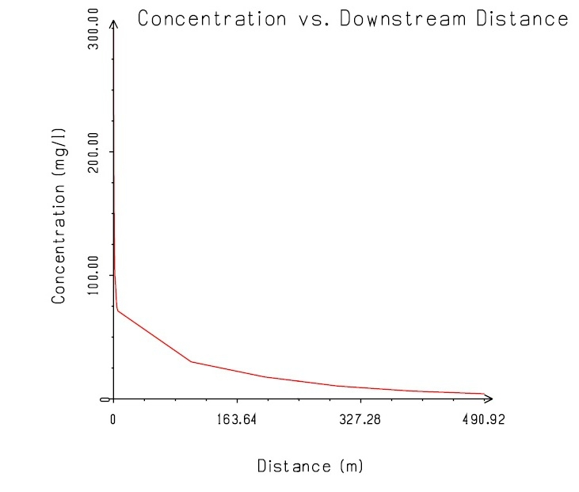 | 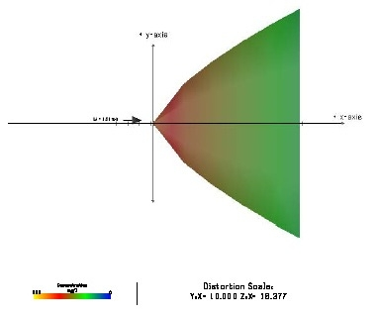
A2 –  50% effluent at 150mg/l | 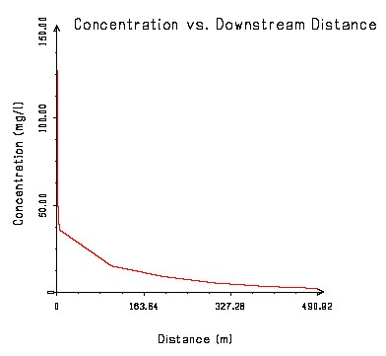 | 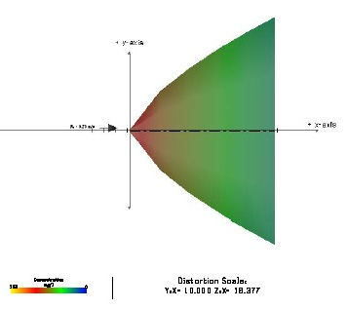
A3 –  20% effluent at 60mg/l | 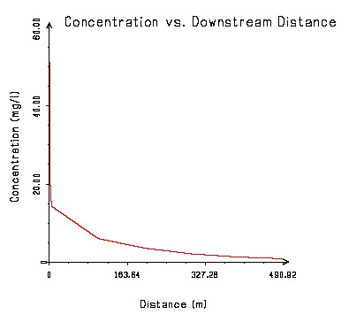 | 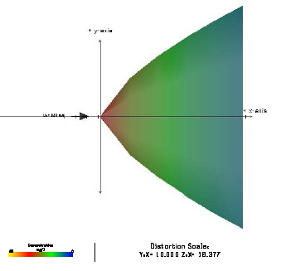
A4 –  5% effluent at 15mg/l | 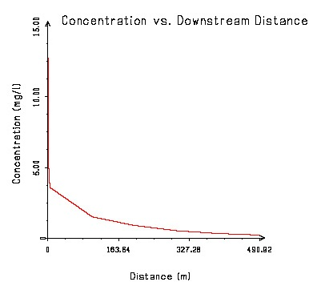 | 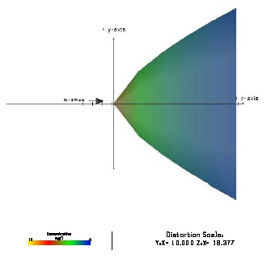

Scenario B (B1-B4, Seabed discharge) – Discharge 1700m from shoreline at seabed
The hydrotest water is stored in the pipeline while the pipeline lies on the seabed for a few weeks. The hydrotest water will have the biocide XC-102 (glutaraldehyde based biocide) at a concentration of 300ppm. The hydrotest water will then be discharged at the seabed without the biocide being neutralized (Scenario B1). Scenarios B2 to B4 are for cases of reduced biocide levels due to natural degradation or neutralisation. The discharge point will be 1,700m from the shoreline as shown in Figure 2. The hydrotest water will be discharged through a 30” opening on the seabed at a rate of 0.3m³/s. Due to the length of time the water is in the pipeline it is assumed that the temperature of the water being discharged will be equivalent to the bottom layer of water in the vicinity of the 1,700m discharge point. Table 3 indicates parameters used in this modelling exercise.

Table 3: Parameters used in Scenarios B1 – B4.
Scenario | Location | Concentration of biocide  % (mg/l) | Ambient Current Speed | Ambient Current Direction (°) | Water Depth  m | Ambient seawater density  (kg/m³) | Effluent  Density (kg/m³)
B1 | 1700m from shoreline at seabed | 100 (300) | 46 | 60 | 45 | 1019.9 | 1019.9
B2 | 1700m from shoreline at seabed | 50 (150) | 46 | 60 | 45 | 1019.9 | 1019.9
B3 | 1700m from shoreline at seabed | 20 (60) | 46 | 60 | 45 | 1019.9 | 1019.9
B4 | 1700m from shoreline  at seabed | 5 (15) | 46 | 60 | 45 | 1019.9 | 1018

Table 4 shows that the hydrotest water rapidly disperses with distance from the discharge point. The plume is in the direction of the prevailing current in this case to the northwest or to the southeast. The toxic dilution zone extends 149m from the discharge point for scenario B1 (100% effluent concentration) down to 0.5m for Scenario B4 (5% effluent). The scales shown are varied from one graph to the other, unfortunately this cannot be corrected in CORMIX and must therefore be interpreted with caution.

Since the plume exists for a limited time (few hours) during the discharge the LC₅₀ (96 hour) will not be encountered.

The graphs show that the dilution caused by the high velocity of the bottom currents (46cm/s) and the mixing of the biocide with the surrounding water causes the concentrations within the plume to reduce rapidly away from the discharge point.

TABLE 4. MODEL RESULTS FOR SCENARIOS B1-B4
Scenario | Concentration along axis of flow (alongcurrent) | Plan view of dispersion of effluent
B1 – 1700m offshore at seabed  100% effluent at 300mg/l | 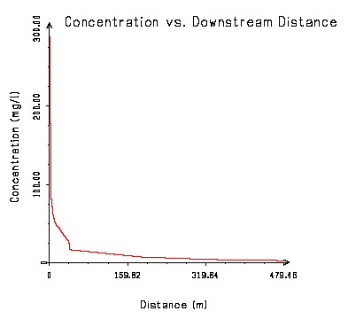 | 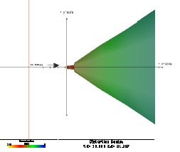
B2 – 1700m offshore at seabed  50% effluent at 150mg/l | 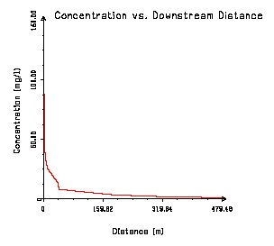 | 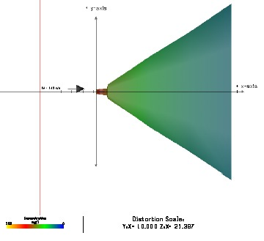
B3 –1700m offshore at seabed  20% effluent at 60mg/l | 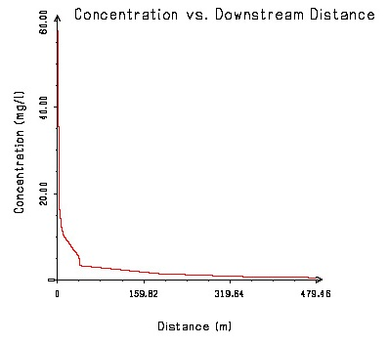 | 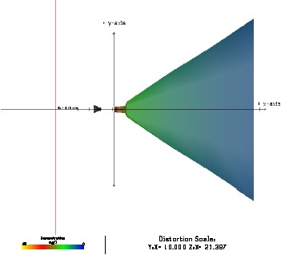
B4 – 1700m offshore at seabed  5% effluent at 15mg/l | 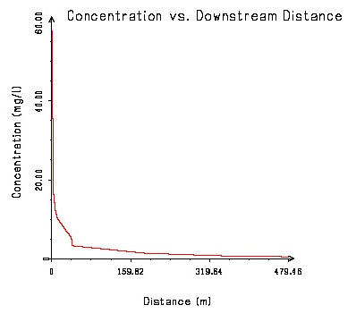 | 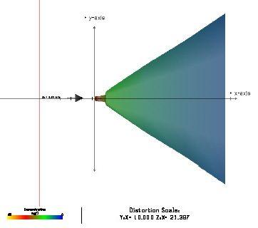

Scenario B (B5-B8, Surface Discharge) – 1700m from shoreline discharge at surface Negatively buoyant discharge – NOT MODELLED
In this scenario, the hydrotest water will be pumped on a barge and the biocide neutralized with an oxygen scavenger. It will then be held for approximately15 minutes before discharge into the surface waters at the same 1,700m discharge point shown in Figure 2 above. The hydrotest water will be discharged through a 30” opening at the sea surface at a rate of 0.3m³/s. The temperature of this water will be assumed to be equivalent to the surface water as the hydrotest water has a chance to warm up on the barge and will not represent the temperature of the bottom layer of seawater as in Scenario A above. The salinity of the water will be the same as the bottom layer of water. Therefore we can work out that the density of the water on the barge with a temperature of 28.4°C and a salinity of 30.7psu will have a density of 1019.08kg/m³.

In this scenario the concentration of the biocide is being reduced by the oxygen scavenger. It is not possible to determine the actual concentration of the biocide remaining in the hydrotest water on board the barge therefore we will assume four possible reductions of the concentration: 100%, 50%, 20% and 5%. We will model these three concentrations for this Scenario B. We should also point out that no toxicity of the oxygen scavenger is recorded. Since no data exist for the toxicity of the combination of the biocide and oxygen scavenger, we will assume that the toxicity of the hydrotest water is represented by the biocide only.

PLEASE NOTE: The above parameters represent the proposed Scenarios B5-B8 as prescribed by EPAS Consultants and bpTT. However, the above Scenarios cannot be modelled using CORMIX since the discharging hydrotest water will be of greater density than that of the surface receiving water (negatively buoyant). This is due to the fact that the water pumped into the pipeline for the hydrotest was bottom layer water which is of higher salinity than that of the surface receiving water. Therefore, the density of this hydrotest water is greater than that of the surface receiving water and the plume will sink. In reality, the effluent will sink through the water column until it hits a density layer equivalent to its own. At this point the plume will spread to the southeast under the surface of the water column. CORMIX, unfortunately cannot represent this situation where there is a surface discharge of negatively buoyant effluent. This represents a limitation of the modelling environment being utilised.

However, based on the modelling conducted for Scenario A above, it can be assumed that the impacts of discharging the hydrotest water at the surface will be less than that of discharging it at the seabed for the following reasons:

- The sinking of the effluent through the water column will increase the dilution through increased mixing through the water column.

- The effluent will most likely not reach the seabed since it will mix with the upper layer water masses and become less buoyant before it reaches the lowest, more dense layers. Therefore, there will be less impact to the flora and fauna at the seabed due to the dilution of the biocide.

Scenario C – 5km from shoreline at SPM, discharge at seabed
This scenario involves the discharge of treated (biocide) hydrotest water discharged at the SPM point offshore at the seabed. Figure 2 shows the location of the SPM. The hydrotest water will be discharged through a 30” pipeline at a rate of 0.3m³/s.

In this scenario, the hydrotest water is stored in the pipeline while the pipeline lies on the seabed for a few weeks. The hydrotest water will have the biocide XC-102 (glutaraldehyde based biocide) at a concentration of 300ppm. The hydrotest water will then be discharged at the seabed without the biocide being neutralized (Scenario C1). The discharge point will be 5km southwest of the shoreline as shown in Figure 2. The hydrotest water will be discharged through a 30” pipeline opening on the seabed at a rate of 0.3m³/s. Due to the length of time the water is in the pipeline it is assumed that the temperature of the water being discharged will have equilibrated to the bottom layer of water in the vicinity of the SPM discharge point. The current speed and direction data is taken from the general conditions for the Columbus Channel discussed in Section 1.4 above. The current speed is assumed to be 46cm/s to the west (270°). Table 5 below indicates parameters used in this modelling exercise.

Table 5: Parameters used in Scenarios C1 – C4.
Scenario | Location | Concentration of biocide  % (mg/l) | Ambient Current Speed | Ambient Current Direction (°) | Water Depth  m | Ambient seawater density  (kg/m³) | Effluent  Density (kg/m³)
C1 | 1700m from shoreline at seabed | 100 (300) | 46 | 270 | 45 | 1019.9 | 1019.9
C2 | 1700m from shoreline at seabed | 50 (150) | 46 | 270 | 45 | 1019.9 | 1019.9
C3 | 1700m from shoreline at seabed | 20 (60) | 46 | 270 | 45 | 1019.9 | 1019.9
C4 | 1700m from shoreline  at seabed | 5 (15) | 46 | 270 | 45 | 1019.9 | 1019.9

The effluent density is similar to the surrounding ambient water. This is because the water discharged at the seafloor has the same temperature and density as the bottom layer water as the hydrotest water remained in the pipeline for several days. The discharged hydrotest water remains on the seabed and disperses along the prevailing current to southeast from the discharge point. The plume does not reach the shoreline in this scenario. Table 6 shows the plumes generated by the hydrotest water. The plume flows along the axis of the current which is to the west (270°). The graphs of the concentration of the effluent versus distance from the discharge point are shown. The data shows that the LC₅₀ concentration of 8.47mg/l is within 142m of the discharge point (Scenario C1). For a biocide concentration of 150mg/l (C2 - 50%), the distance to LC₅₀ is 51m to the west. For a biocide concentration of 15mg/l (C4 - 5%) the distance is reduced to 0.5m. The plume does not reach the shoreline in all cases.

The model shows that in these relatively higher energy conditions the near field zone shows a narrow “jet” field greater in extent than that for Scenario A and B in shallower less intense flow conditions.

TABLE 6. MODEL RESULTS FOR SCENARIO C
Scenario | Concentration along axis of flow (alongcurrent) | Plan view of dispersion of effluent
C1 – 5000m offshore at seabed  100% effluent at 300mg/l | 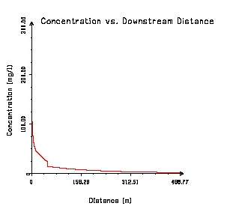 | 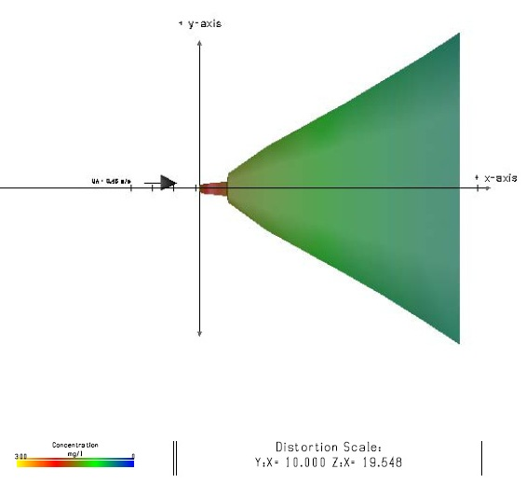
C2 – 5000m offshore at seabed  50% effluent at 150mg/l | 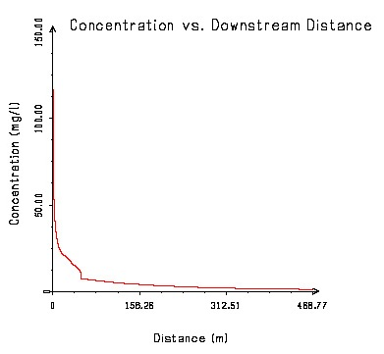 | 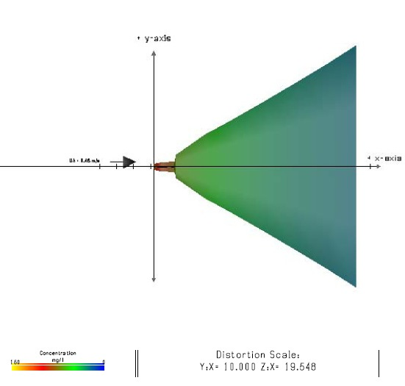
C3 – 5000m offshore at seabed  20% effluent at 60mg/l | 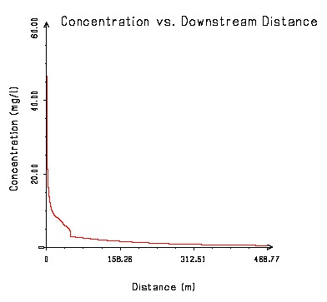 | 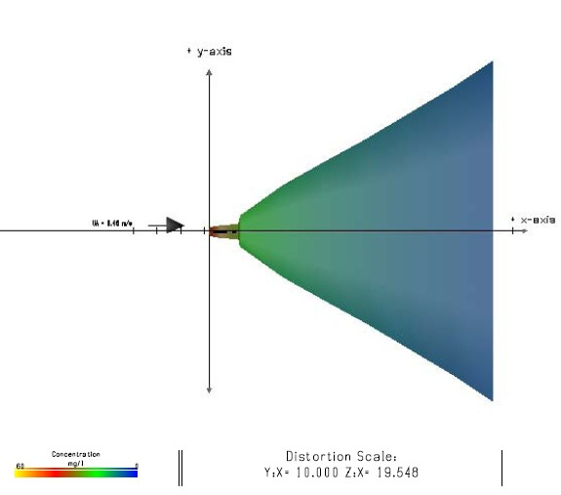
C4 – 5000m offshore at seabed  5% effluent at 15mg/l | 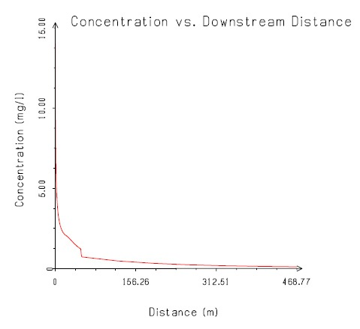 | 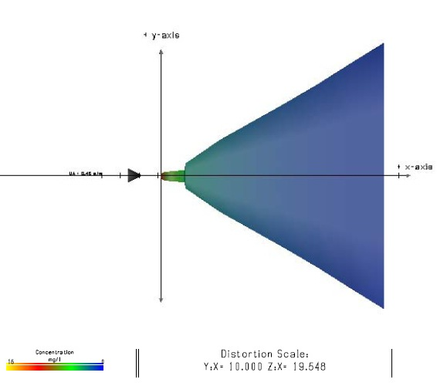

Scenario D – Surface discharge 25km southwest of Galeota Point
This scenario involves the hydrotest water being stored on barges and transported into an area in the middle of the Columbus Channel approximately 25km south of Point Galeota. The hydrotest water will then be discharged at the sea surface from the barge. It is assumed that the hydrotest water will be discharged through a 30” or smaller diameter pipeline. Figure 2 above shows the location of the Columbus Discharge Point.

The temperature of this water is assumed to be equivalent to the surface water as the hydrotest water has a chance to warm up on the barge and will not represent the temperature of the bottom layer of seawater as in the previous case of Scenario B (surface). The salinity of the water will be the same as the bottom layer of water. Therefore the density of the water on the barge with a temperature of 28.4°C and a salinity of 30.7psu will be 1019.1 kg/m³. The density of the receiving water near the surface will be approximately 1016.0 kg/m³. This scenario is such that the effluent density is greater than the receiving water and will therefore sink. This means that the discharge of the hydrotest water in the Columbus Channel can not be modelled by CORMIX for the same reason as discussed in Scenario B (Surface). This is reproduced below.

PLEASE NOTE: The above parameters represent the Scenario D as prescribed by EPAS Consultants and bpTT. However, the above Scenario cannot be modelled using CORMIX since the discharging hydrotest water will be of greater density than that of the surface receiving water. This is due to the fact that the water pumped into the pipeline for the hydrotest was bottom layer water which is of higher salinity than that of the surface receiving water. Therefore, the density of this hydrotest water is greater than that of the surface receiving water and the plume will sink. In reality, the effluent will sink through the water column until it hits a density layer equivalent to its own. At this point the plume will spread to the west in the lower water column. CORMIX, unfortunately cannot represent this situation. This represents a limitation of the modelling environment we are utilising.

However, based on the modelling conducted for Scenario C above, it can be assumed that the impacts of discharging the hydrotest water at the surface will be less than that of discharging it within the lower part of the water column of the seabed for the following reasons:

- The sinking of the effluent through the water column will increase the dilution through increased mixing through the water column.

- The effluent will most likely not reach the seabed undiluted because it mixes as it sinks, thereby lowering its density. Therefore, there will be less impact to the flora and fauna at the seabed as a result of the reduction in concentration (toxicity) of the biocide.

Discussion of Results
While the CORMIX modelling has limitations involved with its application to the hydrotest water discharges, it has provided a useful tool in evaluating the different scenarios presented for the NOEL Pipeline EIA.

Based on the above modelling results, the Scenarios with the least impact to the marine environment are Scenario A with the discharge at 50m from the shoreline and Scenario C at the SPM. In the case of Scenario A the neutralization of the biocide at the shore ponds proves to be the best option since the water can be tested before discharge into the environment. Re-aeration of the neutralized effluent will be better facilitated and this will further reduce the impact of the effluent on the environment. Scenario C although it is located in deeper water, with increased dilution, may be difficult logistically to treat the water before disposal at the seabed.

We believe that discharging at the surface at the locations of Scenario B and C can provide better dilution of the effluent with a lowered probability of affecting the benthic organisms. Given the high energy conditions in these areas it is expected that dilution will be achieved in a short period of time thereby lowering the impact of effluent.

Discharging within the approach channel for bpTT looks to be a viable alternative since the modelling shows:

- Effluent can be disposed after the neutralization and aeration of the effluent at the shoreline ponds. The effluent disposal can be delayed until the biocide shows sufficient degradation and the water is aerated.
- Better control of pump rate from shoreline ponds to reduce impact on environment. Lower pump rate means better dilution by dispersion at any one time.
- Advantage over offshore disposal where it is more difficult to treat the effluent before disposal.

The modelling exercise shows that the region surrounding the outfall where the biocide remains in concentrations above 8.47mg/l (TDZ) is less than 335m (shoreline case with 100% untreated effluent) or 0.6m (shoreline case with 5% residual biocide concentration).

Jordan et al. (1996) showed that Glutaraldehyde-bisulphite complexes (neutralized biocide) have a low toxicity in the environment. The concentration used by bpTT is well below this concentration.

REFERENCES

bpTT Cannonball Field Development Environmental Impact Assessment (EIA), Submitted in January 2004.

Gopaul, N. and Wolf, J. (1996). A numerical model of tidal and wind driven circulation in the Gulf of Paria. Journal of Caribbean Marine Studies. Volume 5: 23-40pp.

Jordan, S.L.P., Russo, M.R., Blessing, R.L., and A.B. Theis. (1996). Inactivation of Glutaraldehyde by Reaction with Sodium Bisulfite. Journal of Toxicology and Environmental Health, 47:299-309, 1996.

USEPA, 2004. http://www.epa.gov/waterscience/models/cormix.html. Web Based Information from the United States Environmental Protection Agency Web Page

Toxic Dilution Zone (TDZ) - the region of the receiving water where the concentration of a toxic chemical may exceed the acute effects concentration.
LC₅₀ concentration of the substance in water having 50% chance of causing death to aquatic life.
psu - practical salinity units, approximately equal to parts per thousand
Toxic Dilution Zone (TDZ) - the region of the receiving water where the concentration of a toxic chemical may exceed the acute effects concentration.
LC₅₀ concentration of the substance in water having 50% chance of causing death to aquatic life.

