HUMAN ENVIRONMENT

5.18 Socio Economic Assessment

5.18.1 Rationale

Social impacts refer to “the consequences to human populations of any public or private actions that alter the ways in which people live, work, play, relate to one another, organize to meet their needs, generally cope as members of society…including changes to the norms, values and beliefs that guide and rationalize their cognition of themselves and their society” (The Inter-organizational Committee on Guidelines and Principles for Social Impact Assessment May 1994, pp. 1).

SIA involves the process of social analysis, which is a systematic investigation of demographic factors, socio-economic determinants, social organizations, socio-political context, needs and values in order to account for social differences, assess impacts and risks, mitigate adverse impact, and in some cases build the capacity of individuals (World Bank 1997).

SIA attempts to assess or estimate, in advance, the social impacts – positive, neutral and negative – likely to occur as a result of change brought about by policy actions or development projects. It also seeks to provide guidelines for mitigation and management of impacts.

An assessment of the existing socio-economic conditions in the communities of Mayaro/Guayaguayare will determine the social impacts of the proposed NOEL Project.

5.19 Methodology

5.19.1 Method of Data Collection

In order to complete this socio-economic assessment both primary and secondary data collection methods were used to collect data for the study. The SIA conducted for the Cannonball Project (Coastal Dynamics Jan 2004) and the SIA for Chachalaca and Coconut Exploratory Drilling Projects (FOSTER Apr 2004) were used as the basis for the compilation of the description of the socio-economic characteristics of Mayaro/Guayaguayare.

A review of these reports was carried out to collate documented and published data on the socio-cultural and economic conditions in the Mayaro/Guayaguayare area as well as to determine some of the implications of past project action on the study area.

During the period 9 February to 9 June 2004 interviews were held with representatives from a number of government agencies to gather data on the study area; up date and verify existing data. Additional information for the study was gathered through interviews with Community Based Organisations (CBO’s) and Non-Governmental Organisation (NGO’s) and field visits which were carried out over the same time period.

Participation in bpTT public consultations, held on 3 June 2004 and 17 June 2004 at the Guayaguayare Community Centre.

The data collected were used to define the socio-cultural and economic environment, determine the developmental plans for the area and identify potential impacts of project activities on the socio-cultural and economic conditions of Mayaro/Guayaguayare.

5.20 Location and History of Development

5.20.1 Location of study area

Mayaro/Guayaguayare is situated on the southeast coast of Trinidad between 1117300mN to 1143700mN and 699200mE to 798000mE (Figure 5.31 as adapted from FOSTER, Apr 2004). The area is bordered to the north by the Naparima Mayaro Road, which runs along the crest of the Trinity Hills. Its eastern border is formed by coastline and the North Atlantic Ocean. Coastline and the Columbus Channel form its southern border. Its western border is demarcated by an administrative boundary, which is set at approximately
699 200 mE, or 1 km east of Canari Point (FOSTER Apr. 2004).

This area is located in the county of Nariva/Mayaro within parts of the wards of Trinity and Guayaguayare and falls under the administrative jurisdiction of the Mayaro/Rio Claro Regional Corporation.

The area occupies approximately 44.4 km² of land, of which approximately 27.5 km² (61.9 %) falls within the first 1km inland of the shoreline and therefore is classified as part of the coastal zone.

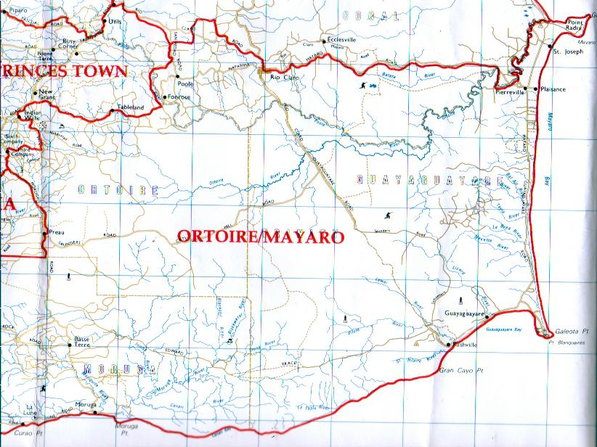
Guayaguayare
Mayaro

(Source FOSTER Apr. 2004)

Figure 5.31: Geographic Location of Mayaro/Guayaguayare

5.20.2 Topography

The topography of Mayaro/Guayaguayare ranges from hilly to gently undulating. The Trinity Hills located northwest of Guayaguayare reach a height of 500 m above sea level at their peak and steeply slope south and east to the coast down to a height of 50 m above sea level. In the rest of the area, land reaches a maximum of height of 150 m to 200 m above sea level and slopes gently to the south, east and west down to sea level.

5.20.3 History of Development

Mayaro/Guayaguayare has a long history of human and natural resource exploitation by foreign interests. Prior to the 1900s the area’s development was facilitated by economic activity mainly agriculture associated with Plantation Economies, and later mineral resource exploitation. Table 5.57 as adapted from FOSTER Apr 2004, presents a timeline of highlights of the history of the development of Mayaro/ Guayaguayare.

TABLE 5.57 Timeline of the History of Development of Mayaro/Guayaguayare
PERIOD | EVENT
1797 | British seized control of Trinidad  74 cotton fields cultivated in the Guayaguayare area  Later converted into extensive coconut cultivation
1849 | Lord Harris develops a system of counties and wards  Beginnings of land-based communication with other parts of Trinidad  Mayaro started to develop with limited facilities such as schools, post offices and churches
1889 | A police station was established in Mayaro  Radix developed as the village centre of activity with a settlement developing on the St Joseph Estate and Plaisance Estate
End of 1800s | Coconut estates developed along the coast of Mayaro  Fishing also established as a main economic activity in the area
1902 | Area becomes important for land-based crude oil production
Early 1900s | Pierreville or ‘Quarters’ was fast becoming a village
1917 | Many Government buildings established in Pierreville  Widening of the Mayaro Trace into the Naparima-Mayaro Road and the construction of the Mayaro-Guayaguayare Road and the Manzanilla Road, both of which contributed to Pierreville becoming a centre of social and economic activity
Today | Area consists of up to 12 communities  Important as a transit point for exploitation & distribution of massive offshore resources of natural gas  Fishing remains one of the primary economic activities

Source: (FOSTER, Apr. 2004)

Communities emerged in the area as a direct result of a royal proclamation of the Spanish King Carlos III (Anthony 1975, cited in Coastal Dynamics Jan. 2004). In his Cedula of Population, 32 acres of land was granted to each Caucasian person, regardless of gender, or 16 acres for each slave induced to the area by Caucasian settlers. Africans and other persons of colour were granted 16 acres or 8 acres for each slave induced to area. In 1849 Lord Harris introduced a system of counties and wards with commensurate rates. This ‘legislation’ set the stage for the development of estates, which later evolved into villages and towns in the area. The emergent communities remain largely unchanged today.

5.20.4 Archaeological Sites

Given the area’s rich archaeological history artifacts have been found in this area. In fact, according to an inventory of archaeological sites conducted by the University of the West Indies, there are some twelve (12) archaeological sites of A/B status, which exists within the southeast section of the Southern Basin of Trinidad. These sites are of intrinsic archaeological importance, and have the potential for future scientific research and cultural management. Sites of ‘A’ status are considered extremely important and should be protected. The sites of ‘B’ status are considered sufficiently important for protection as long as controlled archaeological excavation has not taken place. The location of these sites is along the coastline. The project site at Galeota was not identified as an area of special concern.

5.20.5 Social Demography

There are 10 communities within the administrative jurisdiction of Guayaguayare/Mayaro area. These 10 communities span from Ortoire in the north down to Guayaguayare in the south (Refer to Figure 5.32 as adapted from FOSTER, Apr 2004) The area’s settlement pattern reveals that these communities are physically connected by a network of roads, which all connect with the Guayaguayare Mayaro Road / Rio Claro Guayaguayare Road – the main transport vein into and out of the area.

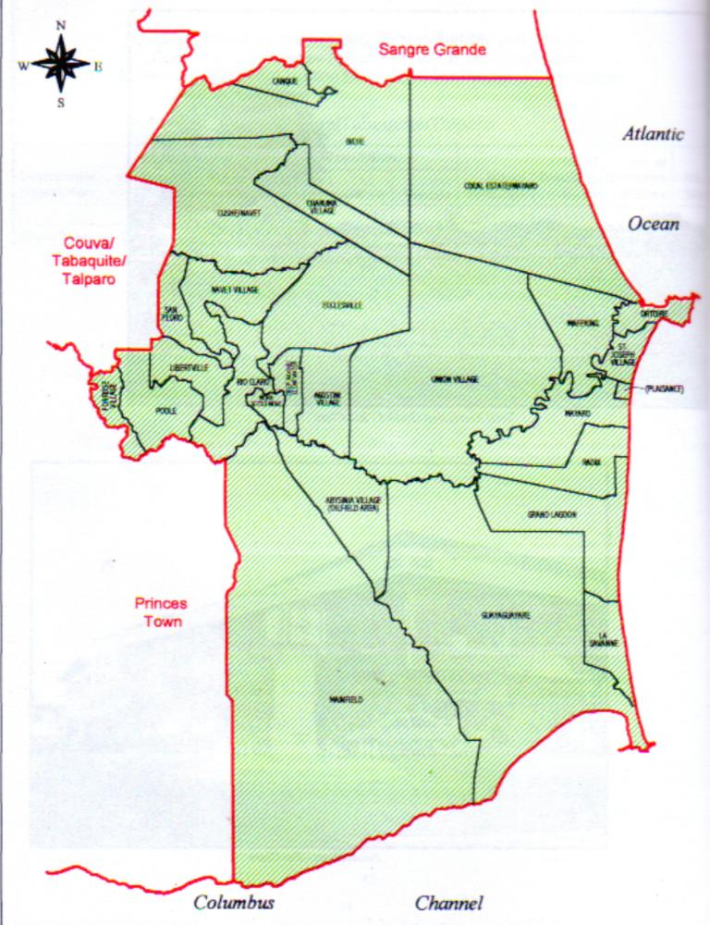
Mafeking
Ortoire
Plaisance
St. Joseph Village
Mayaro
Radix
Grand Lagoon
La Savanne
Petrotrin/Abyssinia Village
Guayaguayare
Source: (FOSTER Apr. 2004)
Figure 5.32: Distribution of Communities in the Mayaro/Guayaguayare Area

The administrative border for the Guayaguayare/Mayaro area is not fixed. It is sometimes shifted, depending on political, administrative and private sector interests, to include Union Village and Kernahan/Cascadoo (FOSTER Apr 2004).

5.20.6 Community Demographics

Settlements in the area do not appear to be planned. Communities have tended to develop in a linear or ribbon pattern that follows the main Guayaguayare Mayaro Road / Rio Claro Guayaguayare Road becoming compacted or nucleated to form villages. Small pockets of houses have also developed along roads branching off this main road.. These communities have also developed in a linear pattern along the branch roads with a gradual spread up onto the hillsides. Where such development is occurring, the housing appears to have a clustered structure rather than linear. This population distribution pattern may be attributed mainly to the area’s topography, vegetation characteristics and the development of its communication and economic systems.

5.20.7 Population Demographics

The Central Statistical Office 2000 Population Census data revealed that there were 32,143 persons in the Mayaro/Rio Claro Regional area with 16,642 (51%) of the population male and 15,501 (49 %) female. This population is housed in some 8,514 households. The Mayaro/Guayaguayare area has a population of 11000 or 34 % of the Mayaro/ Rio Claro regional population, of which 5610 (34%) are male and 5390 (35%) are female. The immediate study area comprises 2,158 households or 25% of the Mayaro/Rio Claro area. There are 7,851 persons of which 3,976 or 51% are male and 3,818 or 49% are female. This reflects an almost even distribution of the sexes in this region.

TABLE 5.58: Mayaro/Guayaguayare Area Population Demographics
COMMUNITY DESCRIPTION | NO. OF HOUSE-HOLDS | POPULATION
 |  | Both Sexes | Male | Female
Mayaro/Rio Claro | 8514 | 32143 | 16642 | 15501
Mayaro/Guayaguayare* | 3000 | 11000 | 5610 | 5390
Plaisance | 208 | 781 | 412 | 369
Otoire | 141 | 574 | 272 | 302
St. Joseph Village | 83 | 302 | 157 | 145
Mafeking | 400 | 1466 | 747 | 719
Grand Lagoon | 324 | 1174 | 622 | 522
Guayaguayare | 467 | 1659 | 862 | 797
La Savanne | 258 | 919 | 461 | 458
Mayaro | 683 | 2558 | 1249 | 1309
Radix | 426 | 1541 | 782 | 732
Petrotrin/Abysisinia (Oilfield Area) | 32 | 81 | 41 | 40
 | 2158 | 7851 | 3976 | 3818

* Population and Household data for the wider study area
Source: CSO, Population and Household Census 2000.

Generally this area is under-populated, with a population density of 40 persons per square kilometer. This figure is significantly lower than the average population density of 237 per square kilometer for Trinidad and Tobago. The data also reveals that the population in this region is unevenly distributed. The majority of the population is concentrated around Mayaro, the main town in the area and along the coastline.

The population of the Mayaro/Guayaguayare area is relatively young. Earlier studies (UWI Institute of Business undated) indicated that 42% of the population in this area is under 20 years. The dependent population, which comprises persons between the ages of 0-15 years old and persons over 65 years old, represents about 43% of the population. In fact, there are 13,119 or 36% of the population between the age groups 0-15 years and 2,591 or 7 % over 65 years. These figures were not available in a disaggregated form for each of the villages that comprised the study area but were assumed to be representative of the area.

This relatively depressed rural area has a lower than average national standard of living. Again it is noted that data on the economic welfare indicators were not available in a disaggregated form for the study area. The most recent official statistics were available for the county of Nariva/Mayaro. The data revealed that the average gross monthly income of TT$ 2, 438 is marginally higher than the average monthly expenditure of TT$ 2, 097, both of which are below national average, which are recorded at TT $ 3, 850 and TT $ 3, 157 respectively.

The county of Nariva/Mayaro was reported among the geographic areas in the country with the lowest average monthly household income. This situation is exacerbated by the fact that households where the head of the household worked as an agricultural, forestry or fishery worker had the lowest incomes nationally. Households where the head was unemployed experienced even greater disparity as these households reported incomes 58.3 % below the national average. Given these findings it can be deduced that the communities of the immediate study area are among the poorest rural communities in Trinidad and Tobago.

There is a high correlation between the unemployment and poverty. Ragoonath, (1997) illustrated this on a geographical map of the poor and the unemployed of Trinidad and Tobago. The study recorded an unemployment rate for Nariva/Mayaro at that time (1994) of 18.1% with a corresponding poverty rate of 38.7%. Although, more recent poverty statistics are not available and given that there has been limited changes in the region, this correlation is still expected to exist in the area. It is noted however, that many of the poor in Trinidad and Tobago are considered terminally poor, that is persons whose poverty situation can be terminated by changing circumstances in the economy or society and as such, their state can be reversed. Thus in an attempt to treat poverty, it becomes necessary to reduce the level of unemployment.

Living conditions and the standard of living of the members of the community were also determined by the quality of their household and access to basic amenities. The 1997/1998 Household Budget Survey Report showed that most of the households in the Mayaro/Guayaguayare area were constructed from wood. In addition, 86% of the population receives a supply of electricity to their households while only 37 % had access to telephone and 44 % receives pipe-borne water.

A high level of illiteracy among the population and the continuous rural-urban drift of the working age population (as they seek to avail themselves of better opportunities in the urban centers) aggravate the socio-economic conditions in the study area.

5.21 Economic Conditions

5.21.1 Macro Economic overview in Trinidad and Tobago

The Social and Economic Policy Framework 2004 indicated that the energy sector is the main engine of growth and development in Trinidad and Tobago and a key source of investment funds and business opportunities. The economic conditions in Trinidad and Tobago appear to be strong with the energy sector characterized by favorable developments, new oil and gas discoveries and expansion in downstream industries accounting for its strength.

The energy sector with a significant contribution of 25% to GDP is one of the major sectors to stimulate growth in the economy and hence the Government has decided to use this sector to create the conditions necessary for long-term development for the people of Trinidad and Tobago.

Government’s plans for the energy sector include:
- Implementing a new fiscal regime for the Oil and Gas Sector.
- Inviting international oil companies to bid for exploration and production of hydrocarbons locally.
- Promoting local participants in the energy sector so that they will continue to stimulate oil production from existing wells located both offshore and onshore.
- Transforming the economy from an oil-based to a gas-based economy.
- Using downstream industries to create sustainable employment e.g. construction of a new ammonia and methanol plant.

5.21.2 Economic Conditions in Mayaro/Guayaguayare

The administrative area of Nariva/Mayaro is a hub of economic activity in Trinidad and Tobago. The town of Mayaro is the main commercial centre, with limited administrative activities. The main economic activities in this area are the production and distribution of oil and gas, commercial fishing, agriculture, domestic tourism and commercial activities (small and micro enterprises).

The Mayaro/Guayaguayare communities accommodate five (5) oil and gas companies, which specialize in exploration, production and distribution of oil and gas. bpTT is the major player among the large enterprises in the area. Recent discoveries by the company in the Red Mango, Kapok and Flamboyant fields accounts for 7 trillion cubic feet of natural gas. bpTT supplies most of the country’s demand for natural gas.

There are also 35 service contracting companies in the study area, which supply oil and gas companies with the necessary skills for labour and ancillary services. It is noted that Mayaro residents own 9 of these companies (SBDC/OAS, undated). In most instances these companies are sub units of companies based outside the area and/or are located mainly in the New Lands village and Galeota areas. The service companies provide employment for the communities’ limited skilled and largely unskilled labour force. Although it is recognized that these companies employ residents from the area, the exact number or the percentage of those employed is not available.

Mayaro/Guayaguayare is also well known for commercial fishing. There are 2 fisheries located in the Guayaguayare/Mayaro area. These are:
  - Plaisance, located on the east coast in Plaisance Village
  - Guayaguayare Seawall, located on the southeast coast in Guayaguayare Village

Twenty-five fishing vessels operate from the Plaisance fishery. Overall this fishery directly employs 82 persons and supports another 98 persons (FOSTER Apr. 2004)

Fourteen fishing vessels operate from the Guayaguayare Seawall fishery. Overall this fishery directly supports up to 109 persons (Ibid).

Fishing as an industry in the area has gradually deteriorated over the last two decades and the income levels of people employed in this industry have fallen considerably (UWI Institute of Business undated).

Fishermen have reported that this is due to:
- A consistent reduction in the fish stock in the area over the last 10 to 15 years
- A consistent reduction in the size of available fishing grounds, which are being converted into sites for oil/gas operations
- Increased competition for access to available fish stock by other local fisher folk from other fisheries along the southeast coast and more significantly, from large foreign fishing vessels equipped with more sophisticated fishing technologies
- Increased losses due to theft of equipment and fishing gear
- Increased losses due to damage or loss of equipment and fishing gear as a result of encounters with other large vessels, many of which are associated with the increasing oil/gas operations in the area
- Lack of negotiating/bargaining power for sale of catch because of the constraints placed upon them by the lack of proper facilities for storage and processing of catch (FOSTER Apr. 2004)

Prior to the 1970s agriculture (specifically coconut cultivation) was the most important contributor to the economic development of the area. At that time the agriculture sector was the major employer in the area. However, with higher wages offered by the oil sector, there was a shift of workers to the oil sector with little hope to return to agriculture.

The most recent data available indicate that there are 443 farmers in Mayaro/Guayaguayare involved in coconut, citrus, cocoa, watermelon and vegetable production There are a number of abandoned coconut estates and undeveloped agricultural lands in the area. There have been some attempts at rehabilitation but this has been on a small scale. There are still a few large estates in the area under coconut production, although there has been a steady decline in the industry for a number of years. In many instances these large estates target the fresh coconut water market.

There has been a resurgence of the level of domestic tourism activities in the area. A direct result of this interest has been increased construction of new homes, guesthouses and restaurants. There is also a planned resort development for the area. Outline planning approval was received to build a 5 star, 300-room, all-inclusive resort.

The Guayaguayare/Mayaro area has an abundance of forest reserves. However, the forestry industry is not well established for the following reasons:
  - Only a few species, namely Teak, Cedar, Hog Plum and Cajuca have commercial value
  - There is a lack of suitable infrastructure, particularly access roads, to facilitate proper management of the forestry resources
  - The area is plagued by illegal harvesting activities

There are 5 sawmills in the area, none of which work at optimal capacity because of the short supply of raw material (UWI Institute of Business undated).

The economic activities in the area have generated some additional spin-off activities in the service sector in particular. This increase in economic activity is seen in the increase of the number of resident owned businesses. Recent data revealed 142 businesses are located along the major road network. These businesses tend to be involved in retailing of alcohol and food and the restaurant business. In addition, a few members of the communities engage in house rental as a major source of income. Overall, there has been an increase in economic activity in Mayaro/Guayaguayare for the past five years. However, this increase in economic activity has not filtered down to members of the community as a whole.

5.21.3 Level of Employment.

The unemployment rate in Nariva/Mayaro was recorded at 15 % in 2002/2003 with the highest rate recorded among the 20-24 age group. It is noted that the female population in the area experience a consistently higher rate of unemployment than their male counterparts. Although the unemployment data for the communities in the study area is not readily available, the rate of unemployment in these communities is anticipated to be consistently higher than the national average. A household survey conducted in this area (Coastal Dynamic, 2004) revealed an unemployment rate of 11% in the Mayaro/Guayaguayare area that which is above the national average.

There has been a consistent rise in the number of self-employed or “own account workers” in the Mayaro/Rio Claro Region from 1991 to 1999. In 1999, the proportion of “own account workers” and “unpaid workers” in the Mayaro/Rio Claro Region was significantly greater than the national average. In contrast, the amount of paid employees in the area has contracted from 63.5% in 1991 to 55.2% in 1999. Nationally, there was a slight increase (0.5%) in the amount of paid employees. The 2003/2004 Coastal Dynamics study (Jan. 2004) reported that approximately 27% of the surveyed population were self-employed while 22% worked for a monthly income.

5.21.4 Sources of Income and Income Earning

The main source of income identified from an earlier survey (Coastal Dynamics, 2004) was from self-employment. The persons who fell into this category represented fishermen, farmers and business owners (shop-keepers, land-lords, restaurant owners). Approximately 27% of the persons surveyed were self-employed while 22% worked for a monthly income. Monthly income earners were mainly public servants. The rest of the surveyed population either worked for wages and salaries, other sources of income or received social benefits. The FOSTER 2004 SIA Report examined the productive capability of the communities of Mayaro/ Guayaguayare. Production capability is dependent on the availability of persons of working age, with appropriate education, technical skills, reasonable health and well-being. The last 4 factors constitute a part of individuals’ and communities’ “quality of life”. This Report concluded the level of educated, literate persons available to satisfy employment needs in the area, especially as it relates to oil and gas is low. This has also been identified as a weakness in the Local Area Concept Plan for Mayaro/Guayaguayare.

5.22 Social Services and Infrastructure

5.22.1 Education

The area is served by 5 primary schools. At the secondary level there is one school: The Mayaro Composite School. The school has no Advanced Level education facilities, except simple arrangements provided by a few private teachers. Students requiring this element of secondary school education have to go to Sangre Grande, Rio Claro, Princes Town or San Fernando (UWI Institute of Business undated).
In addition there are 2 facilities for vocational skill training and 1 facility for tertiary education and skill training. (Foster Apr. 2004, Coastal Dynamics Jan. 2004; UWI Institute of Business undated):

Vocational Skills Training Facilities
Vocational skills training are offered through the National Energy Skill Center programme (NESC) and Youth Training and Employment Partnership Programme YTEPP) (UWI Institute of Business undated). The NESC has a part-time facility in the area, which is co-sponsored by bpTT. YTEPP activities take place in the Mayaro Civic Centre. Both NESC and YTEPP offer training in a variety of vocational skills.

Tertiary Education and Skills Facilities
Training in tertiary education and skills is provided via the UWI Distance Learning Programme initiative (FOSTER Apr 2004). This facility, first established by bpTT, was conducted at the Civic Center of the Lions Club of Mayaro at Plaisance. It has since been relocated to the Learning Resource Center (LRC) located at the bpTT-sponsored Mayaro Resource Centre. The LRC was established on September 11th 2000.

The center offers over 400 online interactive courses

The center charges a registration fee of $50.00 for computer literacy courses. Courses extend between 24 and 30 contacts hours and cost between $65.00 to approximately $200.00 per course.

5.22.2 Health

The Mayaro/Guayaguayare area is serviced by 2 health centers. These health centers provide primary health care services to children and adults. Some of the more common services provided by these centers include pre-natal, ante-natal, child welfare, dental services and chronic diseases.

In addition to the health centers there is the Mayaro District Hospital Facility, which provides an outpatient clinic. This facility provides a wider range of services and handles more severe causalities than the health centers. Some of the more common services provided by this facility include accident and emergency, x-ray and maternity services.

The Mayaro District Hospital has a staff complement of two doctors and four nurses on day shift while the night shift is operated with a staff complement of one doctor and four nurses, in addition to one doctor on call (Coastal Dynamic, Jan 2004).

An earlier study also revealed that the facility cannot handle severe injury. In this case, the patient would be stabilized and/or transferred directly to the Sangre Grande Hospital. The facility is equipped with two ambulances but their roadworthiness is questionable. The hospital indicated that they have a disaster plan . (Coastal Dynamic, Apr. 2004) .

bpTT is well equipped with emergency services having safety as number one on their list of priorities.

5.22.3 Emergency Service

      - Police Stations

There is one police station that serves the wider Mayaro/Guayaguayare area

The crime rate in the area is very low. The available data for 1999 indicated a rate of 1.8% and as such staff can deal with the level of crime in the community. He further noted that systems were in place to deal with any sudden outburst of crime. However, an earlier report indicated that on any one shift there is at least 1 corporal and 6 constables. There is also a Criminal Investigative Department (CID) unit, which has 1 sergeant, 1 corporal, and 6 constables.

      - Coast Guard Services

There is a coast guard out post in the area. The coast guard monitors the illegal drug trade and other contraband. Other services provided by the Coast Guard Unit in the area include emergency response and rescue services in the event of marine incidents and accidents, marine patrolling and auxiliary/back-up services as required for major emergency incidents in the area. (FOSTER Apr 2004)

      - Fire Stations

There are no fire stations in the Mayaro/Guayaguayare area. The closest fire station is Rio Claro and this serves the entire region of Mayaro/Guayaguayare. The Rio Claro fire station is situated about 22 km from the town of Mayaro with a response time of approximately 1 ½ to 2 hours. The strength of the Station is 1 officer and 5 firefighters with a working crew of 1 officer and 4 firefighters and 1 water tanker with a capacity of 10,000 litres of water.

The Sangre Grande Fire Station, bpTT and Petrotrin facilities provide back-up units for the area. The Sangre Grande Fire Station is located approximately 35 km from the town of Mayaro with a response time of 1 hour to the town of Mayaro and 11/2 to 2 hours to Guayaguayare. The strength of the Sangre Grande Station is 1 officer and 7 firefighters with a working crew of 1 officer and 6 firefighters, 1 ambulance (at present out of service) and 1 water tender.

bpTT has extensive facilities located at Galeota to service its offshore operations. These facilities include an emergency room, which has 6-8 stretchers, a fire tender, and an ambulance with 2 stretchers. In addition, there is a helicopter service which is normally used to transport employees to the rig platforms but which can be used to fly emergency cases to Mt. Hope.

Petrotrin also has fire and emergency facilities in Guayaguayare area. Petrotrin has a rapid response unit and 1 back-up resource tank at its disposal. Both Petrotrin and bpTT make these services available to the community in cases of extreme emergency.

      - EMERGENCY RESPONSE CAPABILITY

An earlier study (FOSTER Apr 2004) determined the emergency response capability of essential services in the Mayaro/Guayaguayare . The study highlighted that the emergency response for the area is currently insufficient. The existing communication, health care and security services is ill equipped to effectively handle the following emergency situations associated with the oil/gas operations currently being conducted:
- On-shore emergency
  - Gas distribution line rupture or blow-out
  - Fire resulting from gas/oil distribution line rupture, blow-out or explosion
  - Road accident involving heavy duty transportation equipment
  - Fire or other emergency at any of the oil/gas processing installations in the area, including Galeota Point, Petrotrin or bhp operations

- Offshore emergency
Damage to equipment, including oil/gas installations and associated equipment, marine vessels, including fishing vessels and air transport vessels; injury to persons on or off oil/gas installations; as a result of any of the following accidents or incidents (BpTT Oct. 2001; as cited in FOSTER Apr 2004)
  - Containment Failures (Major hazards)
  - Containment Failures (other)
  - Impacts

TABLE 5.59: Emergency Response Capability of Essential Services in the Mayaro/Guayaguayare Area
COMMUNICATIONS | HEALTH CARE | SECURITY
Road access:  2 main access roads, both in fair to poor condition  Travel time to nearest major hospitals:  Sangre Grande: >2 hours  San Fernando: >3 hours | Emergency response facilities &equipment:  2 ambulances located at the Mayaro District Hospital  Trauma unit for short-term (in-transit) care at the Primary Medical Facility  Inadequate surgery facilities  No in-patient facilities; only 4 beds available at the Mayaro District Hospital | Services:  Coast guard and helipad facilities on site at Point Galeota to respond to sea and air emergencies  Police station located at Plaisance/Mayaro, approx. 30 to 45 mins. travel time from Guayaguayare or Petrotrin/Abyssinia  No fire services in the immediate area. Closest fire station located in Rio Claro, approx. 1 hour travel time to Mayaro and 1.5 to 2 hours travel time to Guayaguayare  bpTT and Petrotrin emergency response services only available in instances of “extreme emergency”
Sea access:  Vessels can bring injured persons ashore at either of the 2 landing sites and at the bpTT jetty at Point Galeota  No facilities to attend to injured at any of the landing sites  Plaisance provide direct, quick access (< 30 mins.) to the Mayaro District Hospital or Primary Health Facility  Guayaguayare Seawall provides reasonable access to:  bpTT emergency response facilities and helipad at Point Galeota (approx. 30 mins.)  Guayaguayare Health Centre (30 to 45 mins.) | Personnel:  Staff complement at the Mayaro District Hospital limited to 5 persons on the day shift and 4 persons on the night shift  Staff complement at the Guayaguayare Health Centre limited to 3 nurses  bpTT has trained emergency response personnel, located at Point Galeota, to handle ‘in-house’ emergencies* | Personnel:  Coast guard personnel available on site at Point Galeota  Police personnel available within 30 mins. to 1 hour depending on the location of the emergency
Air access:
Emergency air lift services available at the:
bpTT emergency response facilities at Point Galeota*
Coast guard and helipad services at Point Galeota
*NB: BpTT will not offer emergency response services in the area unless expressly requested by designated personnel from the Police. Fire and Mayaro District Hospital facilities (Personal interview with BpTT HSE staff

Source;: FOSTER Apr 2004

      - Other Services

Transportation

The main hub of transportation in and around the area is provided by taxis, private cars and maxi-taxis servicing the longer route. There is a limited bus service in the area.

Financial Services

The financial institutions in the wider study area provide a range of financial products to the community and the business sector. There are 2 banks and the Guayamay Credit Union (formerly Amoco Employees Credit Union). The credit union facility provides services to its members, employees of bpTT, their family and the community. In addition, there is the micro credit facility-Micro Enterprises Loan (MEL) Facility that provides access to a fund for business startup and expansion to micro-entrepreneurs in the community up to a maximum of $10,000. In addition, there is the bpTT sponsored Mayaro Initiative for Private Enterprise Development (MIPED) which administers a US 1 million dollar fund aimed at building entrepreneurial skills in the region.

Governmental and Administrative

There are also a number of governmental agencies located within the study area; this includes the Mayaro Magistrates Court, TTPOST, Mayaro Revenue Office and Valuation Departments, Ministry of Works and a branch of the Mayaro/Rio Claro Regional Office.

The other main organizations that are located in the study area include: Mayaro Public Library, Community Centres, Lion’s Civic Centre, Mayaro Public Courts, Mayaro Learning Resource Centre, Mayaro Youth/Sport Facility, and the bpTT financed Mayaro Resource Centre. The bpTT Sporting Complex was converted into a resource centre for the community with programmes from the National Energy and Skills Centre (NESC), Metals Industries Company (MIC), the University of the West Indies School of Continuing Studies and the Trinidad and Tobago Hospitality and Tourism Institute (TTHTI).

The majority of available social services are located in the town of Mayaro. The smaller villages are lacking many of these services having access mainly to health centers, recreational grounds and community centers. The village of Guayaguayare recently opened a homework and computer center funded by the Community Development Fund, the Ministry of Community Development, Culture and Gender Affairs.

Waste Disposal

The Rio Claro Regional Corporation is responsible for the collection and disposal of solid waste in the study area. The waste is disposed of at the Forres Park Landfill some 50 km away. There is no central sewerage treatment plant in the area. The main method of sewage disposal is via pits.

      - Physical Infrastructure

Access Routes

The area is accessible by an existing road network from the major towns of Rio Claro and Sangre Grande, air and sea links. (FOSTER Apr2004)

The Guayaguayare Mayaro Road is the primary land-based communication link between Guayaguayare/Mayaro and the rest of Trinidad. This road begins at the Plaisance/Pierreville intersection, where it connects with the Manzanilla Mayaro Road to its north and the Naparima Mayaro Road to its west. The Guayaguayare Mayaro Road travels in a southerly direction from this intersection along the coastline until it reaches the village of Rustville. Thenceforth, the road continues in a northwest direction into the Pertrotrin Facilities and then through the Victoria Mayaro Forest Reserve. This portion of the road from Rustville onward is named the Rio Claro Guayaguayare Road.

The Guayaguayare Mayaro Road / Rio Claro Guayaguayare Road allow access to Guayaguayare/Mayaro via the Plaisance/Pierreville intersection in the northeast and via the Petrotrin Facilities in the southwest. It is a first class road (FOSTER Apr 2004). It is a dual carriageway asphalt road, approximately 6 m in width.

Its condition may be described as fair. There is evidence of landslips on at least 3 points along its course, in some areas the road surface has deteriorated leaving several “pot holes” and in one area the road seems to be sinking. The current condition of the road is due to insufficient maintenance of its surface and associated drainage over the years and increased flow of heavy truck traffic particularly within the last 5 years (FOSTER Apr 2004). There are extensive road works currently being undertaken to repair the landslips along this road.

Guayaguayare/Mayaro is accessible by sea via three official points of entry. These are:

- At Point Galeota via the:
    - bpTT jetty
    - Coast Guard base and helipad
- The Guayaguayare Seawall Fish Landing Site
- The Plaisance Fish Landing Site

The bpTT jetty at Point Galeota is a deep-water harbor with the capacity to accommodate vessels of varying sizes with a clearance of 16ft in depth. This port is equipped with emergency response equipment and personnel capable of attending to land-based and sea-based emergencies.

Sea and Air Link

The fish landing sites are located in waters up to 3 m in depth at high tide and can accommodate small to medium-sized vessels. The Plaisance Landing Site has ready, open access via the Atlantic Ocean along the east coast of Trinidad. It provides direct access via Plaisance Road to the Mayaro Police Station, Mayaro District Hospital and either of 2 main roads: the Naparima Mayaro Road or the Manzanilla Mayaro Road

The Guayaguayare Seawall Landing Site is located in Guayaguayare approximately 3 km southwest of Galeota Point. This landing site has ready open access via Columbus Channel along the southeast coast of Trinidad. It is more closely situated to the bpTT jetty and Guayguayare Health Centre, both of which can be reached via the Mayaro Guayaguayare Road. The Guayaguayare Health Centre is located approximately 4 km to the west of this landing site.

Electricity

The area is served by an electrical supply. A 33 KV ring, located in Rio Claro, provides the electricity supply for Mayaro/Guayaguayare (UWI Institute of Business undated). Two electrical sub-stations, one in Mayaro and the other in Guayaguayare, provide step-down and step-up voltage control services to users in the area.

Although a large proportion of the population receives an electric supply, reports have indicated that this service is unsatisfactory as the quality and reliability of this service is intermittent and unreliable.

Water

Water supplied to this area is via boreholes. There is a limited scheduled supply to the area with residents receiving water on average 4 days per week. There are 4 main sources of supply of water, one of which is located in the Petrotrin fields. In the area, there is 1 well which provides approximately 900,000 litres per day. This is supplied through a joint arrangement between bpTT and the Water and Sewerage Authority (WASA) where the latter supplies labour required for the operation and maintenance of the plant and the former supplies parts and equipment required to maintain the plant.

The water treatment plants have no storage facilities. Water from various wells in the area is transmitted to the treatment plants, where it is aerated, chlorinated and immediately dispatched to users. WASA manages all of the treatment plants and bpTT owns all of the wells (Coastal Dynamics Jan. 2004).

There is limited access to the WASA grid system in the area. Some houses do not have connection to the water grid. These residents supplement their water supply with stored rainwater in drums or barrels. (Foster Apr. 2004)

Telecommunications

The area is supplied with telecommunication services. Most of the government agencies and businesses are equipped with telephones and internet access. However, only 37% of the households in the area have access to the use of telephones. It should be noted that there are public and private institutions such as the Mayaro Public Library, the Mayaro/Guayaguayare Distance Learning Resource Centre and the newly constructed Guayaguayare Homework Centre, which provide access to these services to the community.

Coastal Recreational Areas

Overall, there are limited beach facilities in the study area. The existing facilities leave much to be desired in terms of maintenance and upkeep.
Guayaguayare Bay is popular with residents of the communities in close proximity for sea bathing, fishing and the collection of chip-chip. An earlier survey (Coastal Dynamics, 2004) revealed that over 80% of the users of the bay in Guayaguayare use it for sea bathing, while 36% use the bay for fishing and chip-chip collection and 22% use it for recreational activities such as walking and exercising.

    - Developmental Plan

The Local Area Concept Plan and the Planning Assessment and Scoping Report for Mayaro/Guayaguayare identified the following strengths, weaknesses, opportunities and threats for the area

      - Strengths

- Off-shore oil and gas resources including 91.4 trillion cubic feet of natural gas reserves could provide the impetus for enhanced industrial activities in the Guayaguayare/Galeota area.
- Established base of oil and gas service companies.
- Available land for developmental purposes.
- Natural beauty and landscape variability.
- Established small-scale local tourism.
- Rich history and sites of archeological importance, which could be incorporated as part of the tourism product.
- Existence of a vibrant community network.

      - Weaknesses

- Low level of academic attainment and skills.
- Lack of opportunities for training/skills development.
- High level of unemployment.
- Decline in agriculture.
- Limited capability of agricultural lands owing to the nature of the soils.
- Insufficient water resources to meet current and projected needs.
- Poor road infrastructure and linkages outwards to San Fernando and Sangre Grande.
- Lack of appropriate facilities for the treatment and disposal of solid, faecal and oily waste.
- Environmental problems.

      - Opportunities

- Development of Galeota as a growth pole for oil and gas based industrial activities, with significant economic benefits accruing to the local population.
- Proposed resort development by Mayaro Business Developers.
- Revitalization of the agricultural sector.
- Sustainable development of the forestry resources and the forging of linkages with the building construction sector.

      - Threats

- Potential conflict between tourism and industrial development requirements.
- Increase potential for pollution along the coast line arising from oil and gas expansion.
- Downturn of the United States economy, which could result in, reduced demand for oil and gas in the short to medium term.
- Depressed oil and gas prices over a sustained period of time could stifle development potential of the area.

There was limited documented data on the development plans for the area. Although several attempts were made to contact the relevant government agency, limited comprehensive documentation was available. Notwithstanding, there is the Local Area Concept Plan and many of the other private companies and developers have individual development plans for the area.

bpTT Initiatives
Since the transition from AMOCO to bpTT, the organization has been working to improve and enhance the quality of its relationship with the communities of Guayaguayare/Mayaro. In this regard, a strategic plan has been developed for the area. Its goal is to transcend the communities of Guayaguayare/Mayaro from dependence to self-sufficiency. bpTT intends to achieve this goal through (bpTT Mayaro/Guayaguayare Development Strategy document undated):

bpTT has embarked on a comprehensive multi-faceted approach for the development of Mayaro/Guayaguayare. Through its Community Economic Development the company seeks to change the structure of the community and built permanent institutions within the community. bpTT has identified five main ingredients for the successful implementation of its plans. These are planning and research, debt or risk capital, equity, human resource development and infrastructure.

The company has therefore implemented a number of intervention strategies including the commissioning of a number of studies, investment in the Ortoire Mall Project for Fishermen, MIPED, academic, social and vocational training for the community, scholarship programmes and the establishment of a steering committee.

- In addition, a representative officer, known as a Communication and External Affairs (C&EA) officer is on location at the Mayaro Learning Resource Centre. Among the responsibilities of this officer is to:
- Improve bpTT’s understanding of community dynamics, issues/needs goals and objectives Communicate bpTT’s policy goals and objectives to the communities
- Receive and act upon feedback from the communities (FOSTER Arp. 2004).

bpTT’s C&EA officer also acts in the capacity of facilitator on at least 2 of the community organizations’ meetings. These are the:
Mayaro/Guayaguayare Steering Committee
Mayaro/Guayaguayare Business Council

  - bpTT Community Relations & Social Investment Strategy
In order to improve the quality of life in Mayaro/Guayaguayare bpTT has established a multi-faceted community development programme which applies world standards of practice to serve the community. bpTT works in partnership with the community, government, non-governmental and community based organizations and other community stakeholders to encourage full participation in project planning implementation and monitoring. bpTT maintains communication with all social segments of the community in order to address needs. Special attention is paid to the most economically disadvantaged social groups. bpTT therefore has four focus areas:
- Education
- Employment Creation
- Environment
- Arts and Culture
Additional, details of the social investment strategy and community relations are given in Section 7 of this report.

  - FISHERIES
Based on the socioeconomic assessment findings that fisheries were a major revenue source for residents of the area and the nature of the project a fisheries report was done.

    - Methodology

  - Information gathered from the literature review was compiled and summarized.

  - Site visits were made to the area on February 13th 2004 and March 13th 2004 during the hours of 6am – 2pm.
- Arrival at the site on both occasions was made to coincide with the arrival of fishing boats at the landing site in order to observe the fishing activities and catch landings.
- Informal talks and interviews were randomly conducted with fishermen on the second site visit. No attempts at structured interviews with questionnaires were made since on the first site visit fishermen indicated that they were frustrated with being interviewed for some reason or the other and had expressed an unwillingness to participate in such interviews.
- The Fisheries Division Biological Data Collector for the site was also interviewed. He has been working at the site for almost 10 years and it is expected that he would have a good idea of fishing resources and activities in the area.

  - RESULTS
    - Site Description

Guayaguayare Bay (Figure 5.25.1) is located on the southeastern region of Trinidad. It is a shallow concave bay running approximately in a northeast-southwest direction. It is bounded to the east by Point Galeota, which extends southwards and separates it from the Atlantic Ocean, and to the west by the Grand Cayo Headland. This area is strongly influenced by the south equatorial and when the Orinoco is in full flood, the waters of this bay are laden with silt and mud. The surface water is always slightly brackish.

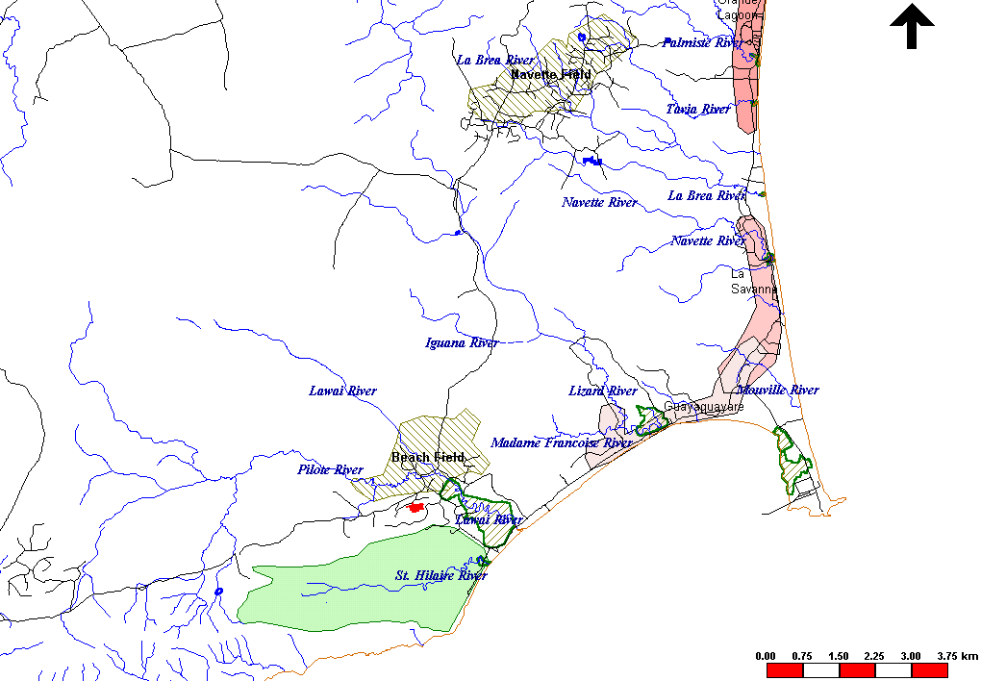

Figure 5.33: Map showing the location of the study area

    - Landing Site

The main fishing depot and mooring area is located at the northeastern corner of the Bay (Figure 5.34).

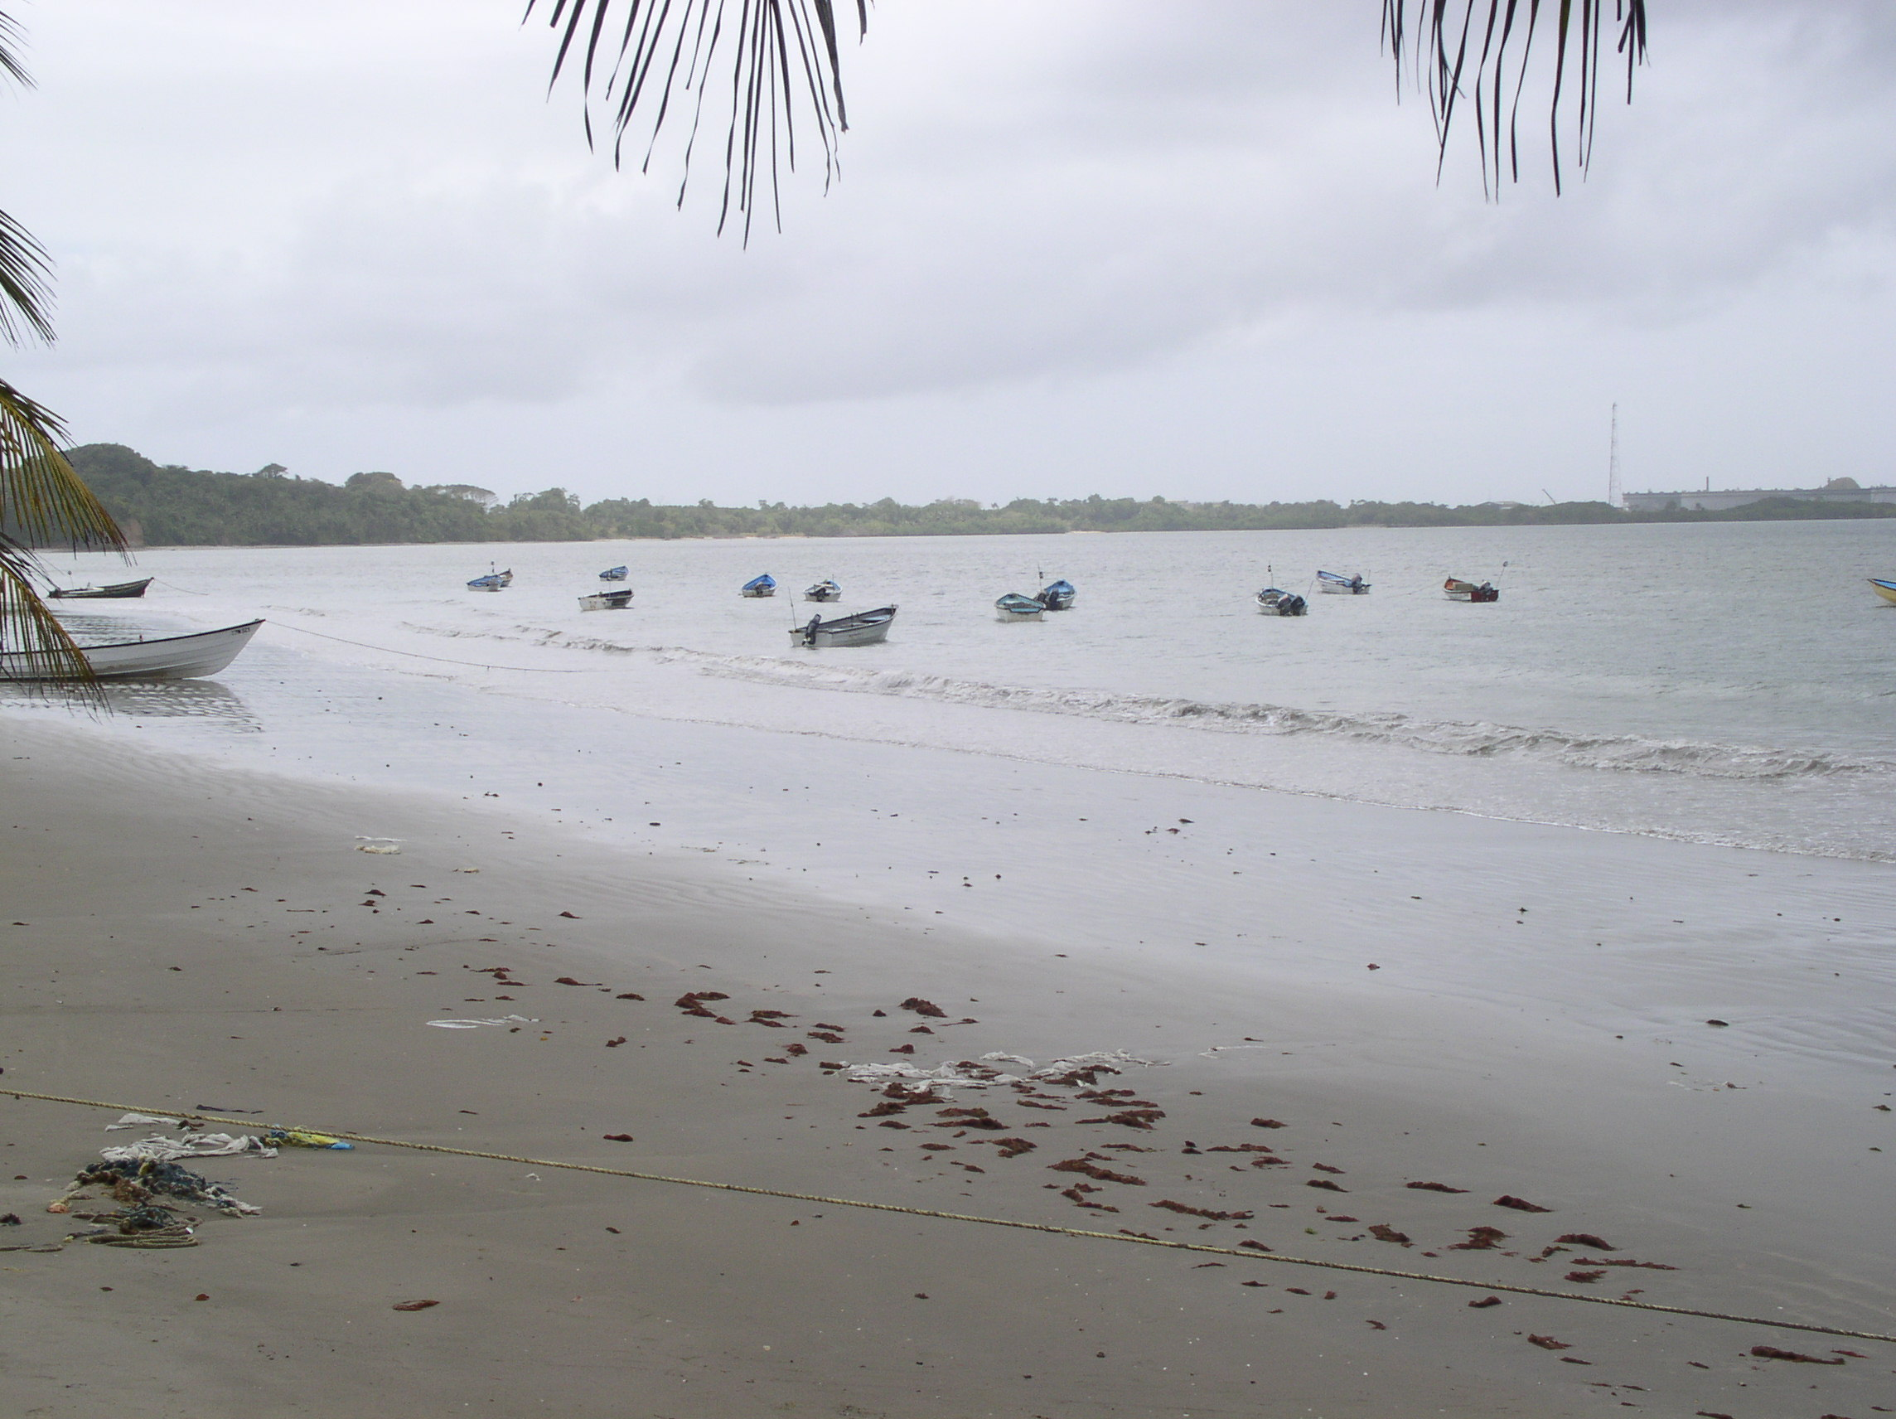
Figure 5.34: Main landing site in Guayaguayare Bay

    - Boats

Fishing in this area is artisanal in nature, characterized by small pirogues (Figure 5.25.2), which have been described as a derivative of the American dug out canoe (Kenny and Bacon, 1981). Pirogues are made out of fibreglass, range in size from 6.7-9.1 meters in length and maybe powered by one or two outboard engines ranging from 45 – 75 HP.

    - Seasonal Migration of Boats

On any given day there maybe approximately 20 – 40 registered boats within the bay. This large range in number is due to the seasonal migration of vessels from one landing site to another in response to the seasonal movements of the main target species (carite and kingfish). Vessels present may belong to a variety of homeports such as Ortoire, Mayaro, Manzanilla, and St. Joseph Village (East Coast) and Moruga (South Coast). On the site visits, boats from the South, East and West coasts of Trinidad were present as was evident by the registration numbers, which can be used to identify the homeport of the fishing vessel. The greatest migrations however, usually come from Mayaro on the East Coast.
Seasonal migration is a characteristic feature of fishing in Trinidad, where boats moved from one landing site to another during the year depending on the location of target species. This makes the fisheries in Guayaguayare Bay very dynamic and very difficult to study.

    - Fishing Methods/Gear Types

5.25.8.1 Gear Types in Trinidad

Fishing areas around Trinidad and Tobago can be delineated according to the type of fishing gear used. Gear types can be classified into five very general categories, each characterized by one or more different types of fishing activities (Fisheries Division, 2002).

Table 5.60 : Description of the most common gear types used in Trinidad and Tobago (Fisheries Division, 2002).
Category of Fishing Gear | Fishing Activities
Fish pot | - Various sizes and types of construction materials; mainly ‘arrowhead’ pots used in the east and southeast coast fisheries
Seine | Multifilament gillnetting from the beach
Line | - Palangue  - Trolling (lines are towed from bamboo outriggers; usually one hook per line)  - Switchering (surface line fishing using dead bait with or without bait)  - A-la-vive (live bait is used; mainly used to target Kingfish)  - Banking
Gillnetting | - Monofilament, transparent gillnetting (locally known as Trans ‘p’)  - Multifilament gillnetting (locally known as ‘Fillet’)
Trawl | Types I, II and III industrial trawlers

    - Gear types in Guayaguayare Bay

In a Frame Survey that was conducted as part of a Fisheries Study of the southeast coast commissioned by bpTT in 2003, it was found that line fishing and gillnetting are the two main types of fishing methods practiced at Guayaguayare. The fishing gears utilised are:

- Hook and line
- Banking (90%)
- Trolling (90%)
- Palangue (67%)

- Gillnets
- Fillet (100%)
- Trans-p (100%)
- Turtle net (45%)
The results of this survey (bpTT, 2003) were verified by informal talks with fishermen and the Fisheries Statistical Data Collector at the landing site on our two site visits to the area. All the boats on both site visits were using the fillet (green twine) net.

    - Gear Dimensions

Although each gear type used in the fishing industry has certain basic underlying features and characteristics, gear features may be modified to make fishing more practical according to the fishing areas. Factors that may affect gear features include:
- Economic, social and cultural aspects
- Environmental conditions
- Target species

The literature review, observation on site visits and interviews with the fishermen and the Fisheries Statistical Data Collector revealed the following information (Table 5.61) with respect to gear type used in the study area.

Table 5.61 :Description of the most common gear types used in Guayaguayare Bay.
Gear Type | Description
Fillet | - Multifilament nets (green twine)  - 200 – 400 lbs; 4-4.25 inches mesh size  - Used mainly at night  - Set at the surface and maybe allowed to drift freely
Trans “p” | - Monofilament nets (transparent twine)  - 200 – 400 lbs; 4-4.25 inches mesh size; transparent nylon twine  - Used either by day or night  - Set below the surface
Trolling | - Surface line fishing using artificial lures or “spoons” without weights
Banking | - Demersal longline operated at the artisanal level  - Consists of a mainline which carries a number of branch lines with hooks  - 150 – 300 baited hooks used to target snappers and sharks
Palangue | - 6-12 inch mesh  - 30 m long (which may be joined in series),  - Suspended from the surface to a depth of 6-8 feet.
Turtle Net

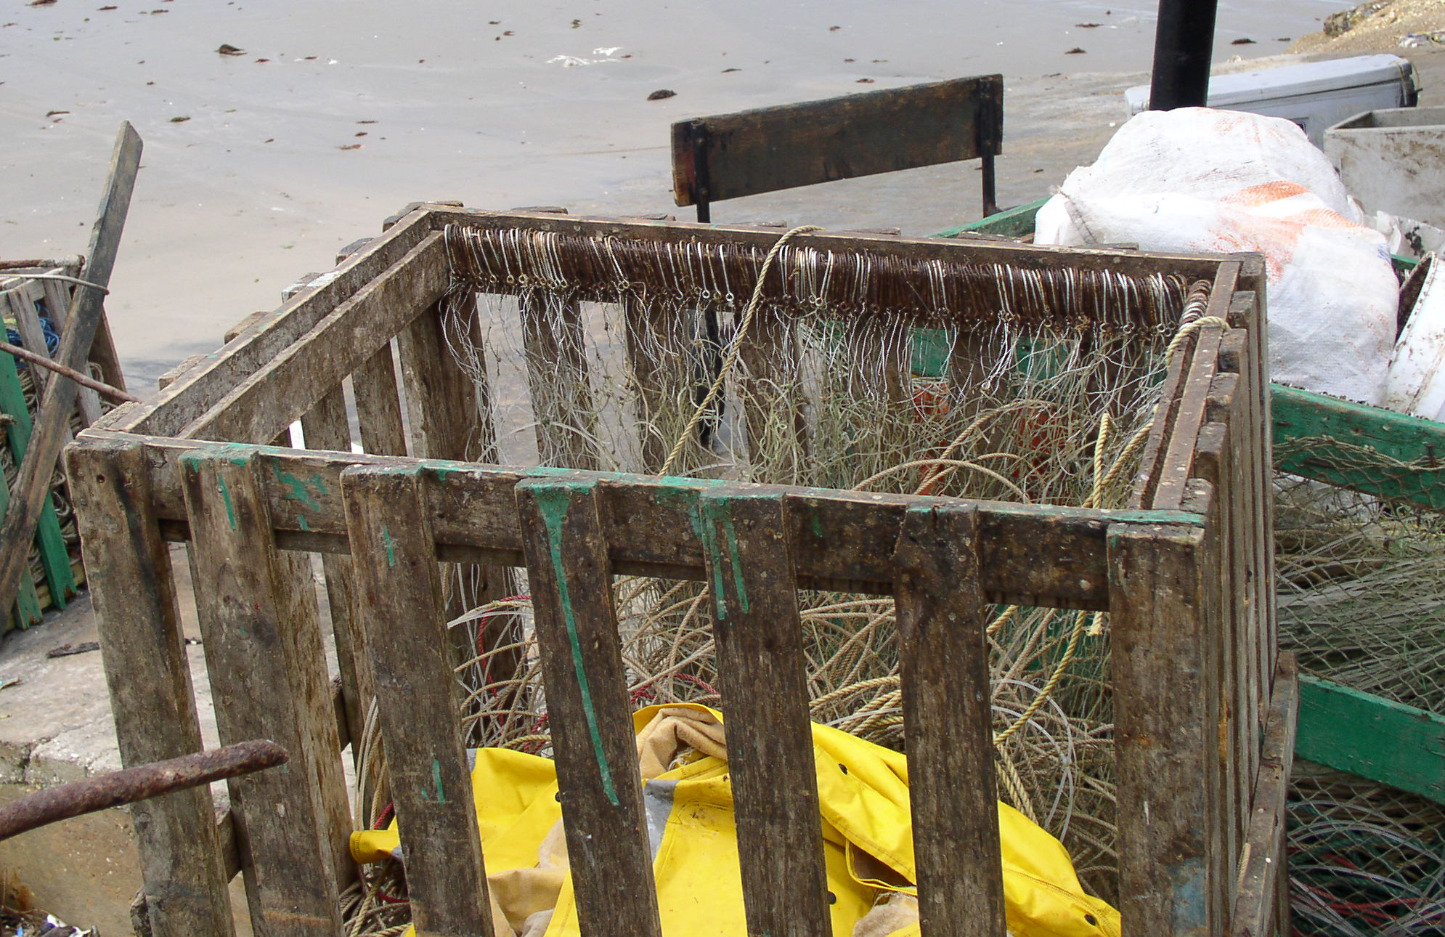
Hooks

A

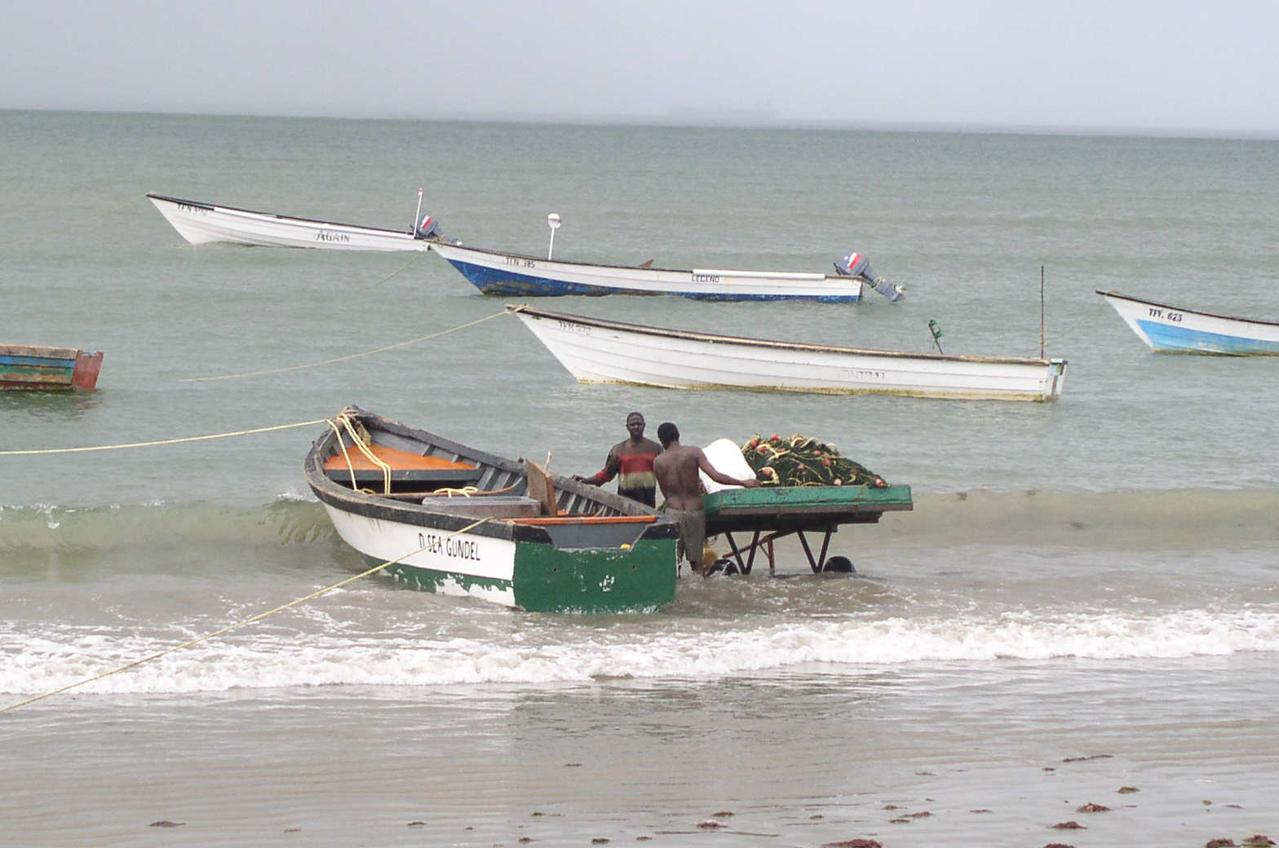
Fillet Net
Pirogues
B
Figure 5.35 : Gear types in Guayaguayare Bay (A) Hooks set for Palangue and (B) Fillet Net
    - Gear Seasonality and activity

Due to the multi-gear nature of Trinidad’s fishing industry, most boats are outfitted with more than one gear type. The gear type used at any one particular time depends on the target species and the season (time of the year). Gear types may be interchanged within a given season depending on the catches. For example, during January to August although fillet maybe the primary gear used in Guayaguayare, some fishermen may opt to try their hand at palangue if catches are low or scarce with the fillet net. Although there are no strict rules regarding what type of gear is used and when, some obvious seasonal generalizations could be made at Guayaguayare (Figure 5.36). The fishing activity associated with the use of each gear type is listed in Table 5.62.

Fillet
Trans ‘p’
Palangue
Turtle Nets
Turtle Nets
January
August
December
February
October

Figure 5.36: Seasonality of Gear Types in Guayaguayare.

Table 5.62: Fishing activities associated with each gear type at the study site (bpTT, (2003).
Number of boats | Number of days fished/week | Duration of fishing trip (days) | Maximum number of trips/day | Departure Time | Arrival Time
Banking
7 | 6-7 | 1-2 | 1-2 | 9 or 3am;  1-2pm | 9am; 8-9pm
Fishing area: Moruga on the south coast to off Manzanilla, including the oil and gas fields.
Additional names of fishing areas: Poui, Moruga, the Basin (Guayaguayare), Mora Rock, Teak, Plaisance
Trolling
7 | 6-7 | 1 | 1-2 | 9 or 3am;  1-2pm | 9am; 8-9pm
Fishing area: Moruga on the south coast to off Manzanilla, including the oil and gas fields.
Additional names of fishing areas: Poui, Moruga, the Basin (Guayaguayare), Mora Rock, Teak, Plaisance
Palangue*
5 | 5-7 | 1 | 2 | 3am | 9am
Fishing area: Moruga on the south coast to off Manzanilla, including the oil and gas fields.
Additional names of fishing areas: Cassia, Moruga, the Basin (Guayaguayare)
Fillet
8 | 5-7 | 1 | 1 | 2-4pm | 9pm;  7-7:30am;  10-1:00am
Fishing area: Moruga to Manzanilla
Additional names of fishing areas: The Basin, the oil and gas fields
Trans-p
8 | 5-7 | 1 | 2 | 3 or 9am; 1-2pm | 9am;  8-9pm
Fishing area: Moruga on the south coast to off Manzanilla, including the oil and gas fields.
Additional names of fishing areas: Poui, Moruga, the Basin (Guayaguayare), Mora Rock, Teak, Plaisance
Turtle Net
4 | Up to 7 | 1 | 2
Fishing area: The Basin (Guayaguayare Bay)

    - Fishing Areas in Trinidad
In this section, the location of gillnet and line-fishing areas around Trinidad is presented.
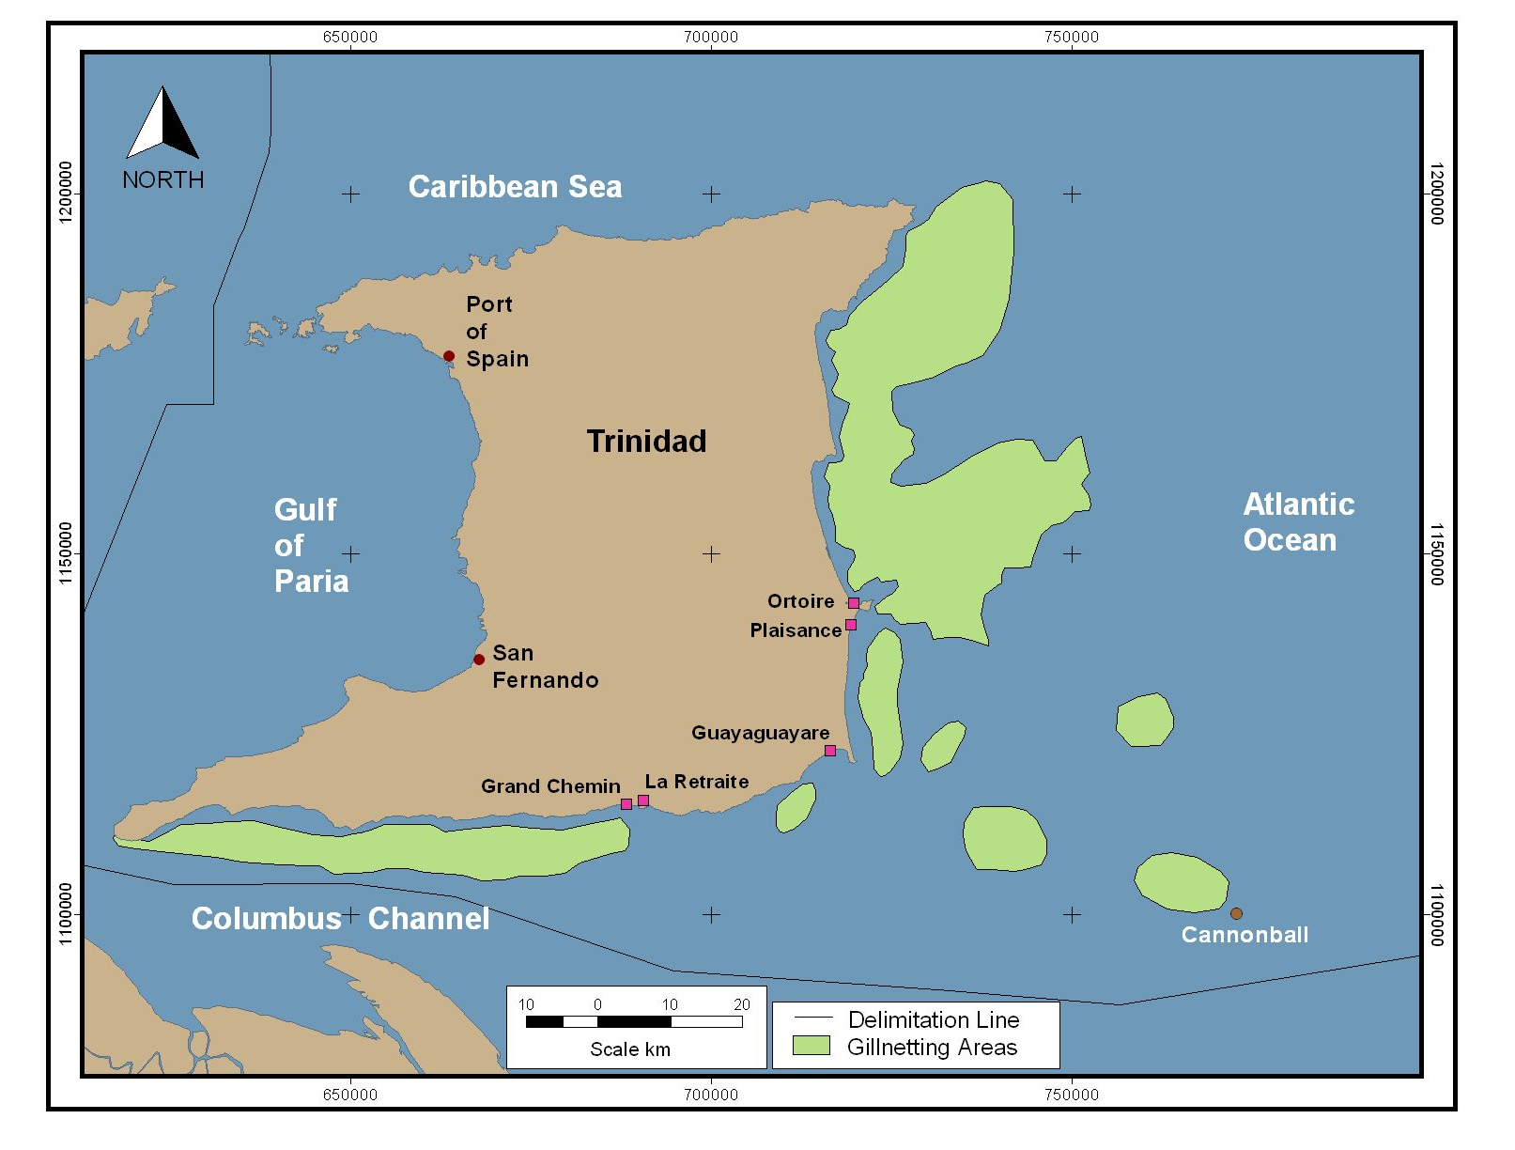

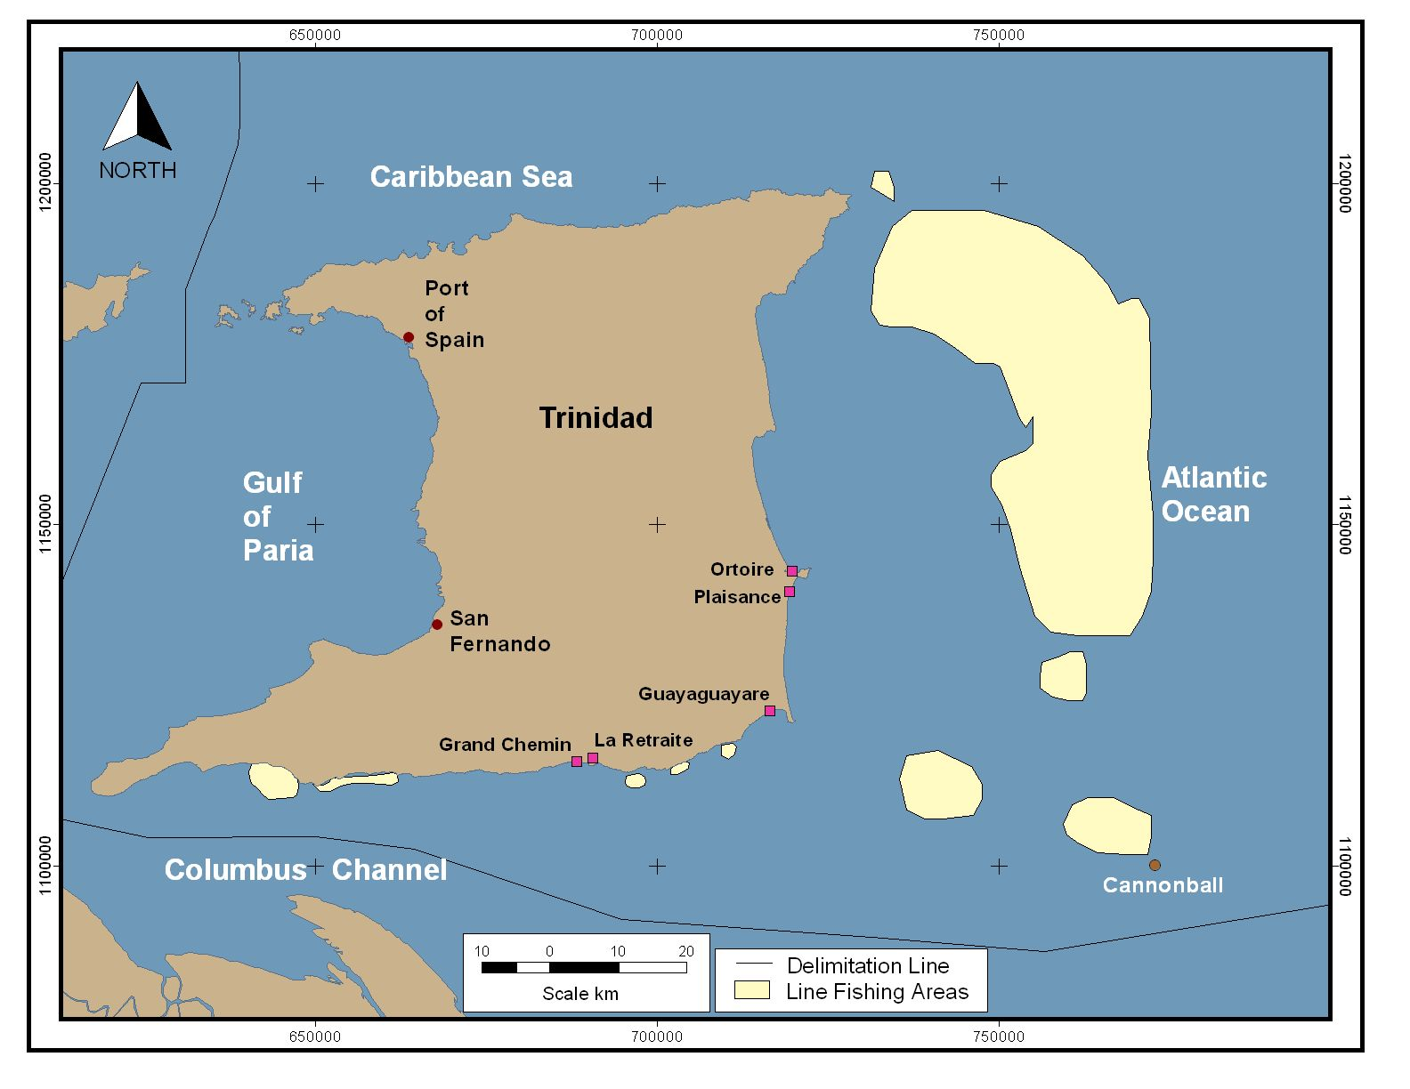
Figure 5.37: (A) Gillnet areas around Trinidad (B) Line areas around Trinidad
(Fisheries Division, 2002)
    - Catches

5.25.13.1 Species Composition and abundance

Carite (Scomberomorus brasiliensis), Kingfish (S. cavalla) and several species of sharks (Carcharhinus spp.) are the most commercially important species landed in the inshore gillnet and line fishery of Trinidad (Henry and Martin, 1992). These findings are reflected in the species composition of the catches for Guayaguayare Bay observed in this study. It should also be emphasized that although many other species are caught in minor amounts depending on the gear type used, Carite, Kingfish and Shark make up the bulk of the landings at this site. Table 5.63 attempts to give a comprehensive list of species caught based on the literature review, observations and informal talks with the fishermen.

    - Seasonal occurrence, migration and breeding patterns of the most commercially important species in Guayaguayare.

Carite and Kingfish

In Trinidad waters Carite and Kingfish are the two most important coastal pelagics in the local fishing industry. Several aspects of the biology of the Scomberomorus species have been investigated, and this literature is listed in a bibliography of the Western Atlantic Scombrids (Manooch, Nakamura, and Bowan Hall, 1978). Sturm (1974, 1978) gives an account of several aspects of S. maculatus, pertaining to S. brasiliensis, in Trinidad waters. These include sizes at first maturity and reproductivity activity, area and time of spawning in Trinidad waters, feeding habits, and suggestions for possible migratory patterns around the island. He identified the main spawning areas for carite to be the Gulf of Paria and the shallow coastal waters of the south coast. Seasonal abundance and migration around the coast for these two species has been documented by Sturm, 1974 and Sturm et al, 1984.

Sharks

Sharks (Carcharhinus spp.) have long life spans and are slow growing animals which produce only a few offspring. Therefore, the stocks are characterized by a close relationship between parent stock and recruitment and by a low capacity to recover from overfishing. Furthermore, sharks have a long gestation period, and the time of birth until the offspring are recruited to the fishery is even longer; consequently, several years elapse before the effects of fishing the parent stock are reflected in recruitment
Attempts to develop a shark fishery in Trinidad and Tobago were encouraged by the need to obtain shark liver oil for the extraction of vitamin A. During 1983 to 1986 the Government of Trinidad and Tobago sought to encourage greater utilization of shark resources through the promotion of a regulated artisanal fishery for sharks. This was implemented through a project executed by the United Nations Development Programme (UNDP) and implemented by the FAO. During the implementation of the activity there was some increase in harvesting of sharks. The project succeeded in promoting increased interest in targeting sharks; reduction in post harvest losses; development of small scale processing facilities for salting and smoking shark flesh and increased awareness of the vulnerability of sharks to over exploitation (Mounsey, 1986). However, as the resource continued to compete in the market place with higher valued species it reverted to being primarily a by catch fishery, as fishermen found it more profitable to target the higher valued mackerels. Consequently net traders were requested to import monofilament webbing of smaller mesh size than was previously used to catch sharks.
Over 23 species of sharks belonging to some four families have been recorded from the waters of Trinidad and Tobago (Table 5.64).

The main species of sharks recorded from gillnets on the South coast of Trinidad are C. limbatus, C. porosus, Rhizoprionodon lalandii, R. porosus, Sphyrna lewini, S. tiburo and S. tudes (Hodgkinson-Clarke, 1991). It is expected that these species would be the significant species in the study area. R. porosus (Puppy shark) and Sphyrna lewini (Chapo) were observed from the landings of fillet nets on both site visits to the area {Fig. 5.38(A) and (B)}.
A biological data collection programme was initiated in 1985 by Fisheries Division for the major shark species (Carcharhinus limbatus, C. porosus, Mustelus higmani, Sphyrna lewini, S. tudes, R. lalandii, and R. porosus) of the artisanal fishery. Much of the data collected however has been inconclusive hence information with regards to seasonal occurrence, migration patterns and breeding patterns is sparse.

Table 5.63 : List of species landed at Guayaguayare Bay, Trinidad.
Family | Scientific Name | Local Common Name | Source
Finfish
Ariidae (D) | Arius or Bagre spp | Catfish | bpTT 2003; FD 2002
Carangidae (P) | Caranx hippos | Cavali | bpTT 2003; FD 2002
Carangidae (P) | Chloroscombrus chrysurus | Plato | bpTT 2003; Stromme & Saetersdal
Carangidae (P) | Oligoplites saurus | Zapate | bpTT 2003
Carangidae (P) | Selene brownii | Moon shine | bpTT 2003; FD 2002
Carangidae (P) | Selene setapinnis | Moon shine | bpTT 2003; FD 2002
Carangidae (P) | Trachinotus cayennensis, T. falcatus | Pompano | bpTT 2003; FD 2002
Carangidae (P) | Trachinotus goodei, T. lathami | Jack, pompano, zelwon | bpTT 2003; FD 2002
Carcharihinidae (P,D) |  | Shark | bpTT 2003; FD 2002
Lutjanidae (D) | Lutjanus griseus, L. jocu | Pargue | bpTT 2003
Lutjanidae (D) | Lutjanus synagris | Lane snapper | Stromme & Saetersdal
Lutjanidae (D) | Lutjauns purpureus | Redfish, red snapper | bpTT 2003; FD 2002
Pomatomidae (P) | Pomatomus saltator | Ancho | bpTT 2003; FD 2002
Sciaenidae (D) | Micropogon furnieri | Cro cro, Racando, Whitemouth croaker | bpTT 2003; FD 2002
Scombridae (P) | Auxis thazard | Bonito | FD 2002
Scombridae (P) | Sarda sarda | Bonito | FD 2002
Scombridae (P) | Scomberomorus brasiliensis | Carite | bpTT 2003; FD 2002
Scombridae (P) | Scomberomorus cavalla | Kingfish | bpTT 2003; FD 2002
Serranidae (D) | Epinephelus itajara | Grouper | bpTT 2003; FD 2002
 |  | Conger eels | bpTT 2003
 |  | Mix fish | bpTT 2003; FD 2002
Shellfish
Panularidae (D) | Panularis sp. | lobster | bpTT 2003; FD 2002
Portunidae (D) | Callinectes danae | Crab | bpTT 2003
Reptiles
 |  | Turtle | bpTT 2003

Table 5.64: List of large coastal and small coastal sharks occurring in the waters of Trinidad and Tobago (Chan A Shing, 1993 and 1995).
Family | Scientific name | Common name | Local Name
Carcharhinidae | Carcharhinus acronotus | Blacknose shark
 | Carcharhinus altimus | Bignose shark
 | Carcharhinus brevipinna | Spinner shark
 | Carcharhinus falciformis | Silky shark
 | Carcharhinus isodon | Finetooth shark
 | Carcharhinus leucas | Bull shark
 | Carcharhinus limbatus* | Blacktip shark | Blackfin shark
 | Carcharhinus obscurus | Dusky shark
 | Carcharhinus perezi | Caribbean reef shark
 | Carcharhinus plumbeus | Sandbar shark
 | Carcharhinus porosus* | Smalltail shark | Big belly; white shark
 | Carcharhinus signatus | Night shark
 | Galeocerdo cuvieri | Tiger shark
Ginglymostomatidae | Ginglymostoma cirratum | Nurse shark
Triakidae | Mustelus canis | Dusky smooth-hound shark
 | Mustelus higmani | Smalleye smooth-hound shark
Carcharhinidae | Negaprion brevirostris | Lemon shark
 | Rhizoprionodon lalandii* | Brazilian sharpnose shark | Sharpnose shark; small shark
 | Rhizoprionodon porosus* | Caribbean sharpnose shark | Sharpnose shark; Puppy shark
Sphyrnidae | Sphyrna lewini* | Scalloped hammerhead shark | Chapo
 | Sphyrna mokarran | Great hammerhead shark
 | Sphyrna tiburo* | Bonnethead shark | Hammerhead
 | Sphyrna tudes* | Smalleye hammerhead shark | Golden hammerhead  Curry shark

* Main species of sharks recorded from gillnets on the South coast.

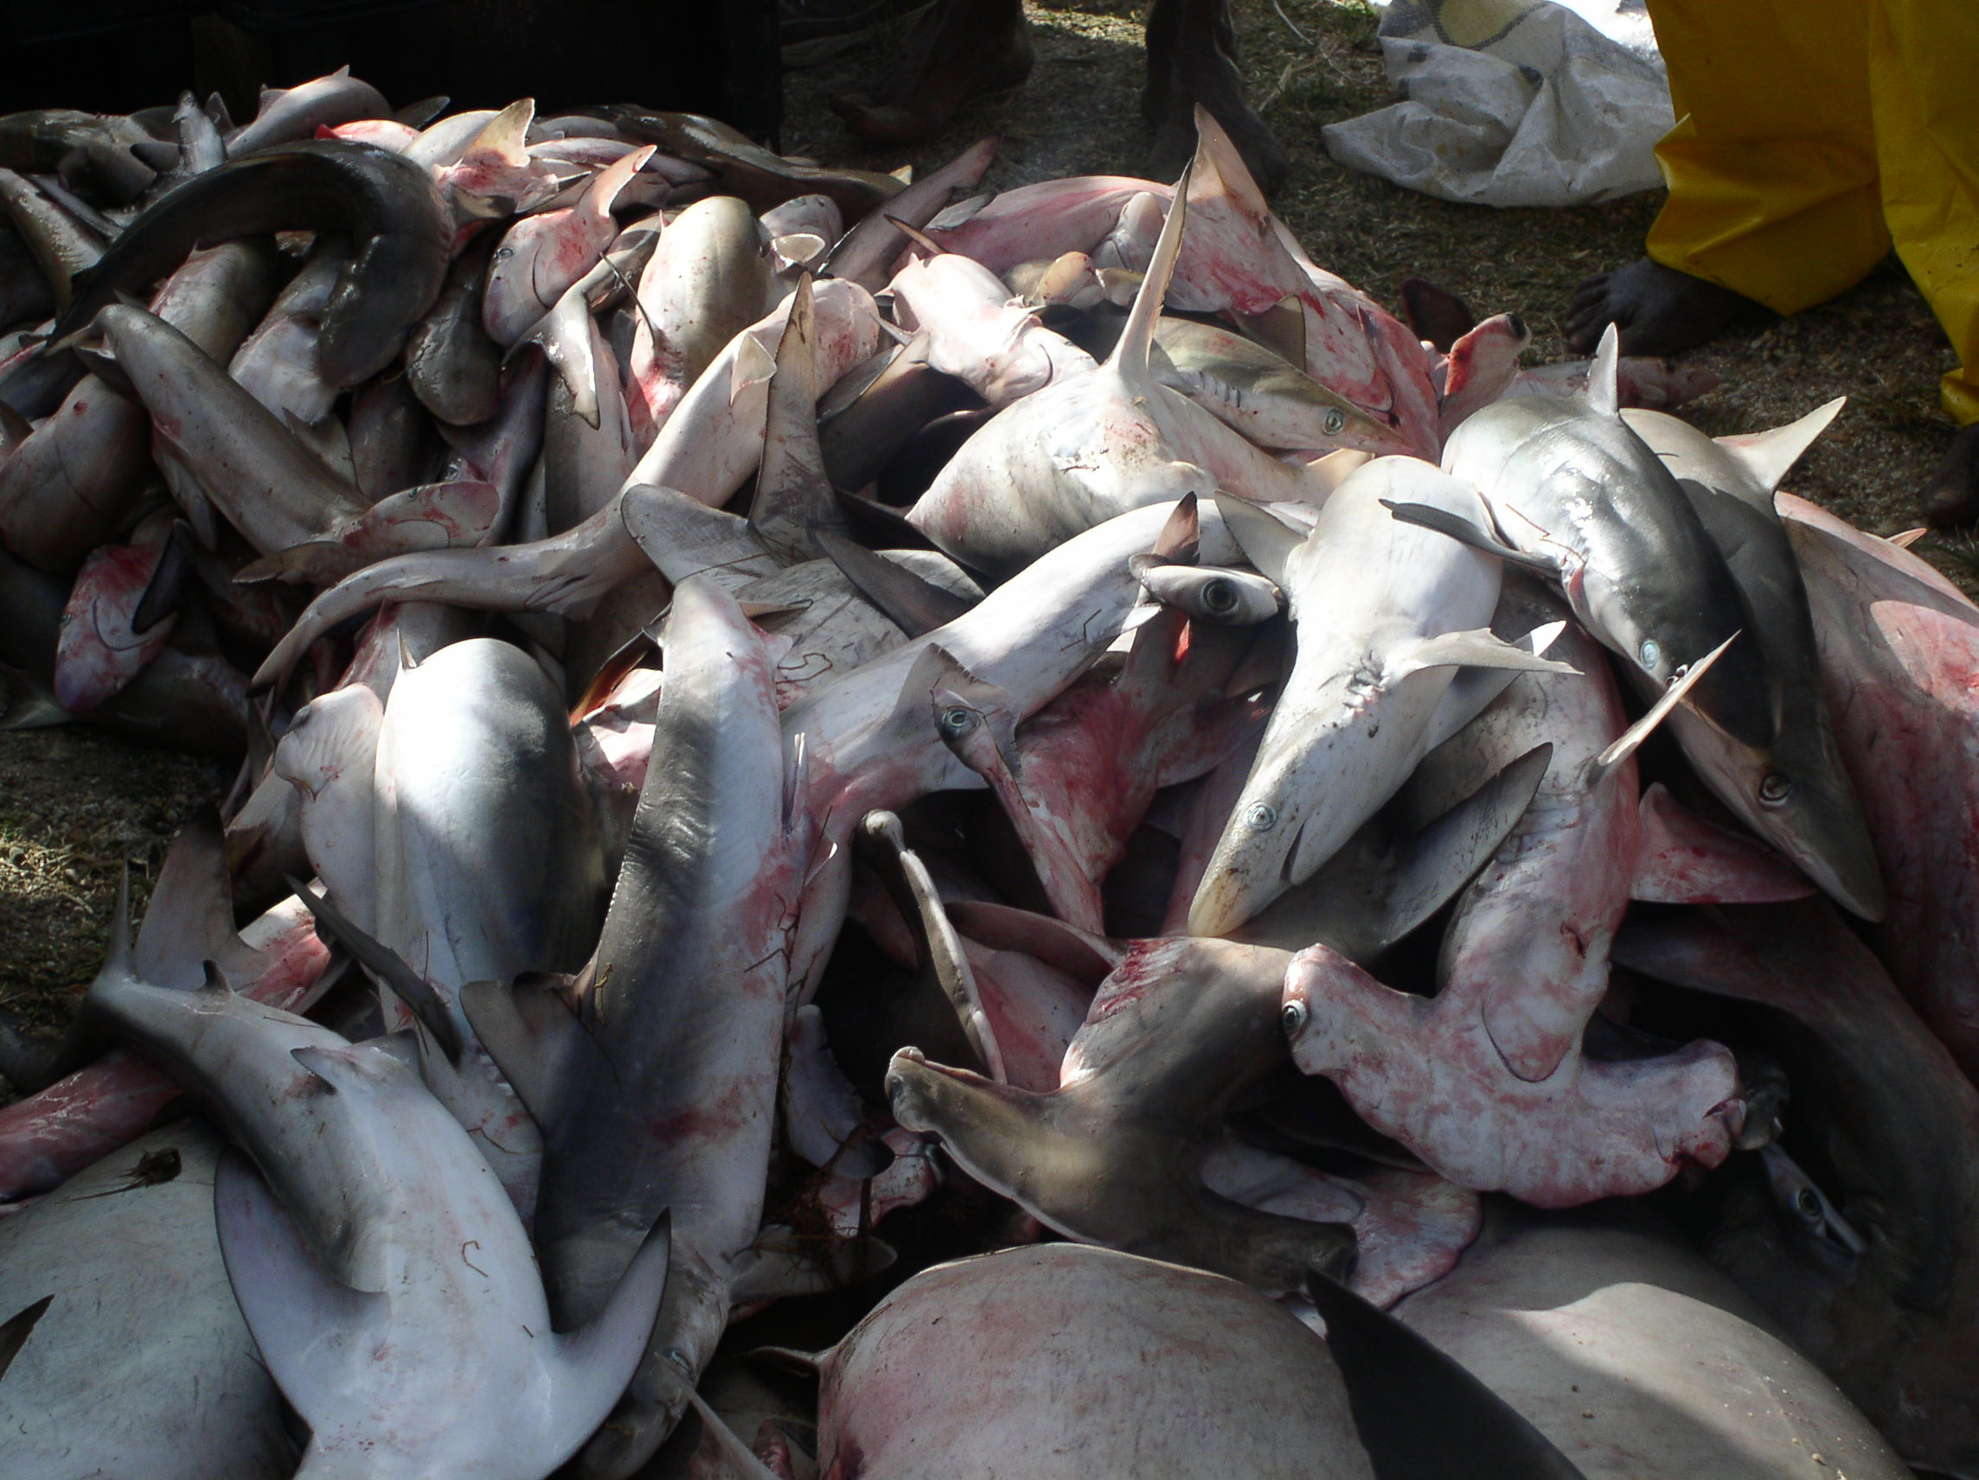
Puppy shark

A

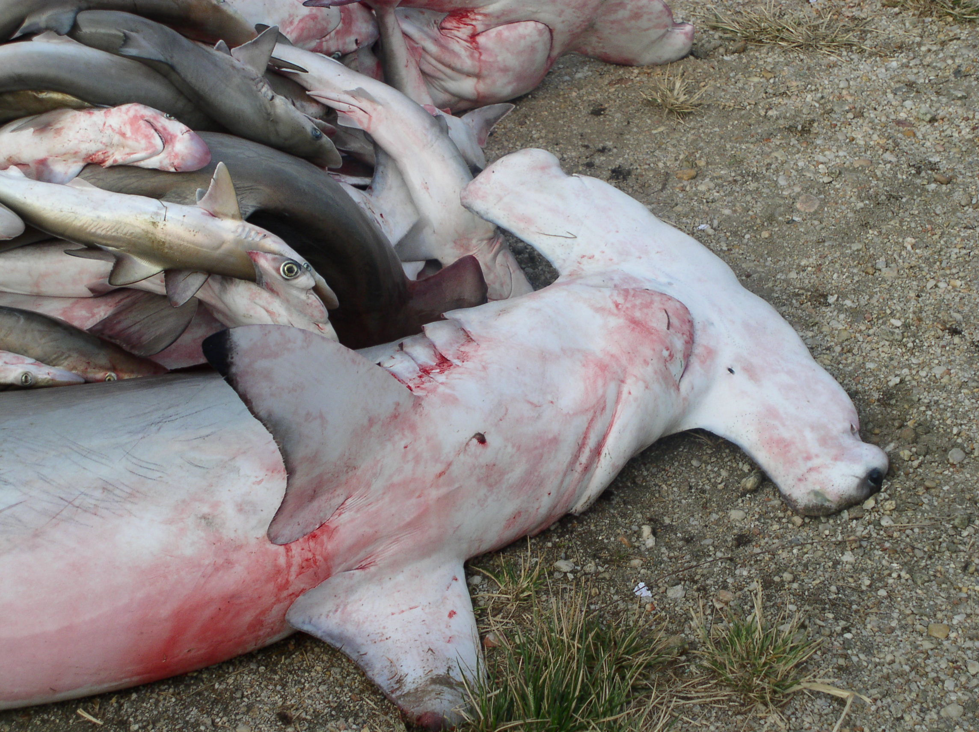
Hammerhead shark
B
Figure 5.38: (A) Shark landings of the artisanal gillnet fishery at Guayaguayare Bay & (B) Hammerhead Shark landed at Guayaguayare Bay
Species | Breeding Season/Pattern | Seasonal Abundance | Migration Patterns | Source
Scomberomorus.brasiliensis | Spawning peak between October – April  Some degree of spawning occurs throughout the year | Maximum abundance in Trinidad waters from May - September | Seasonal movement around Trinidad in a clockwise direction | Sturm, 1978; 1974  Sturm et al 1984
S.cavalla | Spawn around the island throughout the year  Peak spawning activity from September - March | Most abundant from March to August | Moves southwards during the year towards water of lower salinity for spawning | Sturm et al 1984
Carcharhinus  limbatus | Reproductive cycle appears to be seasonal but there is insufficient data to determine the time of parturition or the period of gestation |  |  | Walker, 1992
C. porosus | Ovulation appears to occur during March, April and May  Reproductive cycle appears to be seasonal but there is insufficient data to determine the time of parturition or the period of gestation |  |  | Walker, 1992
Rhizoprionodon lalandii | Ovulation occurs during April, May, June  Parturition occurs during Dec, Jan, Feb  Gestation period is about 8 months |  |  | Walker, 1992
R. porosus | Reproduce throughout the year and show no distinct breeding period |  |  | Castro, 1989
Sphyrna lewini |  | January, February, March |  | Mounsey, 1986
S. tiburo
S. tudes | Ovulation and mating occur in August  Gestation appears to last about 10months  Parturition occurs in shallow waters from late May to June  Distinct breeding cycle |  |  | Castro, 1989
Table 5.65 Summary of available information on breeding season, seasonal abundance and migration patterns for the main species landed at Guayaguayare.

    - Ability of fish to withstand and recover from environmental disasters

Guayaguayare Bay is located on the South coast of Trinidad. According to Boodoosingh 1992, human activity on this coast is minimal and related mainly to oil exploration and production and fishing. The major threat of an environmental disaster thus comes in the form of an oil spill. According to the National Oil Spill Contingency Plan, the study area falls within the Oil Pollution ‘high risk areas’. Historical evidence of oil pollution has been documented by Georges, 1983 who measured beach tar ball concentrations and Khan 1988 who noted elevated levels of petroleum in the surface water at Guayaguayare Bay. In addition to this, natural oil seeps has been noted coming from the rock seabed offshore in Guayaguayare Bay.

Oil spills may affect fish resources in several ways and at different stages of their life cycle. The most vulnerable life stages are the larval and juvenile stages. The ability of the resources to withstand and recover from such a disaster will depend on several factors such as the extent of the spill and the timing of the incident (i.e. during seasonal breeding), the nature, toxicity and persistence of the oil. Although there are no studies, considering its physical characteristics, it is quite likely that this Bay area maybe a spawning ground and nursery area for commercial species including coastal sharks. Studies have reported that Carite (Scomberomorus brasiliensis) spawns in the shallow inshore waters of the south coast.

There is currently no information regarding the ability of fish stocks to respond to an oil spill in the area. It is possible however that an environmental disaster in this area may have a significant effect on catches in the area given its possible function as a breeding ground and nursery area.

  - Health of Fish Resources
Although fish resources in the area are diverse, there are signs that they are on the decline. In a Frame Survey conducted at Guayaguayare Bay, structured questionnaires were used to determine the effects (if any) of previous pipe laying activities by bpTT on fishing activities in the area. It was found that all the fishermen interviewed indicated that fishing had become less productive over the past 10 years. Reasons for reduced productivity in the area included:
- Oil spill - oil in the water leads to fish kills
- Chemical pollution-chemical in the water leads to fish kills
- Trawlers-trawlers destroy sea-beds and kill young fishes
- Transparent nets-these catch young fish which are too young to consume, die and deplete the fish stock
- Increased number of boats-too many boats fishing for available fish stock
- Barge lights close to platforms-the lights on the barges attract fish further out into the ocean, fishermen cannot fish there since they may damage or lose their nets

During this study fishermen also indicated that their landings for Carite and Kingfish are on the decline and that fishing was becoming less and less profitable. Some fishermen also expressed the view that although the mesh size of the nets used have remained the same, the size of Carite (Scomberomorus brasiliensis) and Kingfish (Scomberomorus cavalla) being caught has been getting smaller and smaller. This is a characteristic feature of a fishery that is being fully exploited or over fished.
Fisheries Division data also points to a decrease in the landings of Carite and Kingfish from the inshore gillnet and line artisanal fishery on the south east coast.

    - Marine turtles

There are eight species of marine turtle, in the families Cheloniidae (turtles with hard shells) and Dermochelyidae (turtles with soft shells). Sea turtles are adapted for aquatic existence, coming to land only to nest, with limbs modified for swimming that cannot support body weight on land. Five species of marine turtles occur in Trinidad, all of which are included in the Environmental Management Authority (EMA) list of environmentally sensitive species (EMA, 2004). All have been marked as priority species for the EMA, and all receive both national and international protection (Table 5.66).
Table 5.66: International and national conservation status of marine turtles in Trinidad and Tobago (from EMA, 2004).
Species | IUCN Red List¹ | CITES² | SPAW³ Protocol | CWA⁴ | CW Bill⁵
Leatherback  Dermochelys coriacea | Critically  Endangered  A1abd | Appendix I | Annex II | Protected animal | Schedule IV- Part A  Endangered
Green  Chelonia mydas | Endangered  A1bd | Appendix I | Annex II | Protected animal | Schedule IV- Part A  Endangered
Loggerhead  Caretta caretta | Endangered  A1bd (Not for T&T) |  | Annex II | Protected animal | Schedule IV- Part A  Endangered
Hawksbill  Eretmochelys imbricata | Critically  Endangered  A1bd | Appendix I | Annex II | Protected animal | Schedule IV- Part A  Endangered
Olive Ridley  Lepidochelys olivacea | Endangered  A1bd | Appendix I | Annex II | Protected animal | Schedule IV- Part A  Endangered

¹ IUCN 2003. 2003 IUCN Red List of Threatened Species. Critically Endangered = considered to be facing an extremely high risk of extinction in the wild. Endangered = considered to be facing a very high risk of extinction in the wild.
² Convention on International Trade in Endangered Species of Wild Fauna and Flora. Appendix I = species that are the most endangered among CITES-listed animals and plants. Threatened with extinction; commercial international trade prohibited.
³ Protocol Concerning Specially Protected Areas and Wildlife to the Cartagena Convention for the Protection and Development of the Marine Environment of the Wider Caribbean Region. Annex II = total protection and recovery required, by prohibition of trade or disturbance.
⁴ Conservation of Wildlife Act. Chapter 67:01 Laws of the Republic of Trinidad and Tobago. Protected animal = any animal not specified or mentioned in the Second or Third Schedule.
⁵ Conservation of Wildlife Bill 2003. Endangered = species at risk of extirpation from parts of its range or extinction from its entire range.

    - Caretta caretta

The Loggerhead is a relatively small turtle, named for its large head and strong jaws, used in feeding on crustaceans and molluscs. The major breeding areas of the Loggerhead turtle in the Atlantic are the southeastern coasts of the USA, especially Florida. Loggerheads are highly migratory, undertaking transoceanic journeys as juveniles, moving in the Gulf Stream to the eastern Atlantic Ocean and back in the northern Equatorial Current to the southern Caribbean. The oceanic transport route thus passes just to the north of Trinidad (Gavilan, 2001). Local data are consistent with this picture; the loggerhead turtle rarely nests in Trinidad (Bacon, 1981), but is occasionally caught by fishermen off the north coast (Gaskin & Shephard, 1994). Only occasional individuals wandering off the usual migration route are likely to be encountered in Guayaguayare Bay, and these would be of little ecological or economic importance.

    - Chelonia mydas

The Green turtle (or Greenback in Trinidad) is a resident species, nesting occasionally on the north-east, west and south coasts of Trinidad (Pritchard, 1984). This species is unique among the sea turtles in being herbivorous as an adult, feeding principally by grazing on seagrass beds. The major food source in the Caribbean is turtle grass, Thalassia testudinum (Lageux, 2001). Green turtles make long distance migrations as juveniles, and between feeding and nesting areas as adults, but females return to their natal beach to nest (Lagueux, 2001). Turtles caught in foraging areas in Trinidad may thus have migrated from other areas in the Caribbean, and their capture would not necessarily cause decline in the local breeding population. Green turtles killed when coming to nesting beaches would, however, negatively impact the local population. Together with the Hawksbill, the Green turtle is the major target of the turtle fishery in Trinidad. The species composition of the catch will depend on the area fished; Green turtles in seagrass beds, and Hawksbills in rocky areas and reefs where their prey occur. The Fisheries Division Data Collector and a representative of the Guayaguayare Bay fishermen both stated that Greenbacks were the most common species taken in the turtle fishery there, from nets in seagrass beds in the middle of the basin.

    - Eretmochelys imbricata

The Hawksbill turtle is named for its narrow, sharp beak. Adults are predators, feeding principally on sponges, using their beak to extract these from crevices in rocky areas and reefs. Hawksbills are small to medium sized turtles, usually growing to about 80-85 kg in the Caribbean (Amorocho, 2001). The Hawksbill nests on the east coast and particularly on the north coast, including the Bocas (Pritchard, 1984). This species is utilized by the turtle fishery in Trinidad for meat and, at least formerly, for the carapace, used as a source of tortoiseshell. Chu Cheong (1995) reported prices of TT$5-18 per pound for carapace (several times the value of meat), with some exported to Tobago and England. The export of Hawksbill shell is now illegal (Gaskin and Shephard, 1994). Hawksbills are taken in Guayaguayare Bay, in turtle nets set in rocky areas off Galeota Point, and on the reef.

    - Lepidochelys olivacea

The Olive Ridley (or Batali in Trinidad) is the remaining species of hard-shelled turtle in Trinidad waters. This species is probably the most abundant worldwide, found in all tropical and subtropical ocean basins, but is probably the least abundant marine turtle in the Western Atlantic (Marcovaldi, 2001). The Olive Ridley is rare in Trinidad (Bacon, 1981), but possibly nests on the west coast (Pritchard, 1984; Godley et al., 1993); it has been reported in offshore nets. This turtle has a strong sharp beak, and is a predator of invertebrates, principally crustaceans.

    - Dermochelys coriacea

The Leatherback is the largest sea turtle, commonly growing to over 500 kg mass, and is the only species in the family Dermochelyidae. It is unique among the sea turtles in having a leathery, scaleless skin rather than a hard shell, and is thus easily identified by fishermen and the general public. The leatherback extends further into northern waters than other marine turtles, extending to eastern Canada, as its large size permits retention of body heat. Leatherbacks forage offshore, often in deep water, feeding on cnidarians (jellyfish and siphonophores). This unique feeding niche among marine turtles places them in the planktonic food web (and in danger from swallowing plastic bags). Nesting grounds are distributed circumglobally (approximately 40oN to 35oS). Gravid females are seasonal visitors to the Caribbean (males are rarely encountered) and observations are largely confined to the peak breeding months from March to July (Eckert, 2001). There is a large breeding population using beaches in Trinidad, mostly on the north and east coasts (Pritchard, 1984). Leatherbacks are often caught during the nesting season as incidental catch in fillet nets and trawls. Most fishermen recognize the need to conserve these turtles, and attempt to release them unharmed from nets. The balance of nesting activity is shown by such incidental catches, of females around nesting beaches. Lee Lum (2003) reported 2902 incidental catches on the north coast and 851 on the east coast, compared to only 32 on the south coast and 11 on the west coast. The leatherback is said to be unpalatable and of little commercial value, although the shoulder joints may be eaten (Fisheries Division Data Collector). There was widespread slaughter of leatherbacks on north and east coast nesting beaches in the 1960s (Bacon, 1970), although most of the carcasses were left or used as shark fishing bait (Gaskin & Shephard, 1994). The species has since been effectively protected in Trinidad and is the basis of an ecotourism industry.

  - Incidental catches

The incidental catch of sea turtles is important in Trinidad and Tobago waters. Turtle excluder devices are available, but not used regularly except for shrimp trawls. Leatherbacks are principally caught in green multifilament gill (filette) nets set for kingfish Scomberomorus brasiliensis and carite S. cavalla, when the turtles approach nesting beaches. Lee Lum (2003) estimated that more than 3000 Leatherbacks were caught by the gillnet fishery in Trinidad in 2000, mostly on the north and east coasts from January to August when turtles were arriving to nest. Hawksbill and Green turtle incidental catches were reported to be rare, but these species are clandestinely eaten when captured, even in the closed season (Lee Lum, 2003). Pritchard (1984) noted that the incidental catch of the rare Olive Ridley turtle might be proportionately important, as this slow-swimming species is easily caught in trawls. Fishermen at depots without a turtle fishery suggested that shrimp trawls took many turtles, making the legal fishery not worthwhile (Chu Cheong, 1995).

More than two thirds of Leatherback turtles were released alive after incidental catch, usually requiring nets to be cut. Compensation for net repairs was offered at one time, but is no longer given (Lee Lum, 2003). Catches were associated with green multifilament nets, as these were used at night (when turtles approach nesting beaches) at the surface, and were strong enough to hold turtles. Nylon monofilament nets were set in the day, anchored to the sea floor, and rarely caught turtles, and were not sufficiently strong to hold leatherbacks if caught (Lee Lum, 2003). All incidental catches in gill nets were within 5 km off the beach, although such nets are used up to 15 km from the coast (Lee Lum, 2003). All fishermen surveyed by Lee Lum (2003) knew of the regulations concerning sea turtles, and 65% agreed with them. Incidental capture was a problem on the north coast, where turtles were described as ‘thick’ in the water in the peak nesting season of April and May, and 69% of fishermen regarded them as a hindrance. In contrast, 73% of fishermen on the south coast said that turtles did not affect their fishing activities, and reported turtles nesting only sporadically along that coast (Lee Lum, 2003).

  - Marine turtle fishery

The 1975 Fisheries Act regulates the management of marine turtles and their eggs (as well as all other marine fauna) in Trinidad and Tobago. There is a close season for capture and marketing of turtles from 1st March to 30th September, to protect females during the nesting season. Eggs are protected at all times, and no female may be caught on shore, within a reef, or within 1000 yards of the shore where there is no reef (Gaskin & Shephard, 1994). There is a small turtle fishery in Trinidad based on hard-shelled turtles, using nets of 6-12 inch mesh 30 m long (which may be joined in series), suspended from the surface to a depth of 6-8 feet. Nets are set between known foraging areas of the turtles, and left in place, being checked each morning and evening. Most turtles are caught at night.

Chu Cheong (1995) surveyed 15 fishing depots in Trinidad from 1982-1983 and found turtle fishing at six depots. Only 1-4 persons were involved at each depot (a total of 12 persons), as a part-time activity. The same author (Lee Lum, 2003) surveyed 27 depots in 2001-2002 and found turtle fishing at eight depots, also with a total of 12 persons involved. Only four depots had turtle fisheries in both surveys. The marine turtle fishery in Trinidad is thus small scale, with an admitted (from interviews) 4-10 turtles caught per week at each depot in 1982-1983. The changing incidence of turtle fishing at depots suggests that the fishery is opportunistic rather than traditional in any one location (Table 5.67).

Table Table 5.67: Fish-landing depots in Trinidad with marine turtle fisheries () in 1982-1983
(Chu Cheong, 1995) and in 2001-2002 (Lee Lum, 2003).
Fishing depot (coast) | 1982-1983 | 2001-2002
Carenage (NW) |  | ×
Las Cuevas (N) | × | 
Matelot (N) |  | 
Grande Riviere (N) |  | ×
Toco (NE) |  | 
Balandra (E) | × | 
Mayaro (E) |  | 
Guayaguayare (SE) | × | 
La Lune (S) |  | 
Fullarton (SW) | × | 

The marine turtle fishery is made up principally of Green turtles and Hawksbills, making up 50% and 47.5% of the total (Chu Cheong, 1995), the remainder being Loggerheads. Harpoons may also be used, especially at Grande Riviere, Toco and Carenage (Lee Lum, 2003). Live weights of the catch average 40-50 kg for Green turtles and 80-85 kg for Hawksbills, with a value of TT$ 1-2 per pound wholesale and $ 3-5 retail in 1982-1983, up to $ 8 at inland markets (Chu Cheong, 1995). The wholesale price was TT$ 3-8 per pound in 2002-2003 (Lee Lum, 2003), all prices being live weight. All turtle species fetched the same price, except for Leatherbacks, which were not regarded as good eating meat and were not sold. The fishery was reported to be declining in 1982-1983 as some finfish gave higher returns, and turtle nets were put away when Kingfish or Carite were plentiful. The fishery was unpopular because it is limited by a seven-month closed season, although fishermen agreed with these regulations. At most the turtle fishery was supplementary and provided only part-time earnings. Data are available for the weight and value of turtle meat sold up to 1980, but since then no data have been collected by the Fishery Division, apparently because the redesigned fish reporting form did not include turtles (Chu Cheong, 1995).

    - Turtles in Guayaguayare Bay

Guayaguayare Bay is not an important nesting area for any species of marine turtle although the physical characteristics of the beach are suitable; residents report infrequent nesting of leatherbacks, and possibly of other species (ECO, 2003). Fournillier and Eckert (1997) list 22 sightings of leatherbacks on the beach at Guayaguayare Bay in five patrol nights in 1990, but this report is regarded as questionable. That study only considered the north and east coasts of Trinidad, and listed Guayaguayare Bay among sites on the north coast; the frequency of sightings was comparable to those north coast sites where nesting is common and regular. Gaskin and Shephard (1994) show the Guayaguayare Bay area as not used by nesting marine turtles. One nesting leatherback was reported in 1997, and hatchlings were observed in 2001 (ECO, 2003). A patrol for nesting turtles at the western end of Guayaguayare Bay was instituted during the Bombax pipeline project (BP, 2001), indicating some turtle nesting activity between late August and mid October. Guayaguayare Bay had a turtle fishery in 2001-2002 (Lee Lum, 2003) but not in 1981-1983 (Chu Cheong, 1995), indicating that this fishery was opportunistic rather than traditional.

The survey period at Guayaguayare Bay was in early March that is during the closed season but before the main nesting season. Direct verification of turtle fishing activities or nesting was therefore not possible. Interviews with the Fisheries Division Data Collector and with a representative of the fishermen supported literature findings on turtles in Guayaguayare Bay. Three to four boats set turtle nets from October to February, each boat setting nets on most nights during the season. This is a seasonal activity because of the closed season, and also part-time, the fishermen concerned also using other gear for finfish. Turtle nets were only set by boats resident at Guayaguayare, not by boats visiting from other landing areas, because these nets remain in place for long periods. No turtle excluder devices were used in other fishing gear, except for shrimp trawls. The United States ban on import of shrimps caught without turtle excluder devices was thus successful at Guayaguayare Bay.

Nets were set at 4-5 in the afternoon and left overnight, on the rocky area near the coastguard jetty (for Hawksbills) and in the seagrass beds (for Greenbacks). Fishermen consider Guayaguayare Bay to be the best area for turtle fishing on the south coast because of the widespread rocky bottom. Each boat may catch up to eight turtles per night, and would expect to be successful on most nights, with a total catch of about 10 turtles per night for the whole Guayaguayare Bay turtle fishery. This is a substantially higher catch than reported to the Institute of Marine Affairs survey (10 turtles per week – Lee Lum, 2003), perhaps because that represented a more official investigation. Ten turtles correspond to about 1500 pounds of meat (live weight), sold to vendors for TT$ 3-4 per pound wholesale, or TT$ 8-10 retail. Incidental catches of hard-shelled turtles are consumed even in the closed season. Leatherback turtles were occasionally incidental catches in filette nets, and were released alive if possible. Fishermen reported only seeing one turtle nesting in Guayaguayare Bay. They knew of regular turtle nesting on the east coast, so the lack of nesting observations in Guayaguayare Bay seems to be a true reflection of low nesting activity.

  - Marine mammals

Marine mammals are an ecological rather than taxonomic grouping, including members of the orders Cetacea, Sirenia and Carnivora. The latter (seals and sea-lions) are not present in Trinidad and Tobago waters, but cetaceans are represented by many species of whales and dolphins, and sirenians by the West Indian Manatee Trichechus manatus. The manatee is on CITES Appendix I and the cetaceans are on Appendices I or II; all species are protected in Trinidad and Tobago under the Conservation of Wildlife Act and the Conservation of Wildlife Bill (Table 5.68).

Table 5.68: International and national conservation status of endangered marine mammals in Trinidad and Tobago
(from EMA, 2004).
Species | IUCN Red List¹ | CITES² | SPAW³ Protocol | CWA⁴ | CW Bill⁵
West Indian manatee  Trichechus manatus | Vulnerable  A2d  (not recorded for T&T) | Appendix I | Annex II | Protected animal | Schedule IV- Part A  Endangered
Cetacean species |  | Appendix II (except species in Appendix I) |  | Protected animal | Schedule IV- Part A  Endangered

¹ IUCN 2003. 2003 IUCN Red List of Threatened Species. Vulnerable = best available evidence indicates species is facing a high risk of extinction in the wild.
² Convention on International Trade in Endangered Species of Wild Fauna and Flora. Appendix I = species that are the most endangered among CITES-listed animals and plants. Threatened with extinction, commercial international trade prohibited. Appendix II = species that may become threatened with extinction unless trade is closely controlled.
³ Protocol Concerning Specially Protected Areas and Wildlife to the Cartagena Convention for the Protection and Development of the Marine Environment of the Wider Caribbean Region. Annex II = total protection and recovery required, by prohibition of trade or disturbance.
⁴ Conservation of Wildlife Act. Chapter 67:01 Laws of the Republic of Trinidad and Tobago. Protected animal = any animal not specified or mentioned in the Second or Third Schedule.
⁵ Conservation of Wildlife Bill 2003. Endangered = species at risk of extirpation from parts of its range or extinction from its entire range.

Marine mammals are highly mobile and capable of moving long distances, with many species showing seasonal migrations for food or breeding. Historically both cetaceans and sirenians were abundant in Trinidad and Tobago waters, and were heavily exploited (Reeves et al., 2001a,b).

    - Cetaceans

There are two suborders of cetacean. The Mysticeti (baleen whales) are large (6-30 m body length) whales that lack teeth and feed on relatively small prey using straining plates of baleen that hang from the roof of the mouth. The Odontoceti (toothed whales) are often small (from 1.5 m), including dolphins and porpoises and the sperm and killer whales, which have teeth and feed on relatively large prey. There are four species of Mysticete and 19 species of Odontocete likely to occur in Trinidad and Tobago waters (Ward and Moscrop, 1999; Ward et al., 2001) (Table 5.69).

Table 5.69 : Cetaceans thought to occur in waters of Trinidad and Tobago
Species | Common name | IUCN Red List
Mysticeti
Balaenopterus physalus | Fin whale | Vulnerable
Balaenopterus borealis | Sei whale | Vulnerable
Balaenopterus edeni | Bryde’s whale | Insufficiently known
Megaptera novaeangliae | Humpback whale | Vulnerable
Odontoceti
Physeter macrocephalus | Sperm whale | Vulnerable
Kogia breviceps | Pygmy sperm whale | Insufficiently known
Kogia sima | Dwarf sperm whale | Insufficiently known
Ziphius cavirostris | Cuvier’s beaked whale | Insufficiently known
Mesoplodon europaeus | Gervais’ beaked whale | Insufficiently known
Orcinus orca | Killer whale | Insufficiently known
Feresa attenuata | Pygmy killer whale | Insufficiently known
Pseudorca crassidens | False killer whale | Insufficiently known
Globicephala macrorhynchus | Sort-finned pilot whale | Insufficiently known
Stenella attenuata | Pan-tropical spotted dolphin | Insufficiently known
Stenella frenatus | Atlantic spotted dolphin | Insufficiently known
Stenella longirostris | Spinner dolphin | Insufficiently known
Stenella clymene | Clymene dolphin | Insufficiently known
Stenella coeruleoalba | Striped dolphin | Insufficiently known
Delphinus delphis | Common dolphin | Insufficiently known
Tursiops truncatus | Bottlenose dolphin | Insufficiently known
Grampus griseus | Risso’s dolphin | Insufficiently known
Steno bredanensis | Rough-toothed dolphin | Insufficiently known
Sotalis fluviatilis | Tucuxi | Insufficiently known

The only Cetacean for which reliable data exist for Trinidad and Tobago waters is the Humpback Megaptera novaeanglia, which was surveyed by Swartz et al. (2001) using visual and acoustic methods. The Humpback was reported to be commonly located off the north and east coasts of Trinidad, in waters 50-100 m deep, but not detected along the south and south-east coast. This species formerly gathered in large numbers in the Gulf of Paria, where they were hunted, and it has been suggested that they have declined in the region due to noise disturbance from commercial shipping and oil and gas exploration (Coastal Dynamics, 2004).

Data for other species of cetacean are piecemeal in Trinidad and Tobago waters. The Short-finned Pilot whale Globicephala macrorhynchus is the most frequently sighted cetacean in Trinidad waters. There were strandings at Manzanilla in 1995 and 1999 and at Caroni in 2001, and a pod beached at La Filette on the north coast in 1987 (ECO, 2003). A pod of Killer whales Orcinus orca was observed in the Gulf of Paria, and a dead whale (probably Bryde’s whale, Balaenoptera edeni) was found at Pointe-a-Pierre in 1987 (Ottley et al., 1987). Gervais’ Beaked whale has also been observed in Trinidad waters (ECO, 2003). A pod of bottlenose dolphins Tursiops truncates was recorded off Port-of-Spain in 2001 (ERL, 2002). There is little information on the ecological requirements or migrations of these species, except that whales usually stay in deeper waters while dolphins are more likely to enter bays and shallow waters. Dolphins may be harvested deliberately or as incidental catches in Trinidad and Tobago (Kenny and Bacon, 1981). Cetaceans are susceptible to acoustic disturbance (Richardson et al., 1995)

There are no specific sightings of whales in Guayaguayare Bay, but it is likely that one or more species of dolphin enters the bay to feed on the rich fishing grounds. The bay is too small to support resident populations, so that disturbance would lead to relocation elsewhere, rather than extinction of populations.

    - Sirenian

The West Indian manatee is a large plant-eating aquatic mammal currently known to inhabit the Nariva and Fishing Pond wetlands on the east coast of Trinidad, with occasional sightings in the Oropuche and Ortoire rivers (Boyle and Khan, 1993). The manatee was formerly common and hunted in Trinidad (Romero et al., 2002), but declined to the point where it was considered extinct (Bacon, 1979). It is likely that the current small population (numbered at perhaps 25 individuals) originated by migration from the Orinoco River delta (CEP, 1995). Manatees prefer coastal freshwater or brackish habitat, but are known to enter open waters to migrate (particularly during the rainy season, when low salinities are recorded in the east coast nearshore).

There have been no confirmed sightings of manatee in Guayaguayare Bay or adjacent waters of south-east Trinidad (Coastal Dynamics, 2004). The seagrass beds in the bay would be a suitable food source for any manatees that migrated down the east coast during the rainy season, but such individuals would only represent transient utilization of Guayaguayare Bay.

